INTERNSHIP RESULT REPORT
INDEPENDENT LEARNING PROGRAM (MBKM) AT
PT PELABUHAN INDONESIA (PERSERO) REGIONAL 4 KENDARI
SOUTHEAST SULAWESI PROVINCE

Compiled by:
WA ODE RAHMAWATI B1B120188

DEPARTMENT OF MANAGEMENT FACULTY OF ECONOMICS & BUSINESS HALU OLEO UNIVERSITY KENDARI CITY
2023

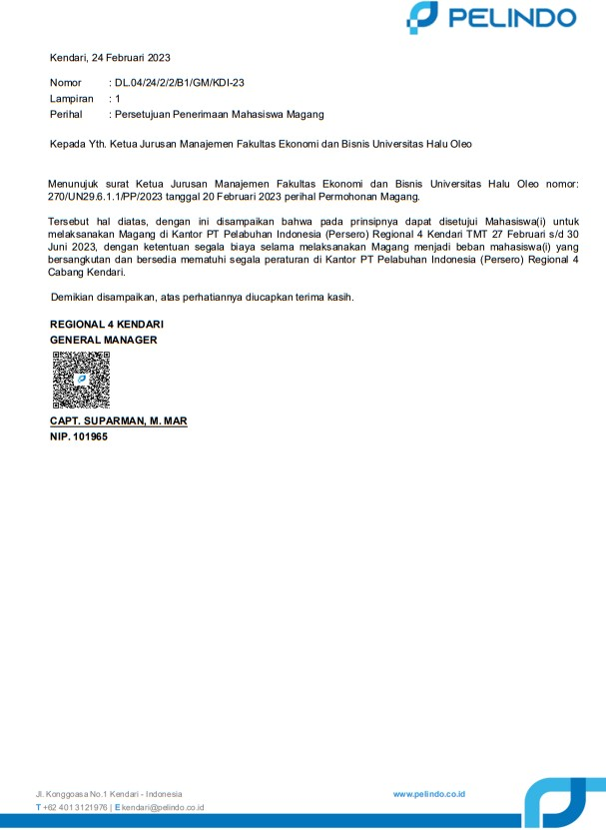

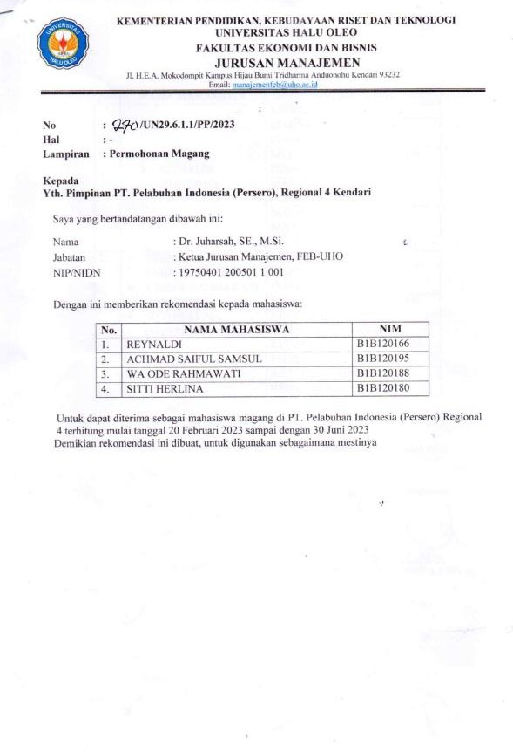

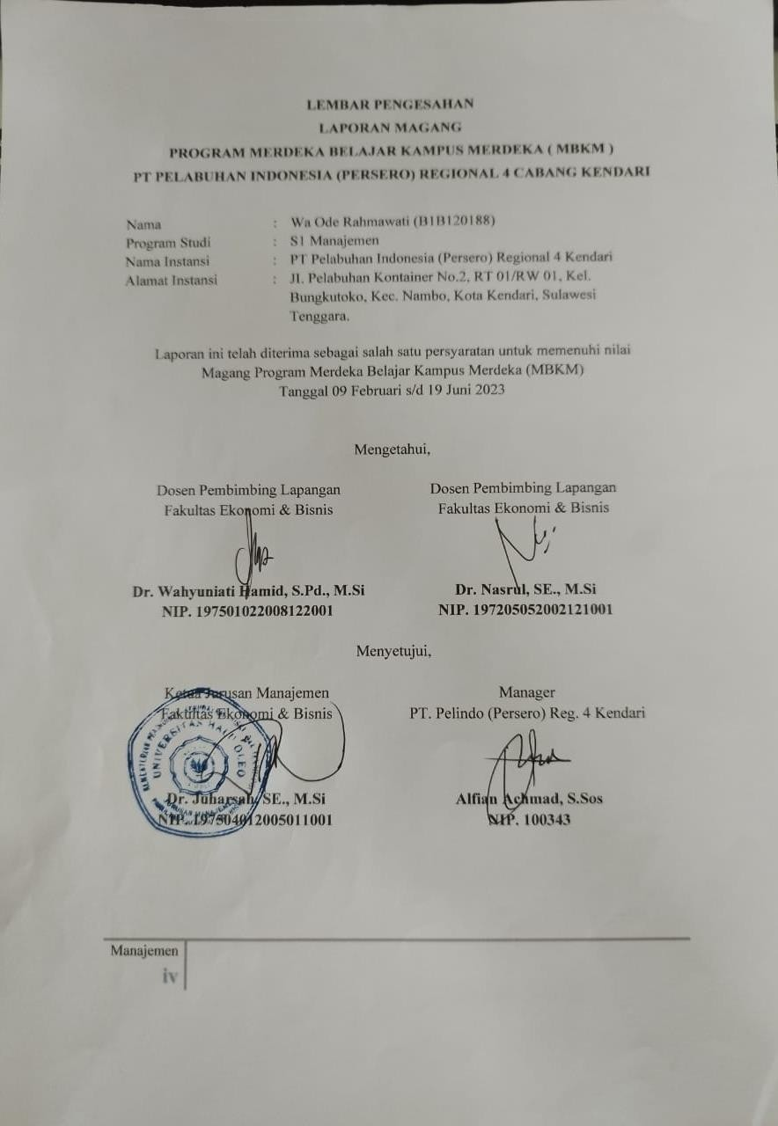

CERTIFICATE OF INTERNSHIP
No. PP.01/7/2/1/B1/GM.R4-23

The undersigned:
Name :Alfian Achmad, S.Sos
Position :Manager of PT Pelabuhan Indonesia (Persero) Regional 4 Kendari

Explain that:

Name :WAODE RAHMAWATI
NIM :B1B120188
Study Program :S1 Management

are really students who have carried out internships at the PT Pelabuhan Indonesia (Persero) Regional 4 Kendari office during the 1 semester period from February 09 to June 19, 2023.

Thus this certificate is made, to be used as appropriate.

Kendari, June 19, 2023
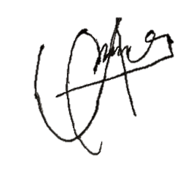
Manager of PT Pelindo (Persero) Reg. 4 Kendari

Alfian Achmad, S.Sos NIP. 100343

INTRODUCTION

Praise and gratitude to God Almighty for His blessings and grace so that the Internship Report at PT Pelabuhan Indonesia (Persero) Regional 4 Kendari, can be carried out properly. Thank you to the field supervisor, Study Program Coordinator and all employees and leadership elements at the PT Pelabuhan Indonesia (Persero) Regional 4 Kendari office, who have guided and provided direction during the writing of this internship report.
Students realize that without the help and guidance of various parties it is very difficult for us to complete this report on the results of the Merdeka Learning Campus Merdeka (MBKM) Internship Program. Therefore, we would like to thank:
- Mr. Juharsah, SE, M.Si, as the Head of the S1 Management Study Program, Faculty of Economics and Business, Haluoleo University, who has taken the time to guide us to complete the report on the results of the Merdeka Learning Campus Merdeka (MBKM) Internship Program.
- Mr. Alfian Achmad, S.Sos, as Manager and Mentor of the Merdeka Learning Campus Internship Program at PT Pelabuhan Indonesia (Persero) Regional 4 Kendari, Southeast Sulawesi Province.
- Mrs. Dr. Wahyuniati Hamid, S.Pd., M.Si, as Field Supervisor of the Merdeka Learning Campus Merdeka (MBKM) Management Internship Program, Faculty of Economics and Business, Haluoleo University, who has taken the time to guide us to complete this report on the results of the Merdeka Learning Campus Merdeka (MBKM) Internship Program.
- Mr. Nasrul, SE, M.Si, as Field Supervisor of the Merdeka Learning Campus Merdeka Internship Program (MBKM) Management, Faculty of Economics and Business, Haluoleo University, who has taken the time to guide us to complete the report on the results of the Merdeka Learning Campus Merdeka Internship Program.

- To all Employees and Staff of PT Pelabuhan Indonesia (Persero) Regional 4 Kendari which I cannot mention one by one.
- Reynaldi as a colleague who has worked together during the Internship at PT Pelabuhan Indonesia (Persero) Regional 4 Kendari.
- Achmad Saiful Samsul as a colleague who has worked together during the Internship at PT Pelabuhan Indonesia (Persero) Regional 4 Kendari.
- Sitti Herlina as a colleague who has worked together during the Internship at PT Pelabuhan Indonesia (Persero) Regional 4 Kendari.

Finally, I hope that God Almighty will be pleased to repay all the kindness of all those who have helped and hopefully this report on the results of the Merdeka Learning Campus Internship Program will bring benefits.

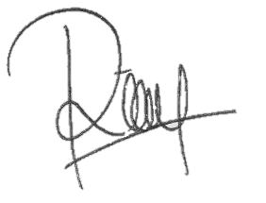
Kendari, June 19, 2023 Student Intern,

Wa Ode Rahmawati

LIST CONTENTS

Page
FOREWORDMAGANG ii
SHEETEND iv
CERTIFICATE OF PERFORMANCEMAGANG
WORDSPREFACE vi
TABLECONTENTS viii
LISTTABLE
LISTFIGURES
CHAPTER IINTRODUCTION
  - BackgroundBackground
  - Internship ObjectiveWork
  - Place and Schedule of InternshipWork
CHAPTER II COMPANYPROFILE
  - DescriptionCompany
  - HistoryCompany Brief
  - StructureOrganization
  - Unit Duties and FunctionsWork
  - General Unit ActivitiesWork 12
CHAPTER III RESULTS ANDDISCUSSION 16
  - Description of InternshipWork 16
  - Relevance of Internship Activities to Subjects Acquired inLectures 74
  - Challenges from on-site activitiesInternships 79
  - Internship Activities ThatCan Change Mindset 80
CHAPTER IVCLOSING 81
APPENDIX 82

LIST TABLE

Page
Table 3.1 Recap of PT Pertamina Trans Kontinental Memorandum Details in MS. Excel 24
Table 3.2 Coklit NotaBill 24
Table 3.3 Reimbursement Recap in MS. Excel 26
Table 3.4 Examples of Recapitulated Records ( OfficeManuscripts) 31
Table 3.5 Equipment Inventory DataOffice 57
Table 3.6 Customer Data by Contribution Year2023 68

LIST IMAGES

Page
Figure 1.1 Office of PT Pelindo (Persero)Kendari
Figure 1.2 Container TerminalKendari Newport
Figure 1.3 Time Attendance ProcessFingerprint
Figure 2.1 Logo of PT.Pelindo
Figure 2.2 Map of the Region andShipping Services
Figure 2.3 Organizational Structure of PT Pelindo (Persero) Regional 4Kendari
Figure 2.4 Port PierNusantara 13
Figure 2.5 Terminal FieldContainer 13
Figure 2.6 Port Pass / 15
Figure 3.1 Separation of Memorandum Form 3 Based oncolor 17
Figure 3.2 IBS Pelindo Application Login 17
Figure 3.3 IBS Pelindo Application Homepage 18
Figure 3.4 Receivables Menu in IBS Pelindo Application 18
Figure 3.5 Payment Period on IBS Pelindo Application 18
Figure 3.6 Bill Payment Receivables History on IBS Pelindo Application 19
Figure 3.7 Monitoring Menu on IBS Pelindo Application 19
Figure 3.8 Entering the Note Number 3 on theMonitoringMenu 20
Figure 3.9 Billing Attachment Feature on Billing MenuMonitoring 20
Figure 3.10 Proof of Note 3 PT Pertamina TransContinental 21
Figure 3.11 Download Proof of Note 3 PT Pertamina TransContinental 21
Figure 3.12 Print Proof of Note 4 PT Pertamina TransContinental 22
Figure 3.13 Proof of Note 4 PT Pertamina TransContinental 22
Figure 3.14 Download Proof of Note 4 PT Pertamina TransContinental 23
Figure 3.15 Copy All Notes 4 PT Pertamina TransContinental 23
Figure 3.16 Proof of UseTooling Services 25
Figure 3.17 Proof of ServiceShip 25
Figure 3.18 Proof of Use of Mooring Services / Services 26
Figure 3.19 Payment History Menu on IBS Pelindo Application 27
Figure 3.20 Downloading PT Rukma's Payment NotePadaya Trans 27
Figure 3.21 Proof of Payment Note (Nota 4) PT RukmaPadaya Trans 28

Figure 3.22 Download PT Rukma Padaya's Proof of PaymentTrans 28
Figure 3.23 Digital Copy of Letter of AgreementCooperation Operation 29
Figure 3.24 Proof of Payment Note PT HUAIndonesia Agency 29
Figure 3.25 Proof of Payment Note PTPELNI 30
Figure 3.26 Proof of Payment Note PT Mitra IntertransForwarding 30
Figure 3.27 Old Office Memorandum / Manuscript Still in the FormCopy 32
Figure 3.28 New Office Memorandum / Manuscript Original Copy Already UsingBarcode 32
Figure 3.29 Homepage atSAP Application 33
Figure 3.30 Entering CodeCompany 33
Figure 3.31 Basic Data Menu onSAPApplication 34
Figure 3.32 Payment Menu onSAPApplication 34
Figure 3.33 Details Menu onSAPApplication 35
Figure 3.34 Debit Feature onSAP Application 35
Figure 3.35 Proof of Concession Payment ProcessCompleted 36
Figure 3.36 GmailCompany 36
Figure 3.37 Income Tax Reimbursement Letter Sent Through 37
Figure 3.38 Reimbursement Letter Document in the Form of 37
Figure 3.39 Document folder ifhas been extracted 38
Figure 3.40 Pelindo Application Homepage 38
Figure 3.41 Creating a Service Note in Pelindo Application 39
Figure 3.42 Submitting Service Memorandum on Pelindo Application 39
Figure 3.43 Cooperation Agreement Letter to the CompanyChina 40
igure 3.44 Letter of Order for Goods and Services 40
Figure 3.45 Document ScanArchive 41
Figure 3.46 Application 41
Figure 3.47 Steps for Making Income Tax Return21/26 42
Figure 3.48 Steps to Input Income Tax Withholding Slip21/26 43
Figure 3.49 Steps for Inputting Income Tax 21/26 for Permanent Employees OverPTKP 43
Figure 3.50 Making Inputs of Income Tax 21/26 forPermanent Employees Morethan PTKP 44
Figure 3.51 Steps for Inputting Income Tax 21/26 for Tax Period Not More thanPTKP 44
Figure 3.52 Steps to Import Income Tax Withholding Slip21/26 45
Figure 3.53 Viewing the Error Descriptionon the 46

Figure 3.54 Steps to Create aID 47
Figure 3.55 Organization Tax ID Creation 47
Figure 3.56 Final Result of CalculationSSP 47
Figure 3.57 Steps to Import ID 48
Figure 3.58 Final Status Import ID 48
Figure 3.59 Steps to Create an Income Tax Billing Payment Order21/26 49
Figure 3.60 Steps to Input Opponent DataTransactions 50
Figure 3.61 Payment Status on MenuPayment Notification 50
Figure 3.62 Steps to Create Withholding DataDomestic 51
Figure 3.63 Inputting Income Tax Data that isWith 51
Figure 3.64 Return and Overbooking ofExcess 52
Figure 3.65 Cut Proof Status on 52
Figure 3.66 Steps to Create Outer Cutting Data 53
Figure 3.67 Inputting Opponent DataTransactions 53
Figure 3.68 Inputting IdentityCutter 54
Figure 3.69 Proof of Cut StatusCompleted 54
igure 3.70 Steps to Make Self-Deposit of Income Tax 55
Figure 3.71 Inputting Proof NumberDepositing 55
Figure 3.72 Steps to ImportESSP Data 56
Figure 3.73 Import Data StatusFinish 56
Figure 3.74 Equipment Inventory LabelOffice 57
Figure 3.75 Pelindo Application Login 58
Figure 3.76 Set Date, Month, Year on Pelindo Application 58
Figure 3.77 Download MemorandumDinas 59
Figure 3.78 Save File in FolderArchivist 59
Figure 3.79 Service Memorandum File AfterDownloaded 60
Figure 3.80 Entering Memorandum Data Form 3 in BookRegistration 60
Figure 3.81 Application Logo 61
Figure 3.82 Application Login 61
Figure 3.83 Homepage atVessp4 Application 62
Figure 3.84 Vessel Service Menu on Application 62
Figure 3.85 Create Word OrderIn 63

Figure 3.86 Memorandum Form.A1 63
Figure 3.87 Create Word OrderOut 64
Figure 3.88 Create Word Order(+) 64
Figure 3.89 Data Entry 2 and 65
Figure 3.90Realizationpage 65
Figure 3.91 MenuRealization 66
Figure 3.92 Return to Main Menu 66
Figure 3.93 Billing Menu onVessp4 Application 67
Figure 3.94 Results of the Form Note Process.A1 67
Figure 3.95 ActivitiesGymnastics 68
Figure 3.96 Pelindo Mengajar Goes ToKendari 69
Figure 3.97 Short Filmmaking DevelopmentPort 69
Figure 3.98 Bump / Entry PassPort 70
Figure 3.99 Directing Passengersto the Ship 70
Figure 3.100 Learning processTeaching 71
Figure 3.101 ParadeCulture 71
Figure 3.102 Open with EmployeesPelindo 72
Figure 3.103 WorldEnvironment Day Community Service 72
Figure 3.104 Reviewing the Field AreaContainer 73
Figure 3.105 Reviewing the Harbor Area of Fast Boats and ShipsNight 73

CHAPTER I INTRODUCTION

Background Background

In order to support aspects of professional expertise, the Management Study Program, Faculty of Economics & Business, Haluoleo University has provided complete educational supporting facilities and infrastructure, but these facilities and infrastructure only support aspects of professional expertise in theory. In the world of work, it is necessary to integrate the knowledge of the theory that has been obtained from the lecture bench and practical training in the field to provide an overview of the real world of work.
Work Internship is a form of lecture through direct work activities in the world of work. This Work Internship is a practical activity for students with the aim of gaining experience from these activities, which can later be used for professional development. This work internship activity is carried out at PT Pelabuhan Indonesia (Persero) Regional 4 Kendari, which is an Indonesian BUMN engaged in port services, logistics and especially port management and development. The choice of work internship location is quite strategic on the grounds that it is not far from the place of residence with a time taken 30 minutes.
The implementation of work internships is carried out at PT Pelabuhan Indonesia (Persero) Regional 4 Kendari, which is one of the companies engaged in port services, logistics and port development management. in Indonesia which is considered to have successfully survived amid increasingly strong market competition. In the implementation of this work internship I chose at PT Pelabuhan Indonesia (Persero) Regional 4 Kendari, because to be able to identify the management that occurs in it, especially process management in one of the fields owned by PT Pelabuhan Indonesia (Persero) Regional 4 Kendari, namely ports and logistics. By doing a work internship at PT Pelabuhan Indonesia (Persero) Regional 4 Kendari, it is hoped that the author will gain knowledge related to the topic, namely financial and marketing management.

Internship Objective Work
The objectives of the work internship activities are:
    - Conducting various work internship activities and studying financial and marketing management carried out by PT Pelabuhan Indonesia (Persero) Regional 4 Kendari,
    - Knowing the service marketing management carried out by PT Pelabuhan Indonesia (Persero) Regional 4 Kendari,
    - Gain experience and insight into the world of work in a professional company engaged in port and logistics services.
    - Train students in the field in aspects of business administration that are not covered by processed lectures.

Place and Schedule of Internship Work
    - Place of Internship

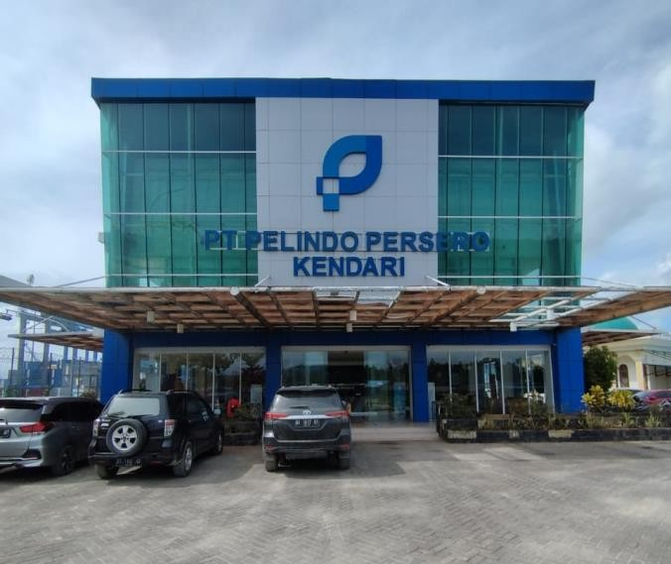
Internship activities at PT Pelabuhan Indonesia (Persero) Regional 4 Kendari, which is located at JI. Container Port No.2, RT 01 / RW 01, Kel. Bungkutoko, Kec. Nambo, Kendari City, Southeast Sulawesi.

Figure 1.1 Office of PT Pelindo (Persero) Kendari

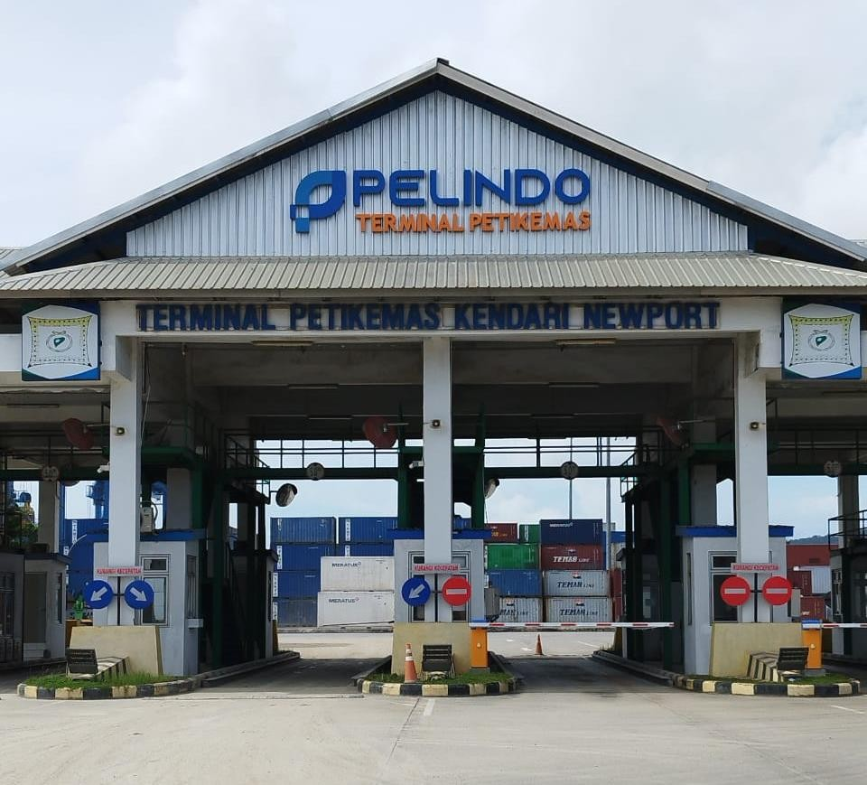

Figure 1.2 Kendari Newport Container Terminal

Schedule of Work Internship Implementation Time

Internships are carried out according to a predetermined schedule which is carried out on February 09, 2023 to June 19, 2023 with working hours at 08:00 WIB to 17:00 WIB on Monday to Friday.

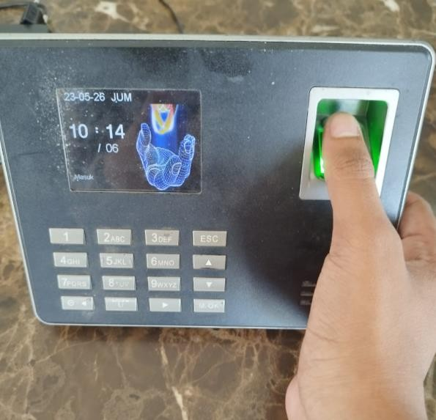
Figure 1.3 Fingerprint Time Attendance Process

Company Description

CHAPTER II COMPANY PROFILE

Figure 2.1 Logo of PT Pelindo
Post integration, Pelindo unveiled a new logo that will be used by the company. The new logo takes inspiration from the shape of a busy, crowded and confusing path or route. This illustrates Pelindo as a port service provider that is always active and plays a major role in sea transportation as the lifeblood of the national economy as well as the realization of the Indonesian sea highway.
Pelindo takes the letter P which is the initials of Pelindo as well as the shape of a fish, which symbolizes the habitat of important marine life for Indonesia. It also symbolizes Pelindo's commitment to safeguarding Indonesia's natural wealth by continuing to contribute to supporting the ecosystem in its operational areas.
The BLUE color used is the color of the Indonesian sea, which is very close to Pelindo. This color symbolizes stability, trust, integrity, professionalism and devotion. This color also symbolizes Pelindo's efforts, as part of SOEs, to provide the best for all stakeholders.
PT Pelabuhan Indonesia (Persero) Regional 4 Kendari Branch is located at Jl. Container Port No. 2, Kel. Bungkutoko, Nambo District Kendari City, Southeast Sulawesi, Indonesia.
Pelindo or PT Pelabuhan Indonesia (Persero) is an Indonesian state-owned enterprise (SOE) engaged in port services, logistics and especially port management and development (operator). Currently, the company operates approximately 94 ports located in 34 provinces of Indonesia. From Sabang to Merauke, Pelindo is one of the strategic SOEs where all ports managed have a significant position in the international trade network based on sea transportation.

Brief History of Company
PT Pelabuhan Indonesia, namely PT Pelabuhan Indonesia (Persero) Regional 4 Kendari Branch. Where this port has a long history, especially concerning the State where Indonesia has a long history as a maritime country. In the past, the maritime kingdoms of the archipelago such as Srivijaya, Majapahit, the kingdom in Maluku once held the key to the world trade route through spices. Traders from Gujarat and China took spices from the Maluku islands and sent them via merchant ships to China, the Arabian Peninsula, Europe and Managascar. Small ports in Indonesia became stopovers and trading centers that brought together traders from various nations, thus becoming large commercial cities. This led to the birth of Indonesian ports in the independence era.
Previously, to manage ports in Indonesia, 4 Pelindo were formed, which were divided based on different regions. Pelindo I, for example, manages ports in the provinces of Nanggroe Aceh Darussalam, North Sumatra, Riau and Riau Islands. Pelindo I was formed based on PP No.56 of 1991, while the name Pelindo I was determined based on Notary Deed No.1 dated December 1, 1992. Pelindo II manages ports in 10 provinces, namely West Sumatra, Jambi, South Sumatra, Bengkulu, Lampung, Bangka Belitung, Banten, DKI Jakarta, West Java and West Kalimantan. Pelindo II was established based on PP No.57 of 1991, Pelindo II Persero) was established based on Notarial Deed Imas Fatimah SH, No.3, dated December 1, 1992. Pelindo III manages ports in 7 provinces, namely East Java, Central Java, South Kalimantan, Central Kalimantan, Bali, NTB and NTT. The establishment of Pelindo III is contained in the Notarial Deed of Imas Fatimah, SH No.5 dated December 1, 1992, based on PP No.58 of 1991. Pelindo IV manages ports in 11 provinces, namely East Kalimantan, North Kalimantan, South Sulawesi, Central Sulawesi, Southeast Sulawesi, Gorontalo, North Sulawesi, Maluku, North Maluku, Papua, and West Papua. Pelindo IV was formed based on PP No.59 dated October 19, 1991. While the deed of formation is Notarial Deed Imas Fatimah, SH no.7 dated December 1, 1992. Each Pelindo

has branches and subsidiaries to manage its business. Pelindo I, II, III, IV are non-listed state-owned companies whose shares are 100% owned by the Ministry of SOEs as the State Shareholder of the Republic of Indonesia. Therefore, there is no information on Major Shareholders or Individual Controlling Shares in Pelindo. The Republic of Indonesia, represented by the Ministry of State-Owned Enterprises of the Republic of Indonesia, is the sole owner and shareholder. The merger or integration of the four Pelindo into one Pelindo which was then named PT Pelabuhan Indonesia is based on Government Regulation Number 101 of 2021 concerning the Merger of PT Pelindo I, III, and IV (Persero) into PT Pelabuhan Indonesia II (Persero); Pelindo II acts as the holding company and the three Pelindo (I, III, IV) act as sub-holding. The establishment of sub-holding that manages business clusters is intended to increase Pelindo's service capacity and business efficiency. Based on the Letter of the Minister of State-Owned Enterprises of the Republic of Indonesia number: S-756 / MBU / 10/2021 dated October 1, 2021 regarding Approval of Name Changes, Amendments to the Articles of Association and Company Logo. So that Pelindo II changed its name to PT Pelabuhan Indonesia (Persero) or Pelindo.
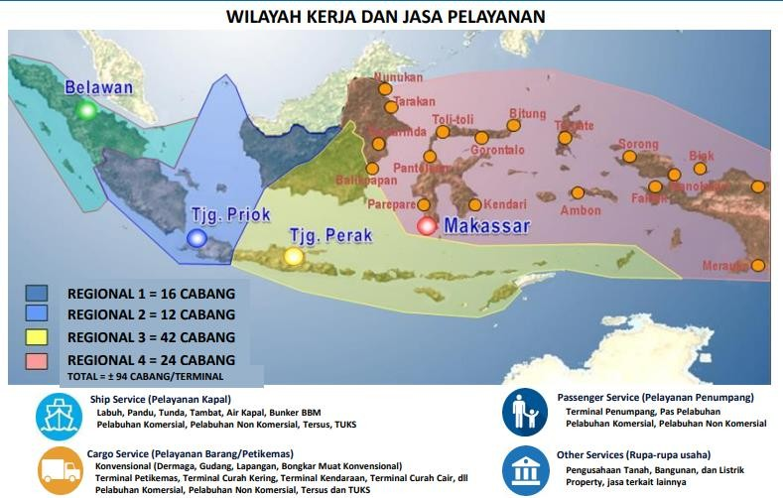
Figure 2.2 Map of Working Area and Services

Organization Structure
Like other public organizations and limited liability companies, PT Pelabuhan Indonesia (Persero) Regional 4 Kendari also has an organizational structure. Labor management at PT Pelabuhan Indonesia (Persero) Regional 4 Kendari, consists of permanent employees, one-year and three-month contract employees, casual daily employees (KHL), and pieceworkers. Permanent employees are workers who have employment agreements with employers/companies for an indefinite period of time (permanent), and earn a certain amount of income regularly. Contract employees are employees who have a work agreement with an employer/company only for an agreed contract period (1 month, 3 months, 1 year) with income according to working time and do not receive social security. KHL or casual employees are employees who are not permanent and receive a daily salary. Piece-rate workers are workers who work on a piece-rate basis, so the distribution of results adjusts to the work that has been completed.
PT Pelabuhan Indonesia (Persero) Regional 4 Kendari, has several fields / sections, to find out the clear position of the department as a whole from the point of view of a unified division, the following is the organizational structure of PT Pelabuhan Indonesia (Persero) Regional 4 Kendari,
The organizational structure of PT Pelabuhan Indonesia (Persero) Regional 4 Kendari consists of:
    - General Manager
    - Operations and Engineering Manager
    - Operations Support Manager

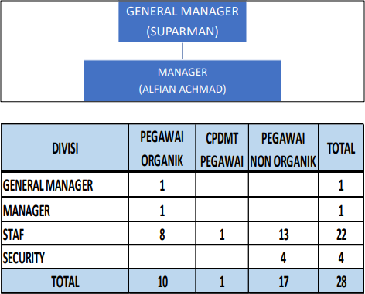

Figure 2.3 Organizational structure of PT Pelindo (Persero) Regional 4 Kendari

Duties and Functions of the Work Unit

- General Manager
  - The General Manager has the function of leading the Branch in terms of preparing management plans, controlling administrative and operational activities in accordance with the direction, policies and objectives of the Company in order to achieve productivity, service, revenue and profit of the Company:
  - The General Manager has the following duties:
    - Manage the Branch in accordance with the vision, mission and objectives of the Company;
    - Manage and maintain the Company's assets;
    - As a company representative in the Branch environment,
    - Manage and develop human resources;
    - Handling legal matters;
    - Implementing the Company's general policies set by the Board of Directors in accordance with applicable laws and regulations;
    - Prepare an annual work plan and budget;

    - Report the realization of the management work program and budget work plan for the current year periodically (monthly, quarterly, semester and yearly):
    - Prepare activity accountability reports and calculation of business results.

Operations and Engineering Manager
  - The Operations and Engineering Services Manager is under and directly responsible to the General Manager:
  - The Operations and Engineering Services Manager has the function of organizing planning, implementation, control, supervision and development of ship service businesses inside and outside port waters as well as passenger embarkation and debarkation services, marketing, rentals, port passes or levies, conventional loading and unloading services, animals, plants, marketing, rentals, port passes / levies and other miscellaneous business activities as well as construction, maintenance of facilities and equipment, workshops, environmental impact analysis and port waste pollution;
  - The Operations and Technical Services Manager has the following duties.
    - Planning, controlling, implementing, and supervising the operation of anchorage facilities, guiding, mooring, water supply, stacking yards, warehouses, port passes, smooth passenger flow. conventional loading and unloading services, as well as construction of facilities and procurement of equipment and other businesses:
    - Develop marketing and rental plans for conventional loading and unloading facilities, warehouses, piling yards, land utilization, buildings, electricity, mechanical equipment, barges, fuel oil, clean water, and fire extinguishers:
    - Carry out dock, warehouse and field cleaning

stacking, port buildings and environmental management and environmental impact assessments;
    - Plan, implement, evaluate and develop the implementation of ISPS Code policies and standardization for the company's business needs and compliance with regulatory requirements (Regulation Compliance);
    - Give consideration to the classification of land and water use within the port working area;
    - Plan, implement and supervise maintenance programs, repair of equipment facilities and port buildings:
    - Plan, implement and control the procurement program of operational materials, spare parts and technical supplies;
    - Carry out periodic evaluation and review of the port Master Plan;
    - Plan, implement, evaluate and develop the implementation of K4L policies for the company's business needs and fulfillment of regulatory requirements (Regulation Compliance);
    - Strive for the achievement of ship service revenues, terminal services and business forms in accordance with the budget work plan;
    - Give consideration to the classification of land and water use within the port working area;
    - Supervise the movement of vessels within and outside the mandatory pilotage waters;
    - Compile operational activity reports;
    - Prepare study materials in the framework of business cooperation related to Operations;
    - Organizing telecommunications port andorganizing SAR assistance:
    - Coordinate the Port Service Center (P2JP) / One-Stop Service Center (PPSA):

Operations Support Manager
  - The Operations Support Manager reports directly to the General Manager:
  - The Operations Support Manager has the functions of planning, implementing, controlling, and supervising the activities of financial administration, accounting, treasury, taxation, human resources, general, housekeeping, law, public relations, and social and environmental responsibility:
  - The Operations Support Manager has the following duties:
    - Plan financial administration, treasury, taxation. general accounting and cost accounting, inventory management, and carry out verification of receipts and expenditures;
    - Plan and prepare materials for the preparation of the branch budget work plan and its control;
    - Store and secure documents,
    - Develop, implement and evaluate the risk management program in accordance with the provisions of the Company;
    - Plan and control activity programs, budgets, and costs related to finance and accounting administration;
    - Plan the administration of human resources, welfare and health care of employees, retirees and their families;
    - Handling legal issues and organizing public relations;
    - Carry out office administration, housekeeping, protocol, compile office needs and equipment, carry out maintenance of office equipment, office cleanliness, and TJSL;
    - Controlling the program of activities and budget costs related to the HR field;
    - Compile, process data and information, analyze and evaluate, present data systematically, quickly and accurately,

either with computer media or other media;
    - Prepare HR reports and control the HR business information system, and general administration, both computerized and manual;
    - Handling Security Unit (Satpam) within the port working environment area and branch assets outside the port working area;
    - Organizing equipment maintenance, data processing which includes software and hardware and is responsible for the smooth implementation of computerized systems, both in terms of hardware and software.
    - Controlling program management activities related to the field of data and information.

General Unit Activities Work
    - Goods Service
Goods or cargo services are in the form of loading and unloading services starting from the ship until delivery to the owner of the goods. This cargo service consists of general dock services, special docks, field services, and warehouse services. These services are services stipulated by laws and regulations. In its implementation, this service cooperates with subsidiaries.
Pelindo runs an integrated service in handling goods services, using the facility:
      - Pier: A specially designed building in a port that is used or a place for ships to moor or dock to carry out loading and unloading activities for goods and passengers.

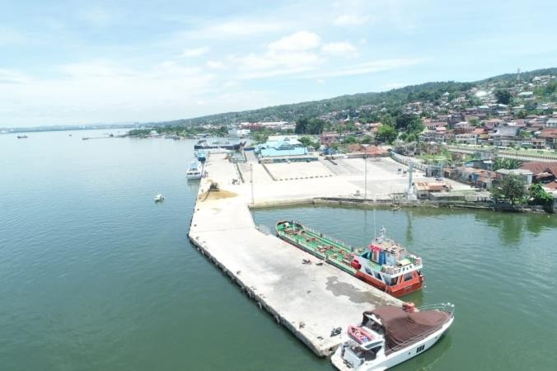
Figure 2.4 Nusantara Port Docks

      - Stacking Warehouse: An enclosed building or place used to store goods coming from a ship or to be loaded onto a ship.
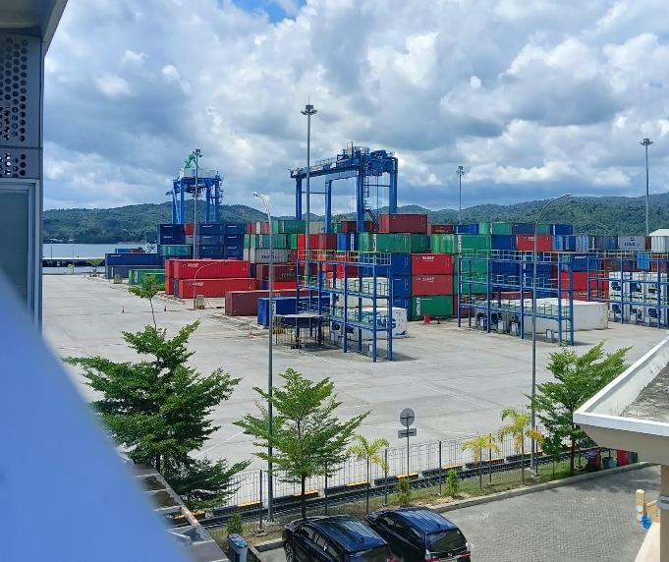
      - Stacking Field: An open area within the terminal area used for placing or stacking containers or other goods, which are arranged in a planned manner whether the goods are to be loaded onto ships or goods after being unloaded from ships.

Figure 2.5 Container Terminal Field

- Receiving/Delivery: Work to move goods from stockpiles/stacking areas in warehouses/stacking yards.

and hand over until it is arranged on the vehicle at the warehouse door/stacking yard or vice versa.

Ship Services
Ship service is a service of ship operational activities from entering to leaving the port. Ship services include:
      - Mooring services: Services provided for vessels docked at the wharf to carry out loading and unloading activities.
      - Guiding services: Services provided for ships to enter and exit the dock through the port channel, so that shipping navigation can be carried out safely, orderly and smoothly for the safety of ships and the environment.
      - Tug service: Services provided by a tugboat to push or pull a vessel to or from the dock.
      - Water, garbage and waste services: Services provided for water services, garbage and sewage management of vessels.

Miscellaneous Services

In addition to actively carrying out port management activities, Pelindo also operates in other relevant fields such as leasing land, buildings, and other supporting facilities needed in port activities. In carrying out port operations and business activities, the Company entered into Business Partner Cooperation (KSMU) with several business partners from the private sector, such as terminal operator cooperation, tugboats, and management of other port facilities.

Miscellaneous services are services that support activities in the port. Services include:

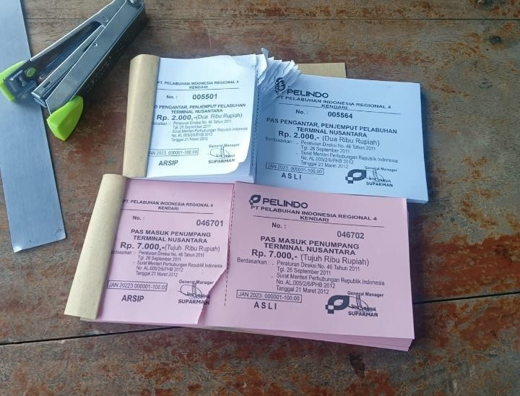
      - Port Pass: Port area entry fee for individuals and motorized vehicles.

Figure 2.6 Fitting Port / Bonggol

- Harbor Equipment Maintenance Services: Services provided, in the form of rental of forklifts, cranes (land, floating and electric), tugs, motor boats, and fire extinguishers.

CHAPTER III
RESULTS AND DISCUSSION

Description of Internship Work

Internship activities are carried out at PT Pelabuhan Indonesia (Persero) Regional 4 Kendari, internship activities carried out by students for 1 semester. The main activities at PT Pelabuhan Indonesia (Persero) Regional 4 Kendari, are Port Business Entities (as terminal operators), Shipping Companies that handle the distribution of goods from the port of origin to the port of destination, Stevedoring Companies (which handle loading and unloading of goods from and to ships), Forwarding (transportation management services), But not all activities are carried out by students while undergoing internship activities. This is because it takes hard skills or skills in doing something, which if you don't have it, it will slow down the work so that the time that is always required to be fast and efficient is not achieved.
Then the next activity carried out by students and other interns is to assist in recapitulating data. The data can be in the form of sales results to outlets that are still in the form of invoice sheets or PO (Purchasing Order) notes and data on requests for fresh goods to partners. In the process, concentration and accuracy are needed because otherwise it will have an impact on calculation errors or data input errors. What is recapitulated is the total revenue from the sale of goods or products to Mr. Suparman (General Manager). The recapitulated invoices contain sender and recipient data, then what items or products are requested along with the quantity requested, then the quantity of goods sent or agreed by the Trading Department and how many items or products are received by the customer or consumer, as well as the price of each item or product. In addition, on the invoice sheet there is also a statement if the goods sent are not in accordance with what is received by the consumer, namely damaged, dead, or compliment (given free of charge). In the process of recording, accuracy is needed, even though it is only a simple calculation of the total revenue from the goods or products sold.

In the implementation of the internship, our group was divided into several divisions, including the SPJM Division, and the Regional 4 Division. Here is the list of duties:
At Division Regional Students conducted several activitiesincluding :
    - Separation of Ship Services Pranota (Nota 3) based on color, for example red color for Guiding Services and yellow color for Mooring Services.
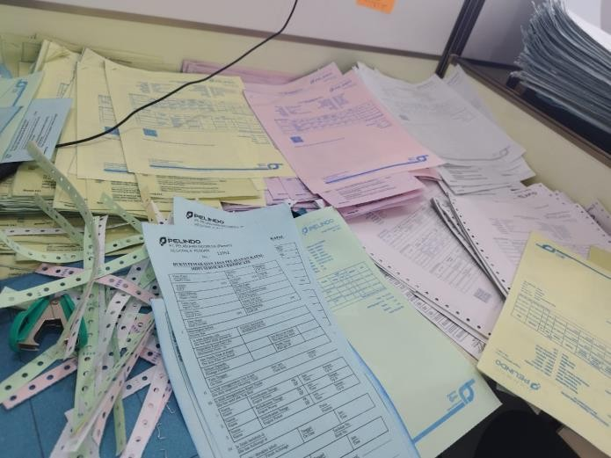
Figure 3.1 Segregation of Form 3 Notes by color
    - Matching and research (coklit) at PT Pertamina Trans Kontinental The steps for conducting Coklit at PT Pertamina Trans Kontinental are as follows:
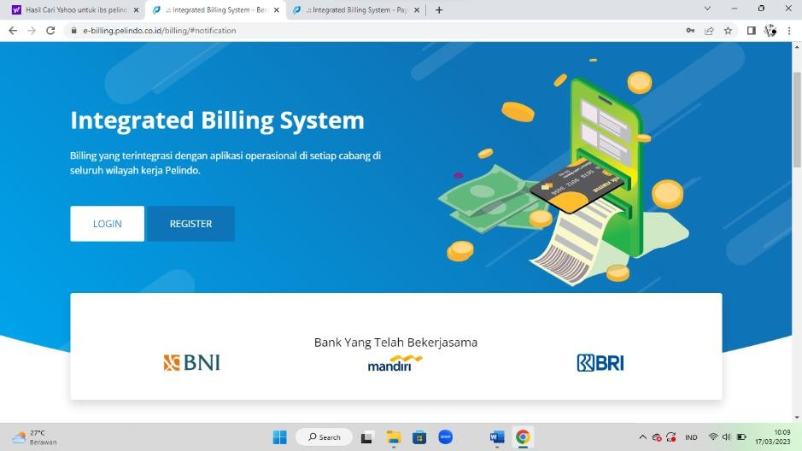
      - Pelindo 4 IBS Application Login
Figure 3.2 Pelindo IBS Application Login 4

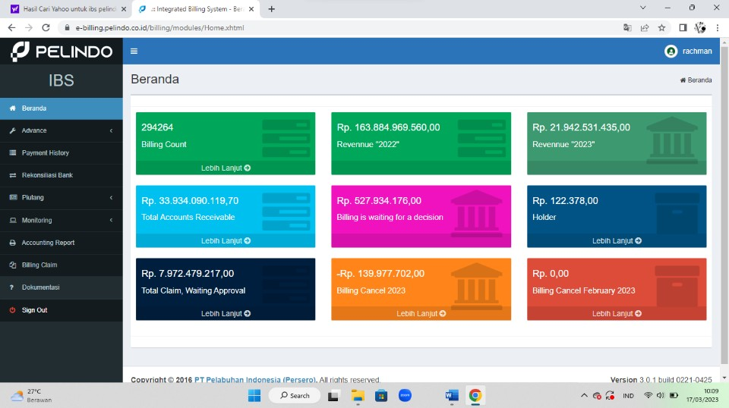
Figure 3.3 Homepage of Pelindo IBS Application 4
      - 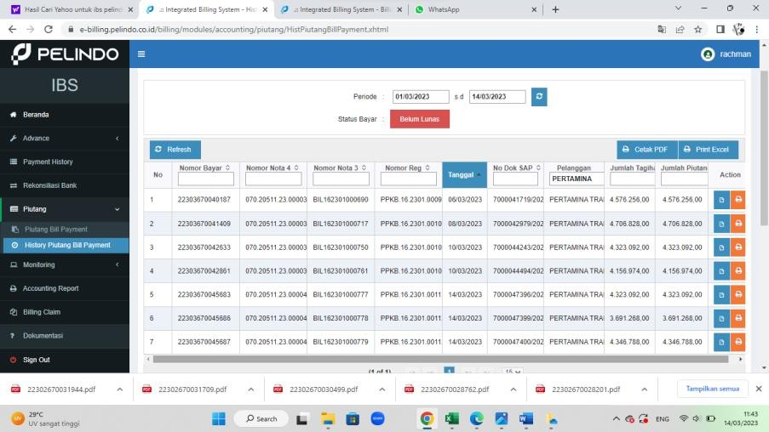Select the Accounts Receivable Menu then Click on Bill Payment Accounts Receivable History
Figure 3.4 Receivables Menu in the Pelindo IBS Application 4
      - Change Payment Period example: March 1, 2023 to Delivery Date
Figure 3.5 Payment Period in Pelindo 4 IBS Application

      - Click the blue sign that says Payable until it appears as shown below then copy note 3
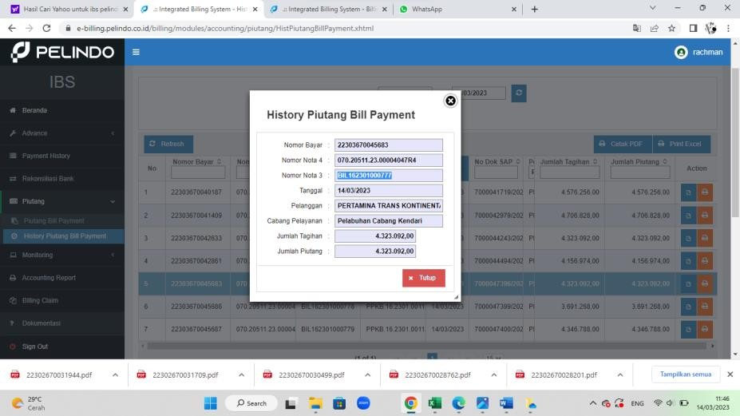
Figure 3.6 History of Bill Payment Receivables in Pelindo 4 IBS Application

      - Next click Monitoring then Select Billing Monitoring after that Change the Period Date March 1 to Date of Work Time
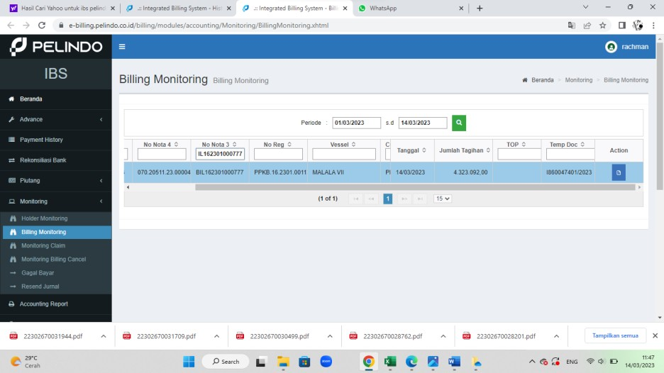
Figure 3.7 Monitoring Menu on IBS Pelindo 4 Application

      - Enter the Nota 3 number that has been copied from the accounts receivable menu into the Nota 3 column in the Monitoring Menu.
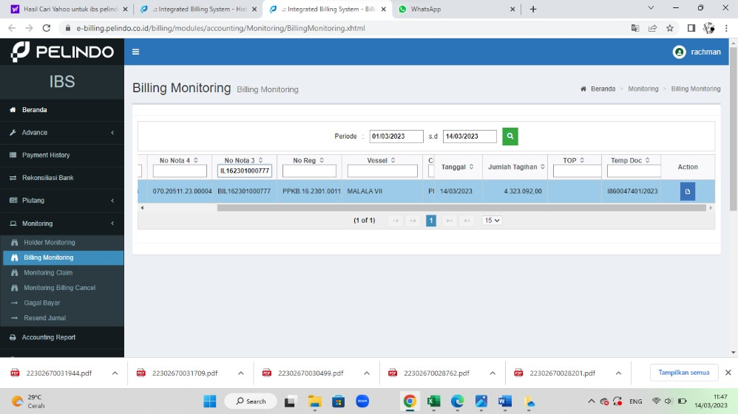
Figure 3.8 Entering Note Number 3 in the Monitoring Menu

      - Click on the blue sign that reads payable until it appears as shown below select Billing Attachment then Click Download which corresponds to Note number 3
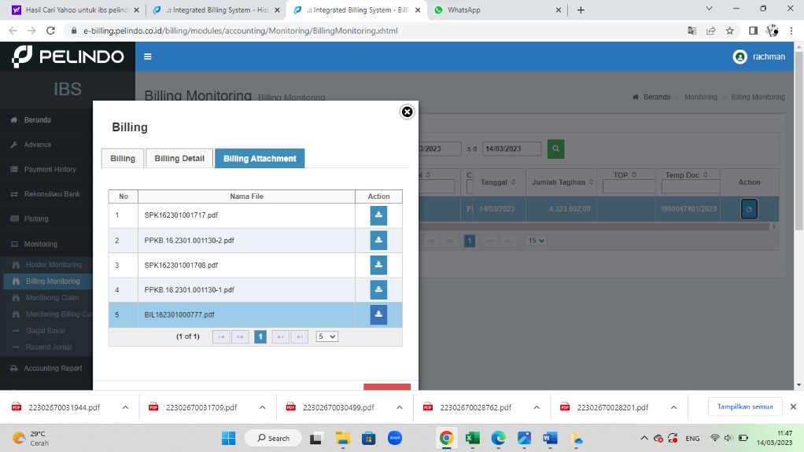
Figure 3.9 Billing Attachment Feature on Billing Monitoring Menu

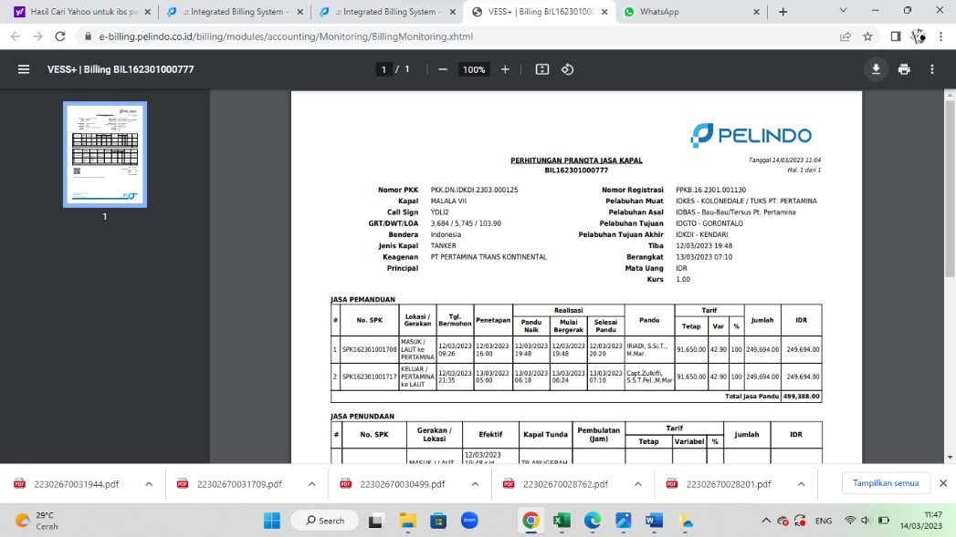
      - Next appears Proof of Note 3 as shown below
Figure 3.10 Proof of Note 3 PT Pertamina Trans Continental

      - 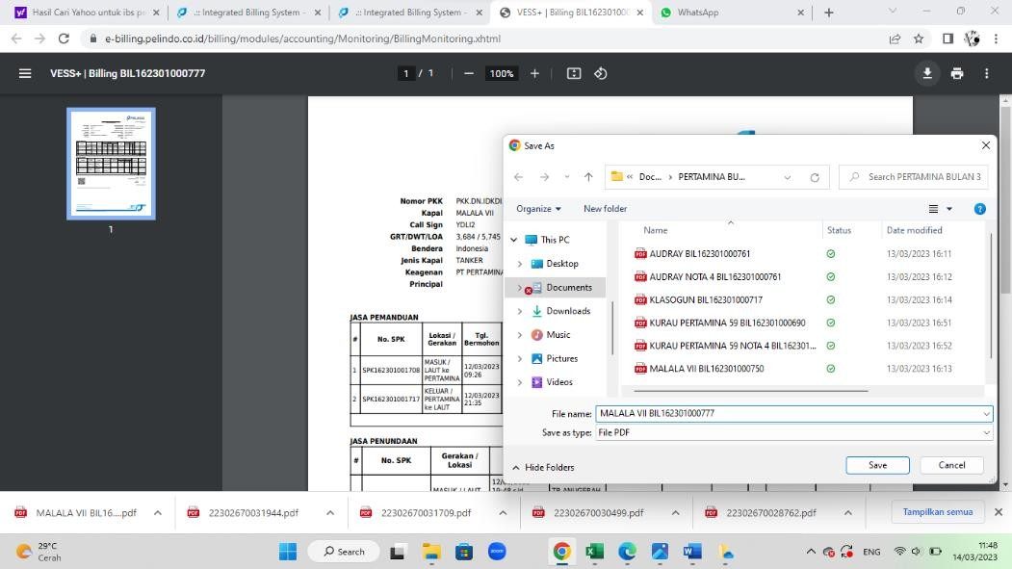Then press the download button to save the Proof of Note 3.
Figure 3.11 Download Proof of Note 3 PT Pertamina Trans Kontinental

      - Next, return to the Bill Payment History Menu then click the orange Print Button
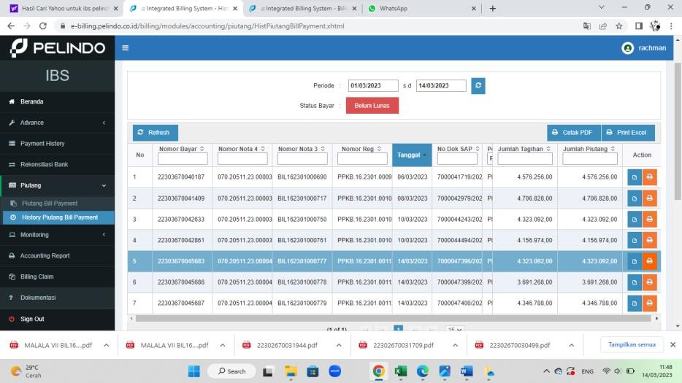
Figure 3.12 Print Proof of Note 4 PT Pertamina Trans Continental

      - After pressing the print button, a page will appear in the form of Proof of Payment Note (Note 4)
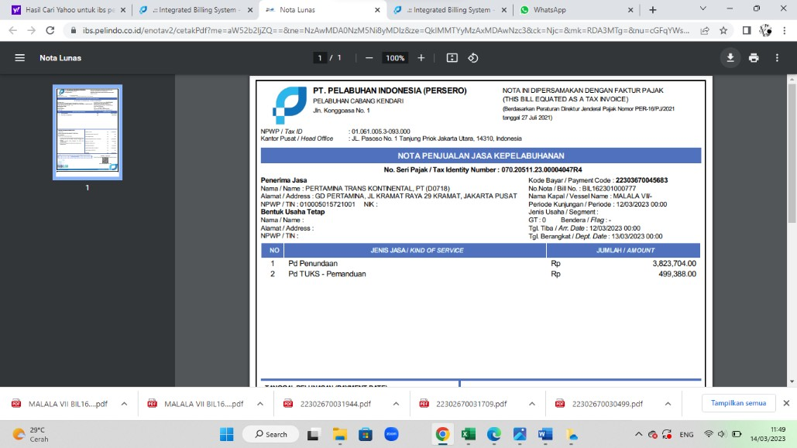
Figure 3.13 Proof of Note 4 PT Pertamina Trans Continental

      - 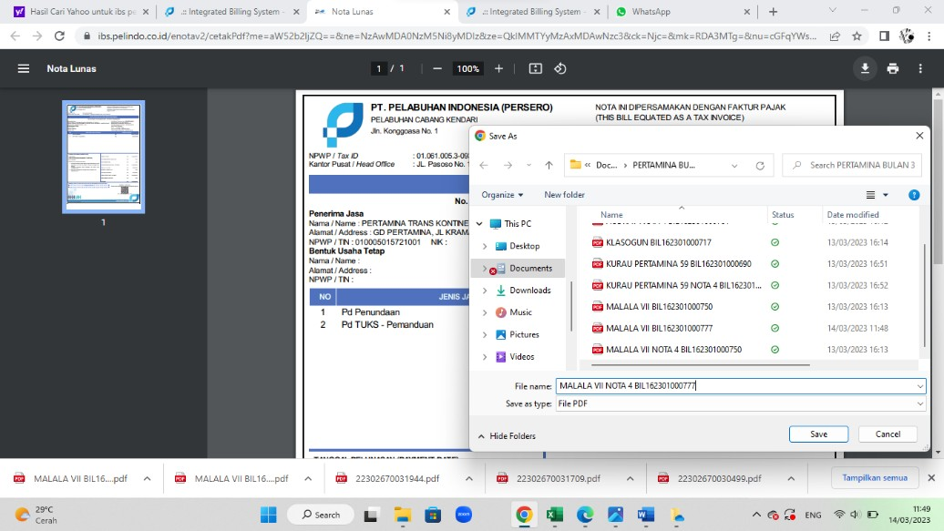Then press the download button to save the Proof of Note 4.
Figure 3.14 Download Proof of Note 4 PT Pertamina Trans Kontinental

      - Return to the Bill Payment Receivables History Menu then Copy all the Notes that have been entered starting from the payment number to the amount of Receivables
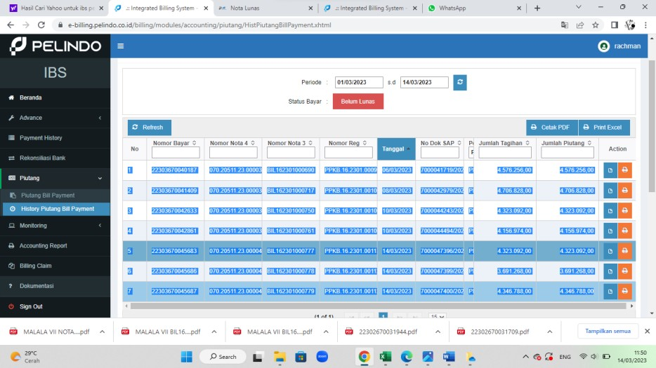
Figure 3.15 Copy of All Memorandum 4 PT Pertamina Trans Kontinental

      - Open the Excel application and then definitely the Notes that have been copied before to make a Recap of the Notes Details of PT Pertamina Trans Kontinental in March.
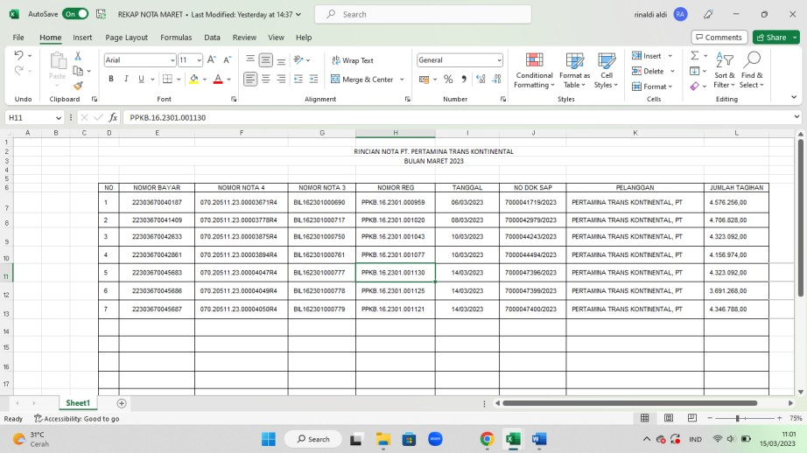
Table 3.1 Recap of PT Pertamina Trans Kontinental Memorandum Details in MS. Excel

      - Finally make Coklit as shown starting from the Vessel Name, ETA, ETD, Status, Pandu Date, Tunda, Speedboat, DPP Amount, VAT, Stamp, and the corresponding amount seen from Note 3 and Pay Number, Note No. seen from Recap Note Details
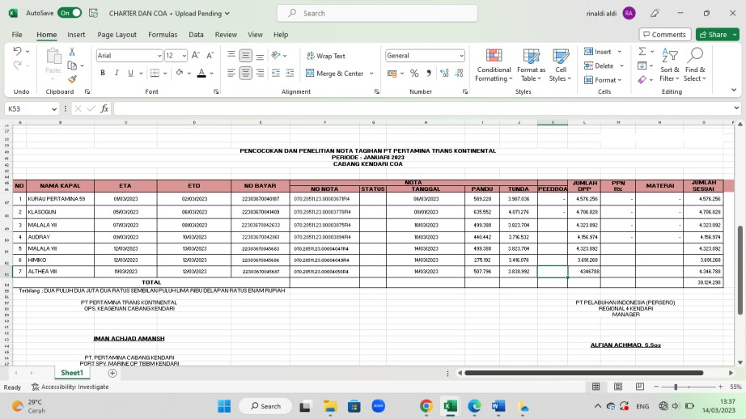
Table 3.2 Coklit Table of Bill Notes

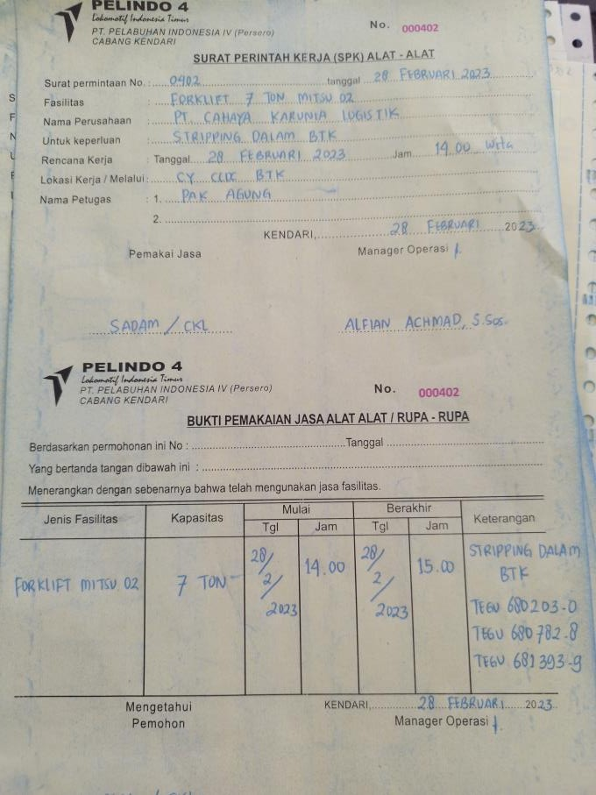
    - Analyzing Proof of Service for Tools
Figure 3.16 Proof of Use of Equipment Services

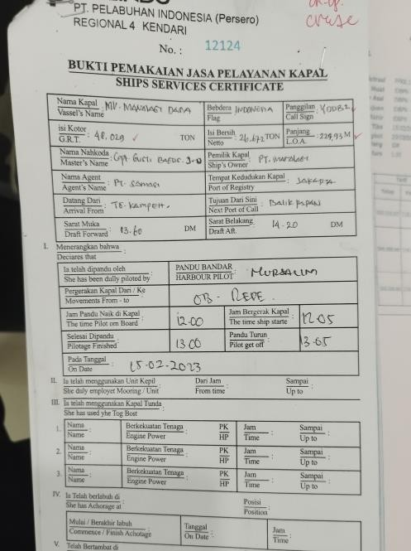
    - Analyzing Proof of Use of Ship Services
Figure 3.17 Proof of Use of Ship Services

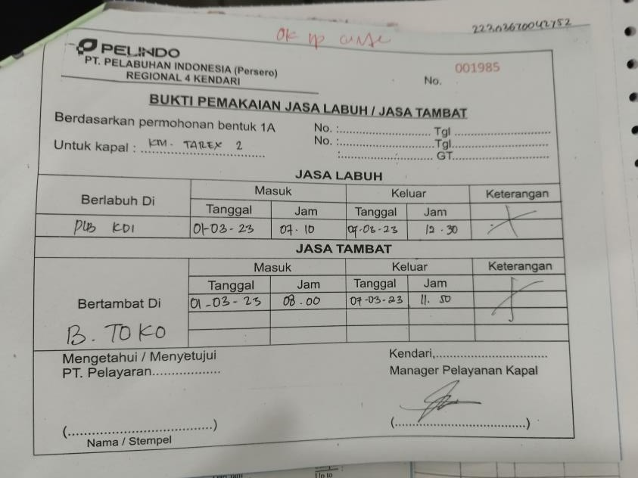
    - Analyzing Proof of Use of Mooring Services and Mooring Services
Figure 3.18 Proof of Usage of Mooring Services / Tethering Services

    - Analyzing PT Rukma Padaya Trans's Payment Note on Pelindo 4 IBS Application (Reimbursement Recap)
Steps to check PT Rukma Padaya Trans's Paid-off Note:
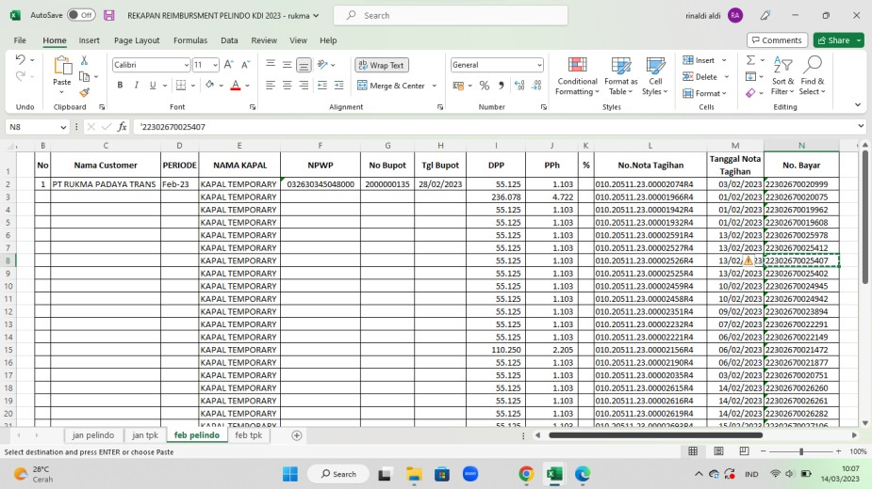
      - First Open Reimbursement Record then Copy the Pay Number
Table 3.3 Recap of Reiumbersment in MS. Excel

      - Next, login to the Pelindo 4 IBS application, then click the Payment History menu, change the Payment Period, then enter the Pay Number that has been copied into the Pay Code column.
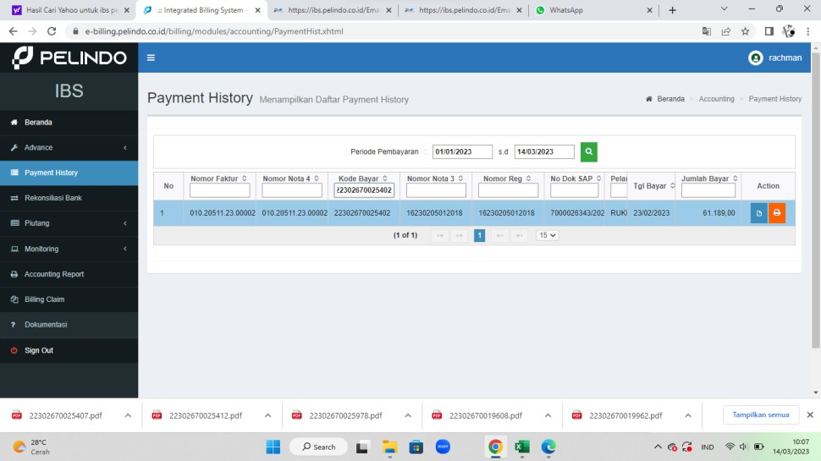
Figure 3.19 Payment History Menu on IBS Pelindo 4 Application

      - Next, Download the Paid-off Note by pressing the orange print button
Figure 3.20 Downloading PT Rukma Padaya Trans's Payoff Note

      - After pressing the Print button, a page will appear in the form of Proof of Paid Note (Note 4)
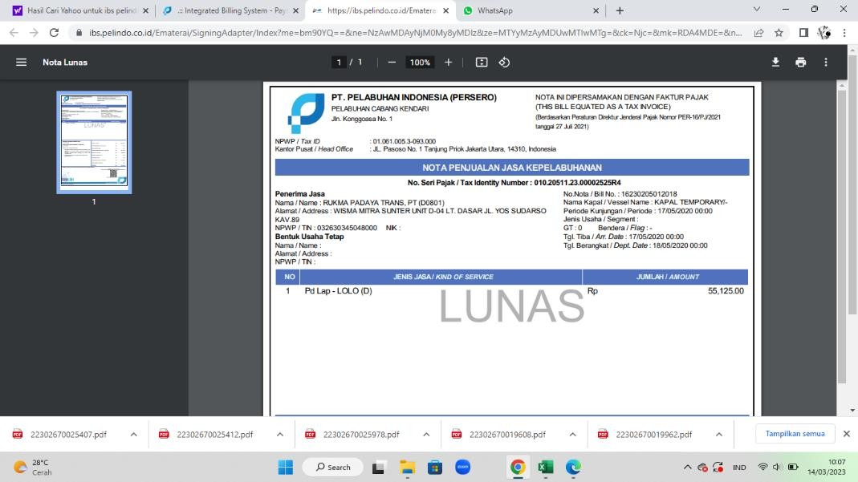
Figure 3.21 Proof of Payment Note (Nota 4) PT Rukma Padaya Trans

      - 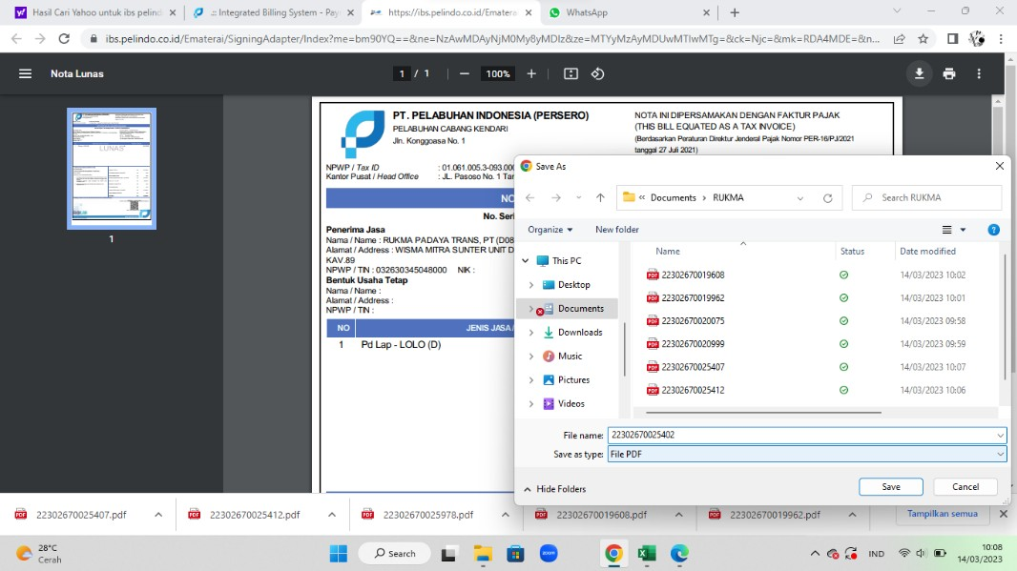Press Download Button to save the Proof of Paid Receipt
Figure 3.22 Download Proof of Payment Note (Nota 4) PT Rukma Padaya Trans

      - Finally, do it repeatedly for all Pay Numbers in the Reimbursement Record at PT Rukma Padaya Trans.

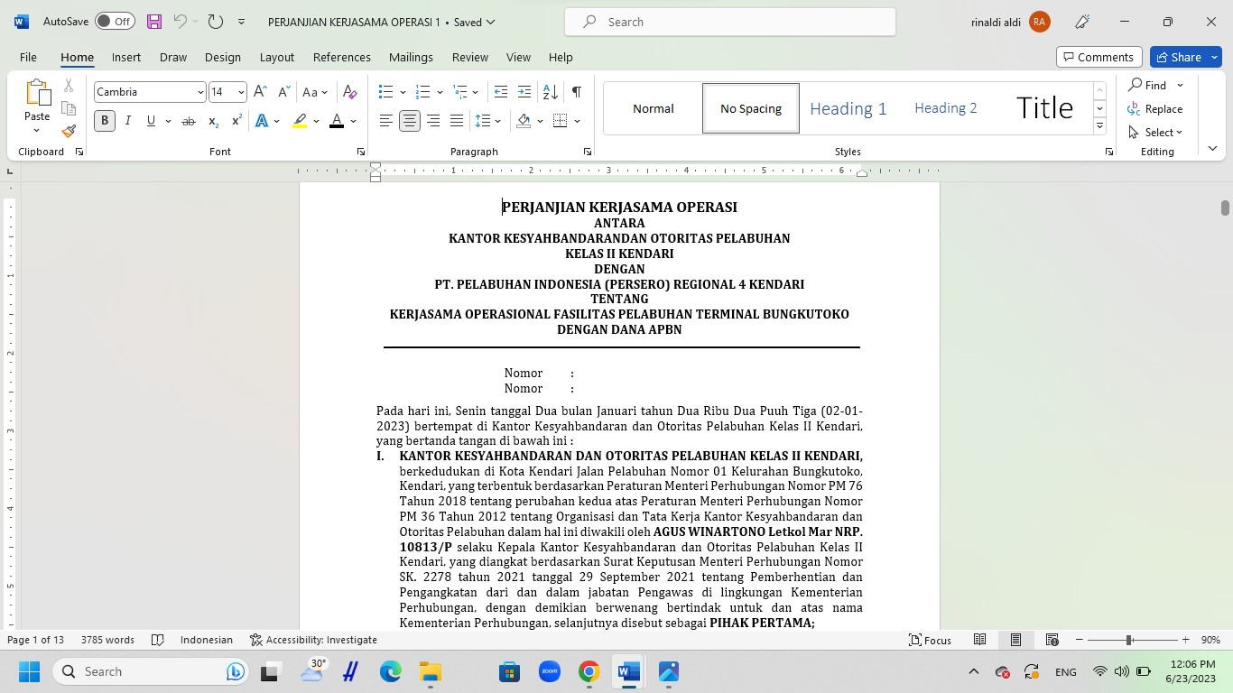
    - Make a copy of the digital version of the Letter of Cooperation Agreement
Figure 3.23 Digital Copy of Letter of Cooperation Agreement

    - Analyzing PT HUA Indonesia Agency's Payoff Note on Pelindo 4 IBS Application
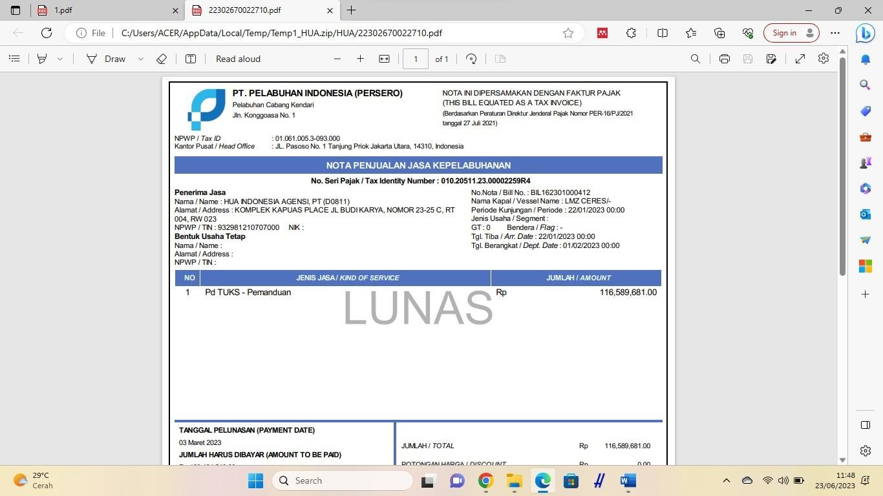
The steps are similar to PT Rukma Padaya Trans.
Figure 3.24 Proof of Payment Note PT HUA Indonesia Agency

    - Analyzing PT PELNI Baubau Branch Payment Notes from Pelindo 4 IBS Application
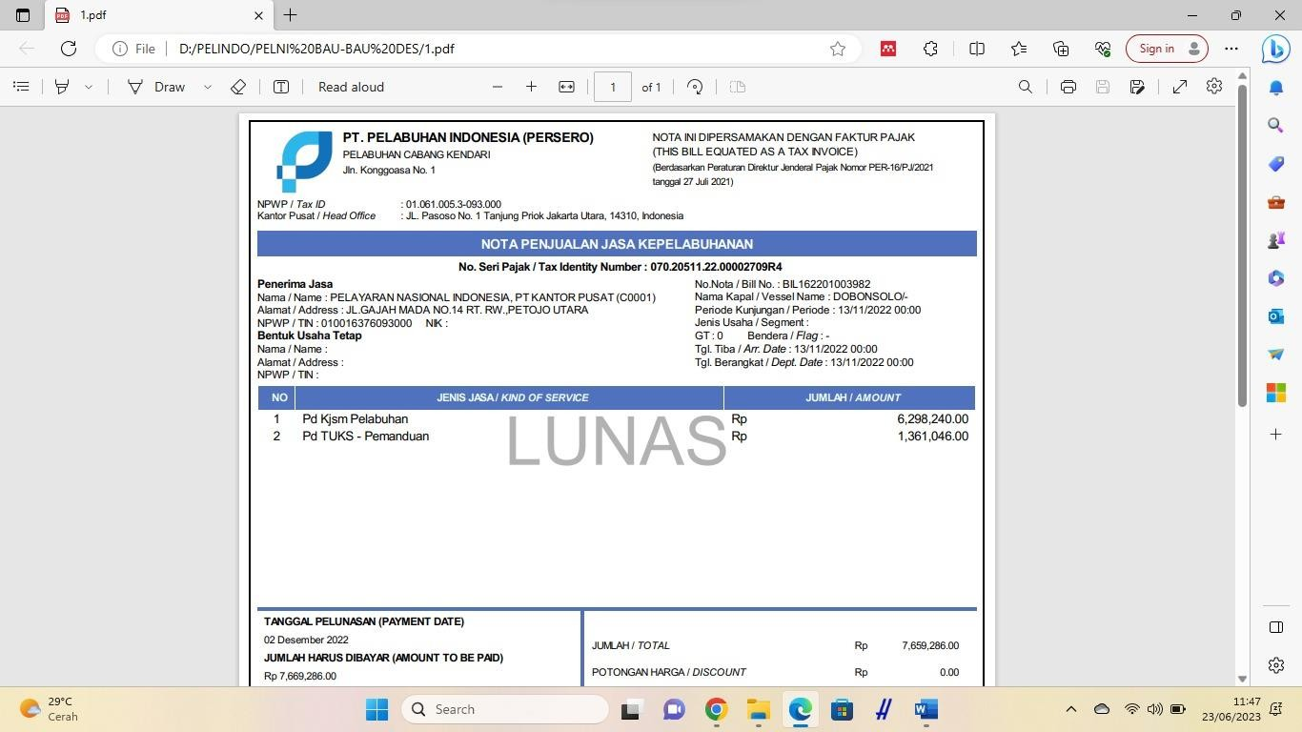
The steps are similar to PT Rukma Padaya Trans.
Figure 3.25 Proof of PT PELNI Payment Note

    - Analyzing PT Mitra Intertrans Forwarding's Payment Note from Pelindo 4's IBS Application
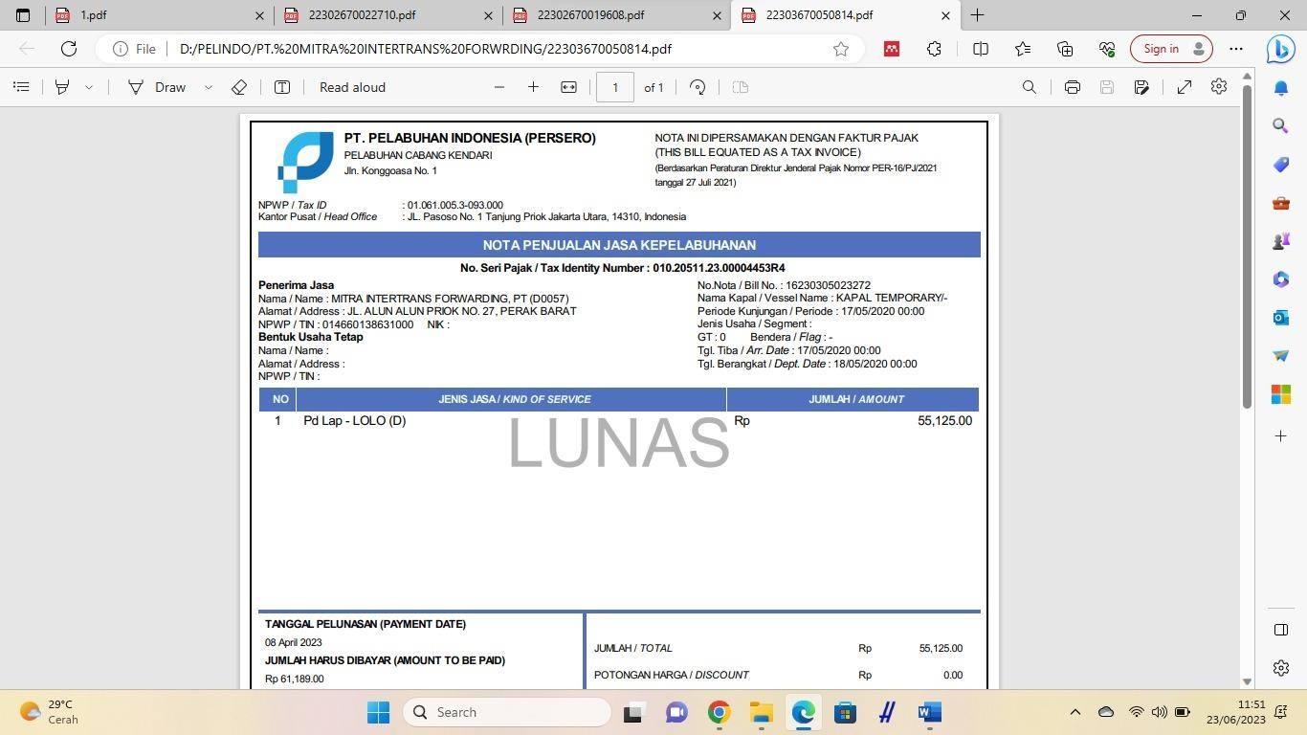
The steps are similar to PT Rukma Padaya Trans.
Figure 3.26 Proof of PT Mitra Intertrans Forwarding Payment Note

    - Recap the list of active archives of the work unit: HR and General Services Group Year 2022 to Present
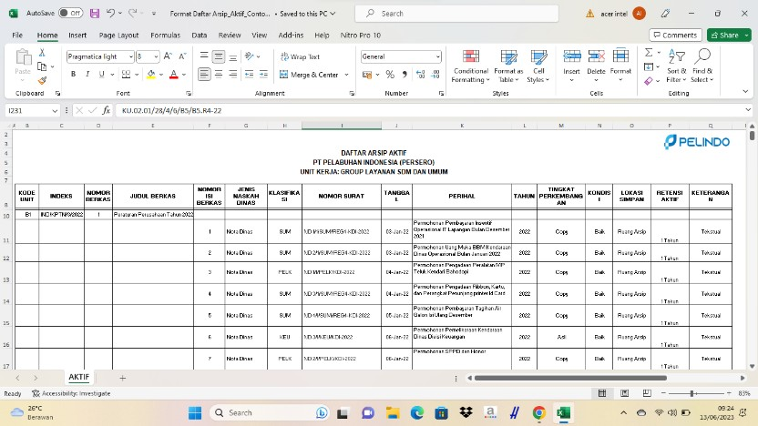

Description:
Table 3.4 Examples of Recapitulated Records (Memorandum/Service Manuscript Records)

Content numberfile filled in Document / Archive sequence number
Type of ManuscriptService filled in Form of Service Manuscript (ND, BA, Letter
In/Out, Announcements etc.)
Classification filled in Classification code
NumberLetter filled in Service Manuscript Number
Date filled in Date of Service Manuscript
Subject filled in Regarding Office Manuscripts
Year filled in the Year of the Office Manuscript
LevelDevelopment filled in Original/Copy/Electronic/Citation/CopyCondition filled inGood/Damaged
LocationSave filled Archive Storage Place
RetentionActive filled in Retention Period of Records in the Unit
processing according to JRA
Description fill in the Specific Description of the archive type, such as textual, cartographic, audio etc.

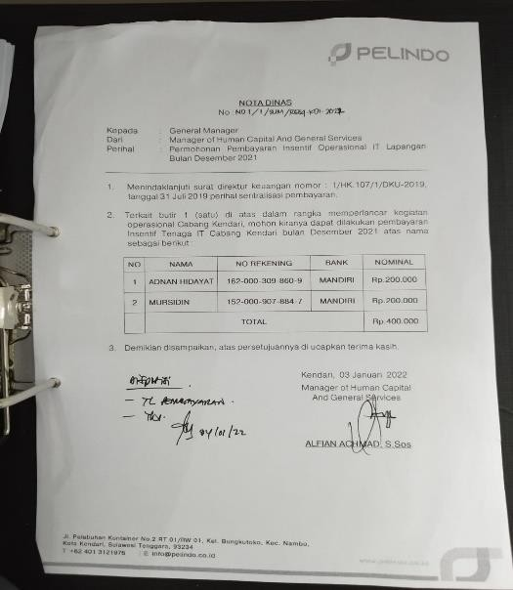
Figure 3.27 Old Office Memorandum / Manuscript Still in the Form of Copy

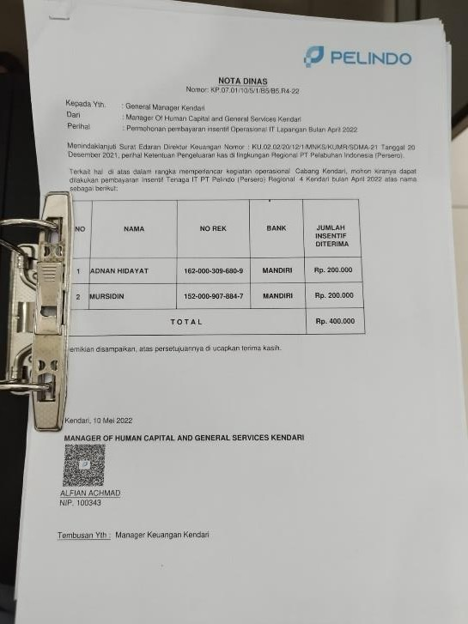
Figure 3.28 New Office Memorandum / Manuscript Original Copy Already Using Barcode

    - Analyzing the Payment Process: Concession / Revenue of Nusantara Terminal Port and Boat Base, Non-Tax State Revenue (PNBP), namely Ship Guiding and Delaying in SAP Application
Steps in Making the Payment Process on the Pelindo 4 IBS Application:
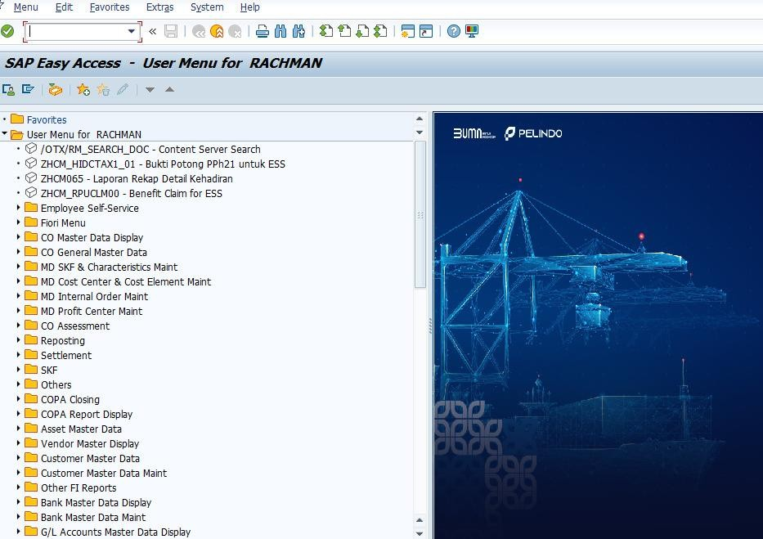
      - SAP Application Login
Figure 3.29 Home in SAP Application
      - Enter the Company Code found on the Paid-off Note into the SAP Application, then Enter
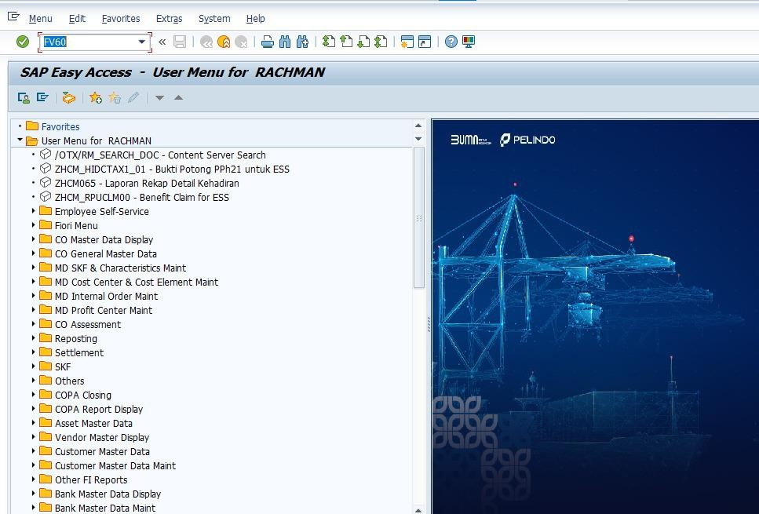
Figure 3.30 Entering the Company Code

      - After that it will appear as shown below, in the Basic Data menu fill in all the requested data according to the Paid-off Note, namely: Vendor, Invoice Date, Posting Date, Amount, Reference.
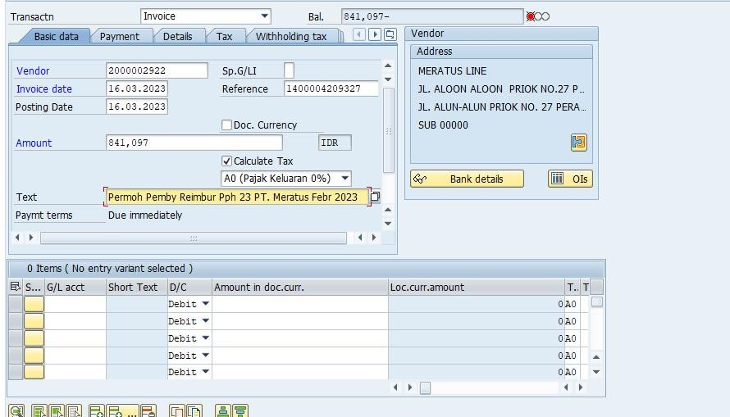
Figure 3.31 Basic Data Menu in SAP Application

      - Next, enter the Payment Menu, then fill in all the requested data according to the Paid-off Note, namely: BaselineDT, Due on, Part.bank.
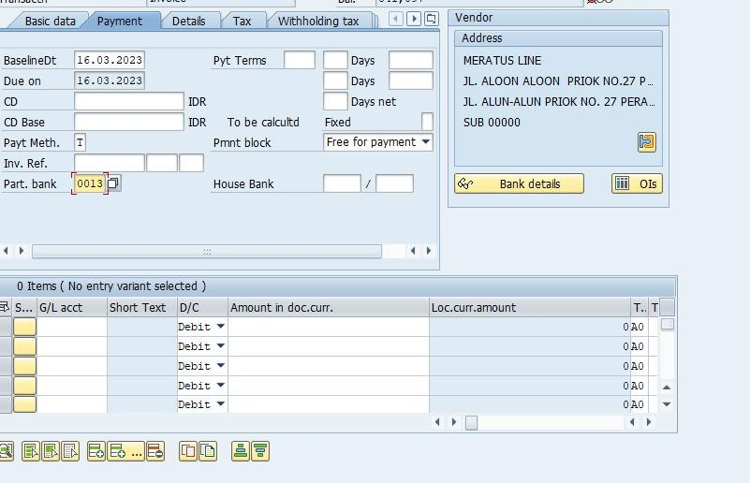
Figure 3.32 Payment Menu in SAP Application

      - Next, enter the Details Menu, then fill in all the requested data according to the Paid-off Note, namely: G/L, Assign, Header Text
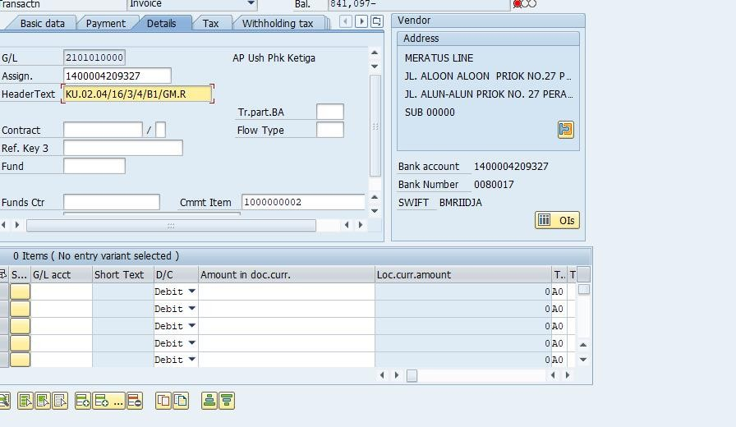
Figure 3.33 Details Menu on SAP Application

      - After all the data has been entered, then the column below will be filled in by itself, then click the yellow table
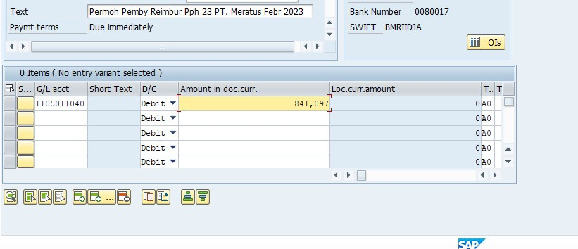
Figure 3.34 Debit Feature on SAP Application

      - Finally, an image will appear as below which means that the Concession Payment Process has been completed and is ready to be Approved.
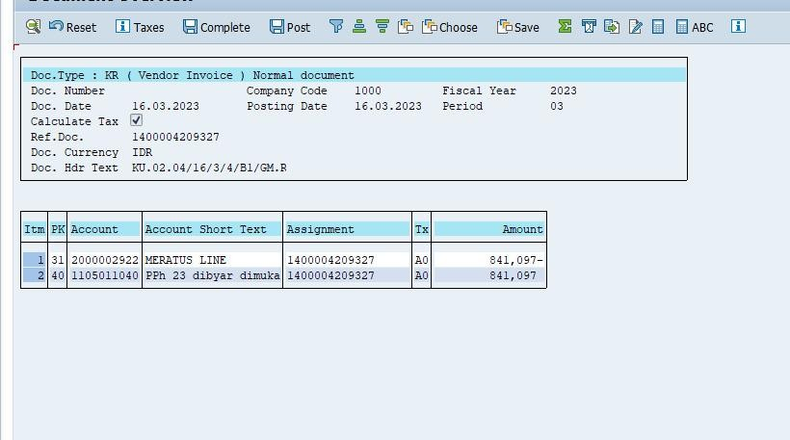
Figure 3.35 Evidence that the Concession Distribution Process Has Been Completed

    - Analyzing Office Memorandum in Pelindo E-Office Application
Steps in Creating a Service Note in the Pelindo E-Office Application:
      - 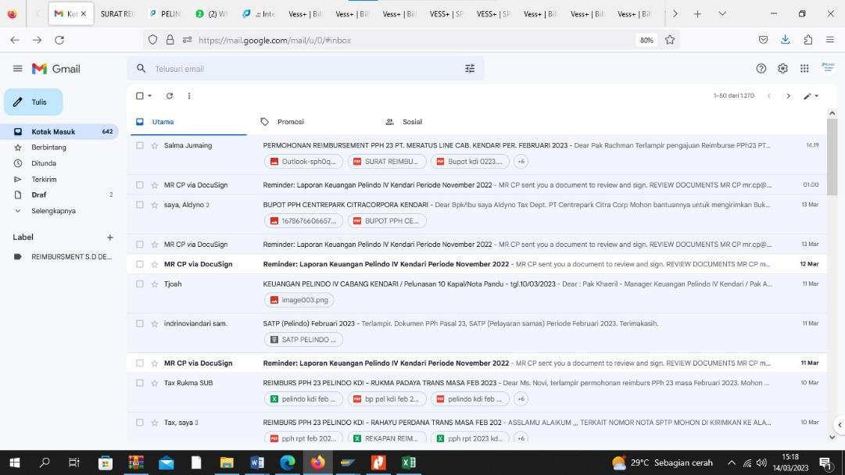First Income Tax Reimbursement Letter is sent via Company Gmail
Figure 3.36 Company Gmail

      - 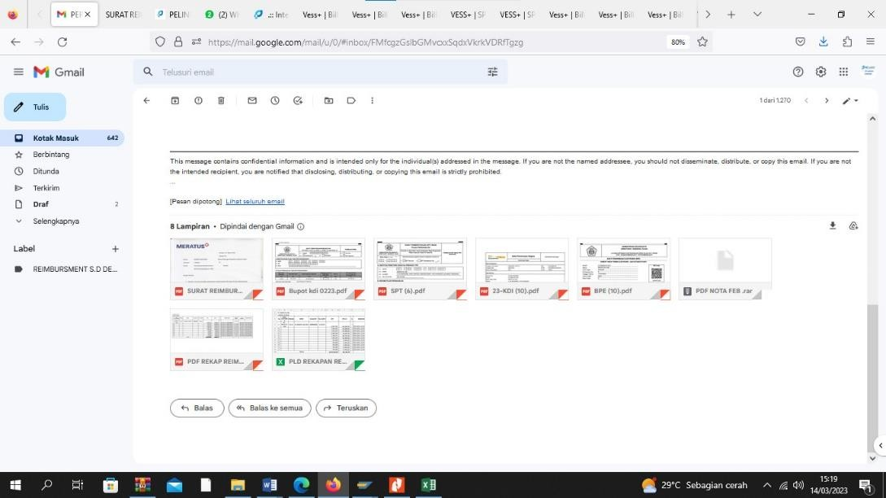Open Messages, After that download all the documents that have been sent
Figure 3.37 Income Tax Reimbursement Letter sent via Gmail

      - 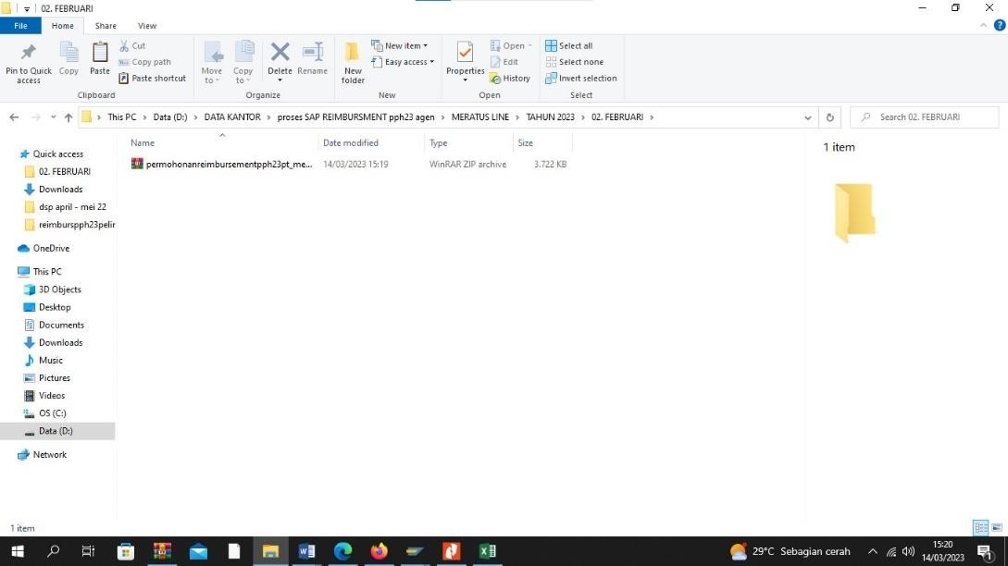Open the downloaded document, then Extract
Figure 3.38 Reimbursement Letter Document in RAR form

      - 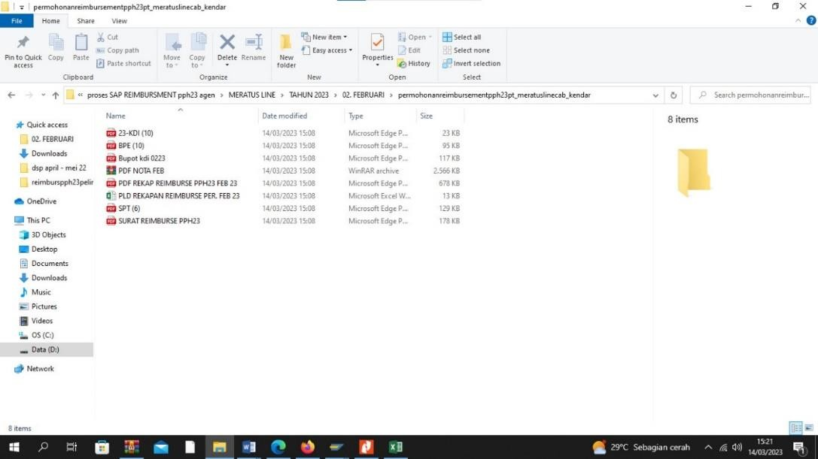Once extracted, all documents will appear along with the recap letter.
Figure 3.39 Document Folder if already extracted

      - Open Pelindo E-Office Application to create a Service Note from the Reimbursement.
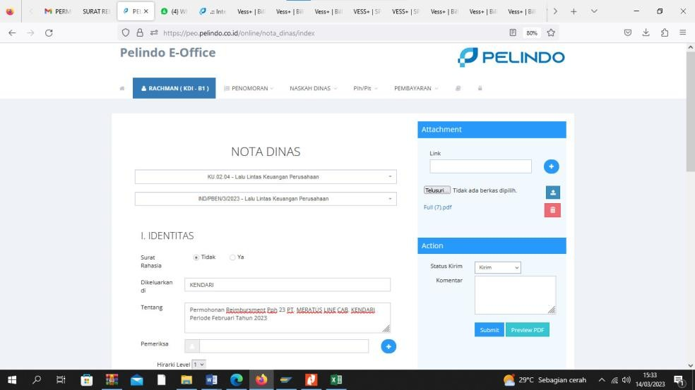
Figure 3.40 Homepage of Pelindo E-Office Application

      - After that, fill in all the data according to the file that has been downloaded in Gmail before
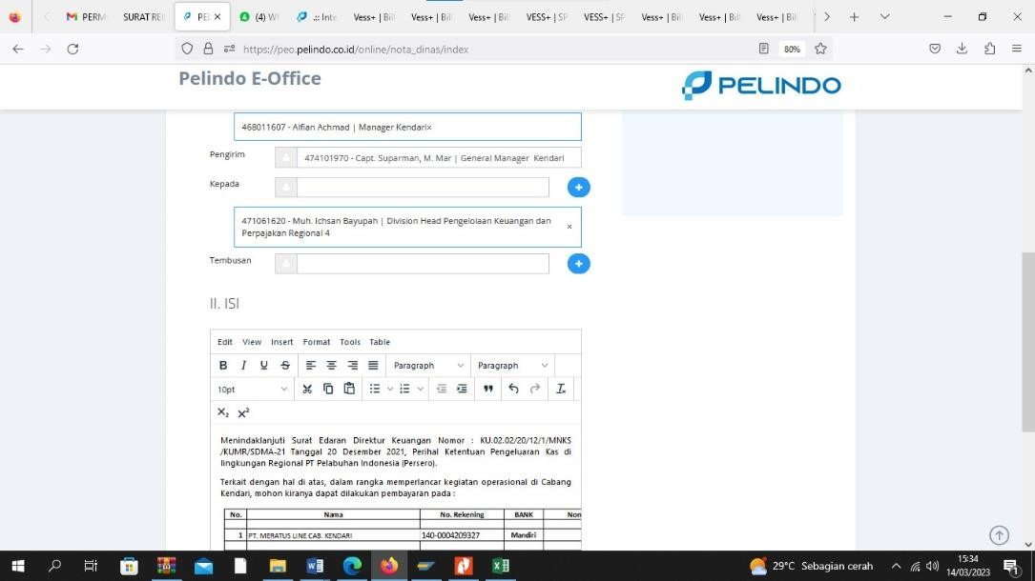
Figure 3.41 Creating a Service Note in Pelindo E-Office Application

      - 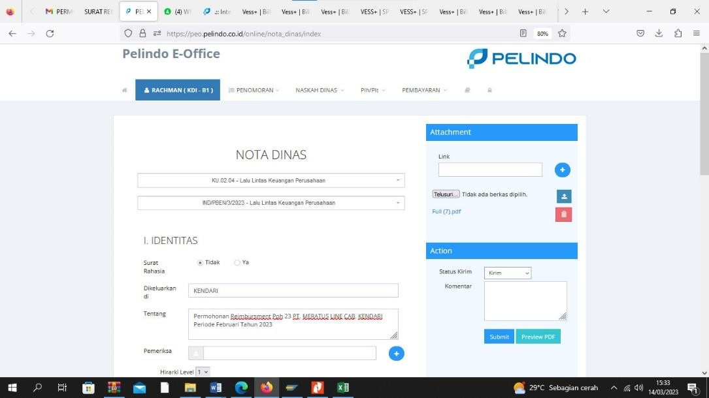Finally, when all the data has been filled in correctly, then Submit.
Figure 3.42 Submitting Service Memorandum in Pelindo E-Office Application

    - 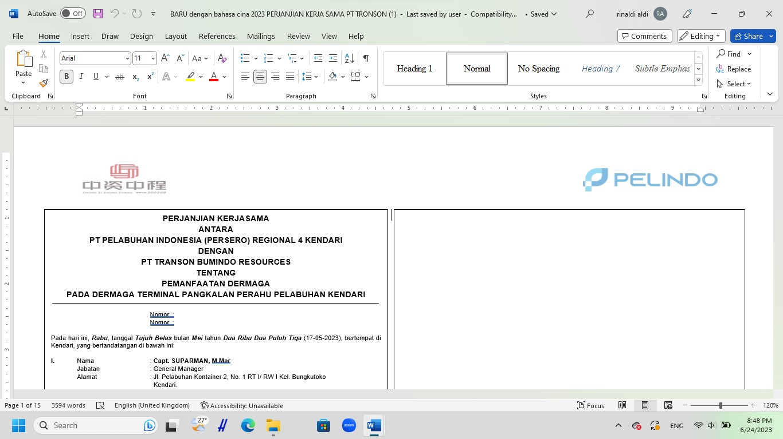Making a Cooperation Agreement Letter to a Chinese Company
Figure 3.43 Cooperation Agreement Letter to Chinese Company

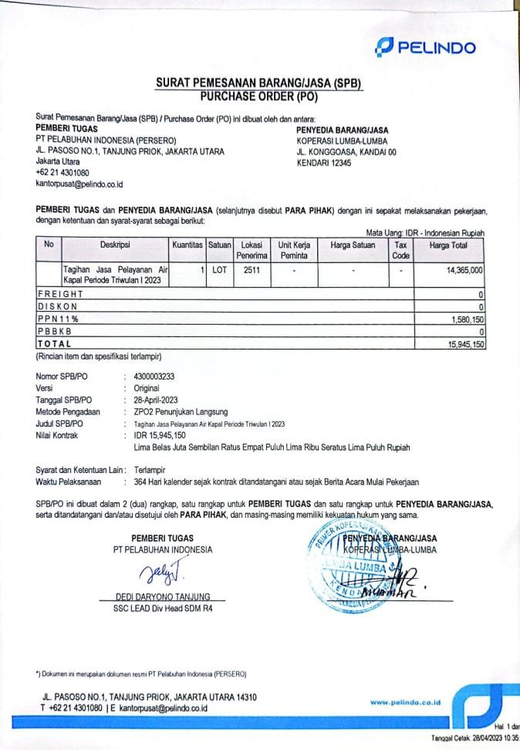
    - Goods and Services Order Letter
Figure 3.44 Order Letter for Goods and Services

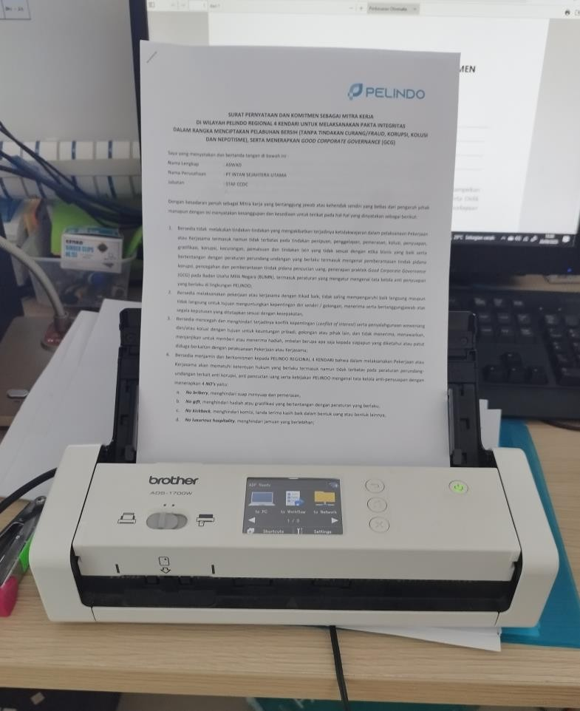
    - Scan Archive Documents

    - Make Income Tax Return 21/26
Figure 3.45 Scan of Archive Documents

Steps to make Income Tax Return 21/26:
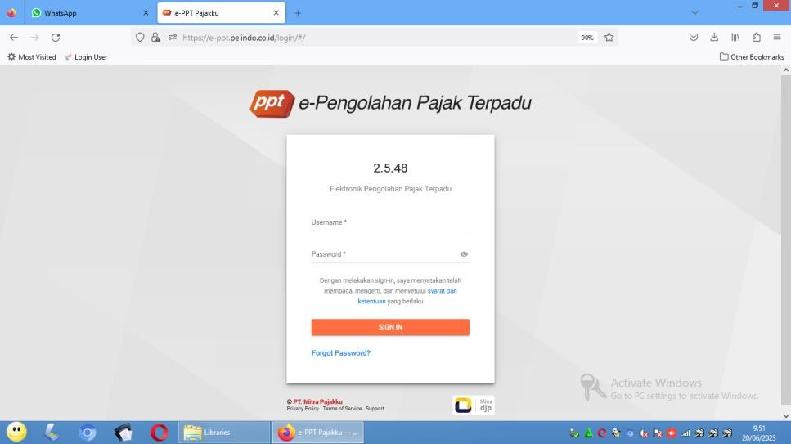
      - e-PPT Application Login
Figure 3.46 e-PPT Application

      - Select the Income Tax 21 menu
      - Select SPT List
      - Click the "+" icon or the Create icon
      - Select the Organization or NPWP for which the tax return will be made
      - Select Period
      - Select Year
      - Click Create
      - The SPT created will appear on the SPT List menu.
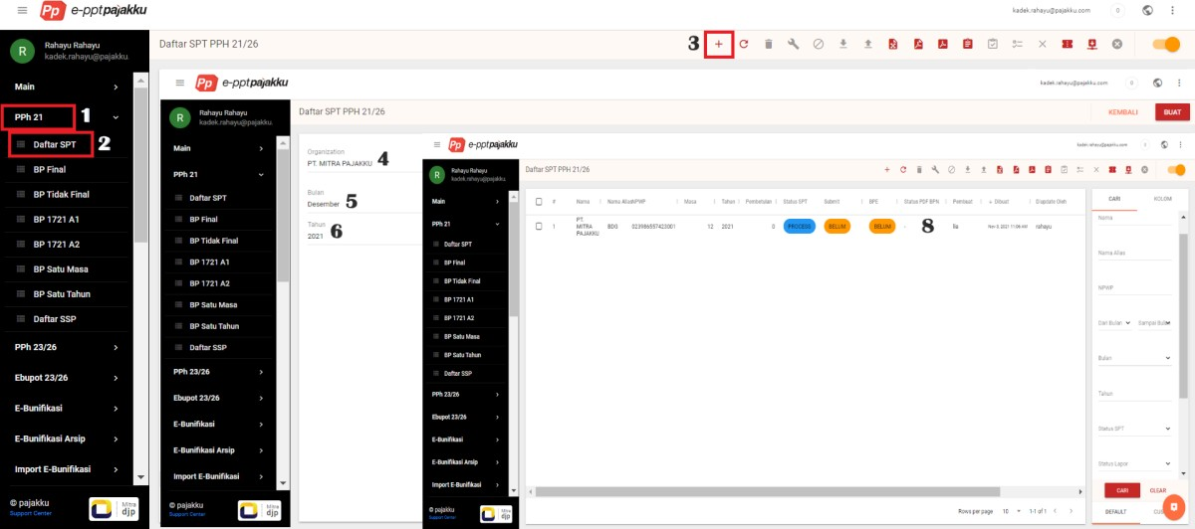
Figure 3.47 Steps for Making Income Tax Return 21/26

    - Inputting Bukti Potong PPh 21/26
Steps for Inputting Income Tax Withholding Slip 21/26:
      - Click on the Income Tax 21 menu
      - Select SPT List
      - Scroll right, click the three dots button on the Actions column
      - Click Open tax return
      - Click Settings to set the withholding slip number
      - Select the Cut-off Number menu
      - Customize the withholding slip number
      - Save

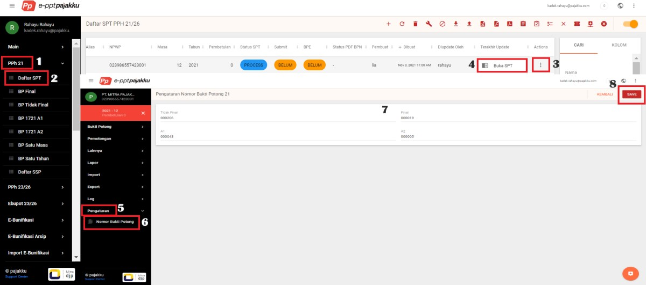
Figure 3.48 Steps for Inputting Income Tax Withholding Slip 21/26

    - Input Income Tax 21/26 for Permanent Employees Over PTKP
Steps to Input Income Tax 21/26 for Permanent Employees Over PTKP:
      - Click Income Tax 21
      - Select SPT List
      - Scroll right, click the three-dot button on the Actions column
      - Open tax return
      - Click the Cutting menu
      - Choose One Period
      - Click the Add button (+)
      - Complete the data in column A and column B
      - Select the Create button
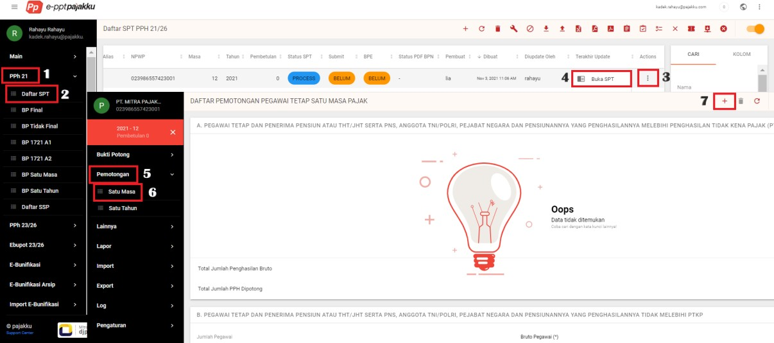
Figure 3.49 Steps to Input Income Tax 21/26 for Permanent Employees Over PTKP

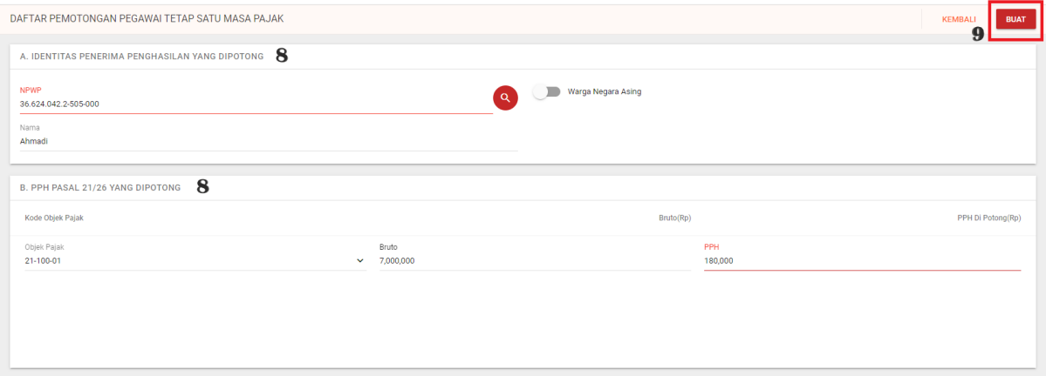

Figure 3.50 Making Income Tax Inputs 21/26 for Permanent Employees Over PTKP

    - Inputting Income Tax 21/26 for One Tax Period Not More than PTKP
Steps to Input Income Tax 21/26 for Tax Period Not exceeding PTKP
      - Click Income Tax 21
      - Select SPT List
      - Scroll right, click the three-dot button on the Actions column
      - Click Open tax return
      - Click the Cutting menu
      - Choose One Period
      - Complete Number of Employees and Gross Amount
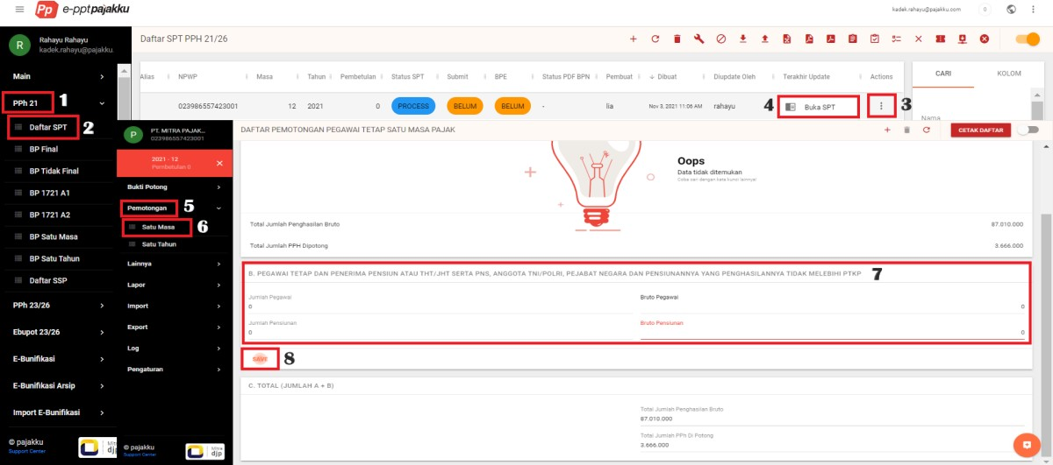
      - Click Save
Figure 3.51 Steps for Inputting Income Tax 21/26 for Tax Period Not exceeding PTKP

    - Importing Withholding Slip Data for One Period of Income Tax 21/26 Steps to Import Withholding Slip Data for One Period of Income Tax 21/26:
      - Click Income Tax 21
      - Select SPT List
      - Scroll right, Click the actions button, then Open tax return
      - Click the import menu
      - Select the type of piece proof to be imported
      - Click the Template button to download the import template
      - Click choose file
      - Select the file to import
      - Click the Import button
      - Refresh, and make sure the status is Finish
      - If Failed, click the Actions button and select More Info to view the error description.
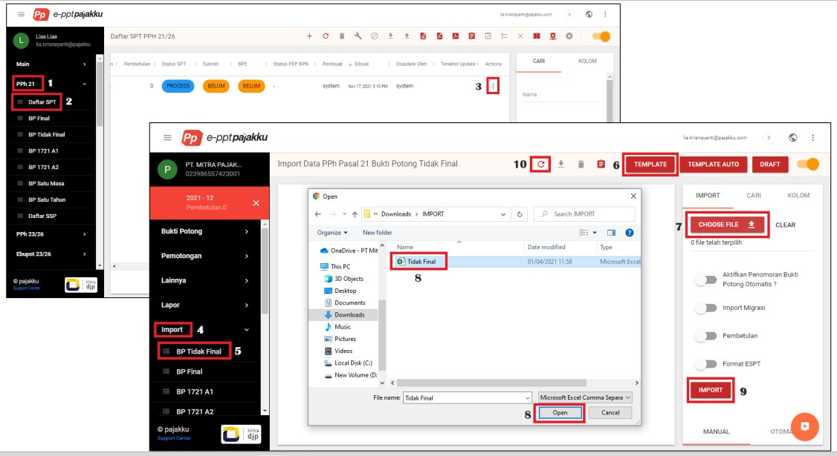
Figure 3.52 Steps for Importing Income Tax Withholding Slip 21/26

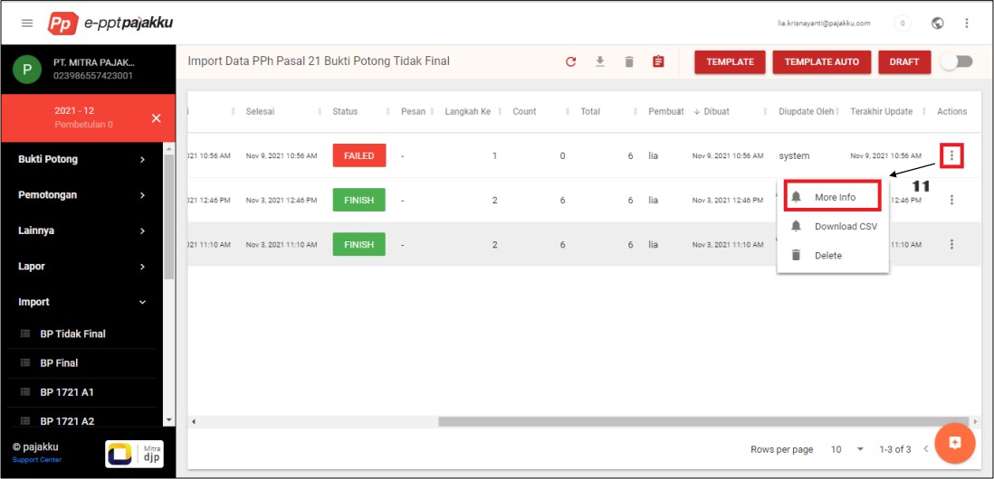

Figure 3.53 Viewing the Error Description on the Proof of Cut

    - Create Income Tax Billing ID 21/26
Steps to Create Income Tax Billing ID 21/26:
      - Close the tax return
      - Click on the e-Billing menu
      - Select Settings
      - Input the Client ID and Client Secret of the e-Billing account, then Save so that the status becomes connected.
      - Then, click on the eSSP Data menu on the e-Billing menu.
      - Then click the Calculate button
      - Select the TIN of the organization for which you want to create a Billing ID
      - Select Tax Period and Year
      - Tick mark Income Tax Article 21
      - Click Calculate
      - Select the SSP that has been successfully calculated, then click the Generate button.

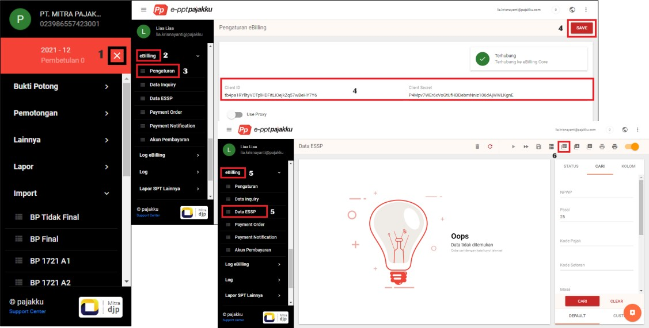

Figure 3.54 Steps to Create a Billing ID

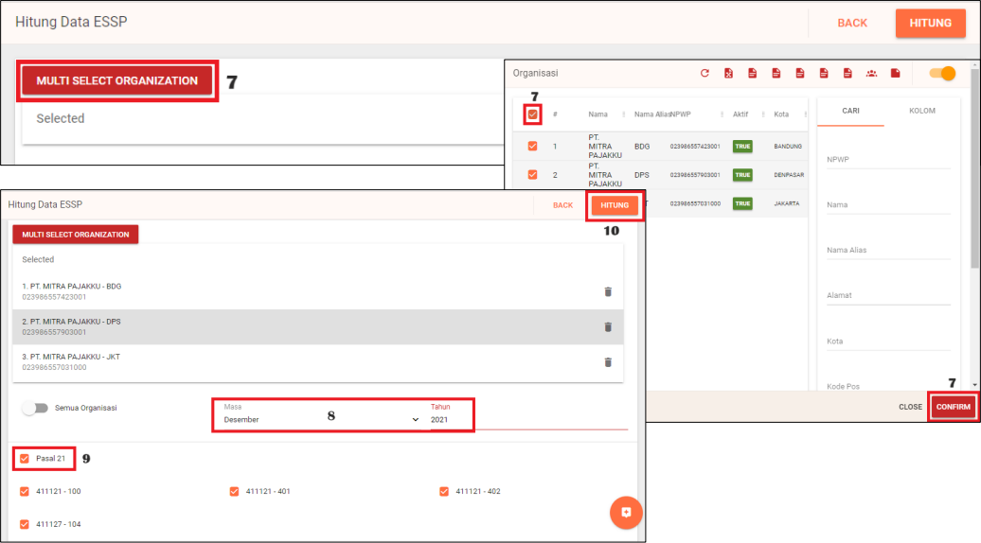
Figure 3.55 Organization's NPWP Billing ID Creation

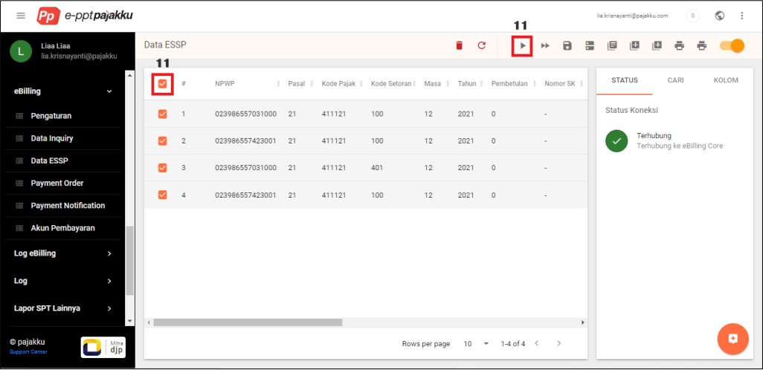
Figure 3.56 Final Result of SSP Calculation

    - Importing Income Tax Billing ID 21/26
Steps to Import Income Tax Billing ID 21/26:
      - Click on the e-Billing menu
      - Then, click Import ESSP
      - Download the ESSP Template and complete the import data
      - Click Choose File, and select the essp file to import.
      - Click Import
      - If the import status is Finished, Click ESSP Data
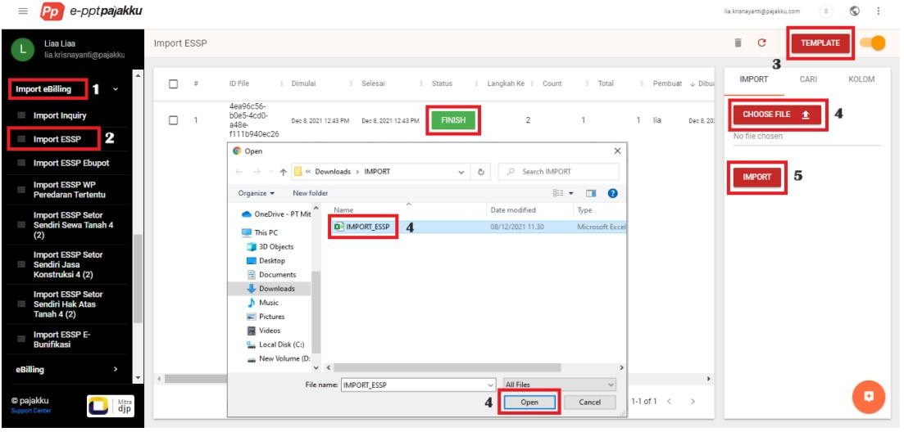
      - Select the SSP that has been successfully calculated, then click the Generate button.
Figure 3.57 Steps to Import a Billing ID

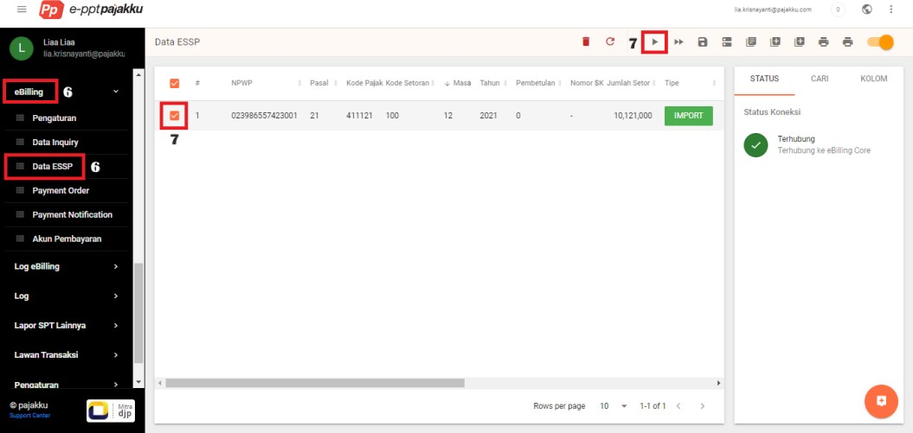

Figure 3.58 Billing ID Import Final Status

    - Make Payment Order for Income Tax Billing 21/26
Steps to Create an Income Tax 21/26 Billing Payment Order:
      - Click on the e-Billing menu
      - Select Payment Order
      - SSP Tickmark that has been successfully generated
      - Click the Print Billing icon
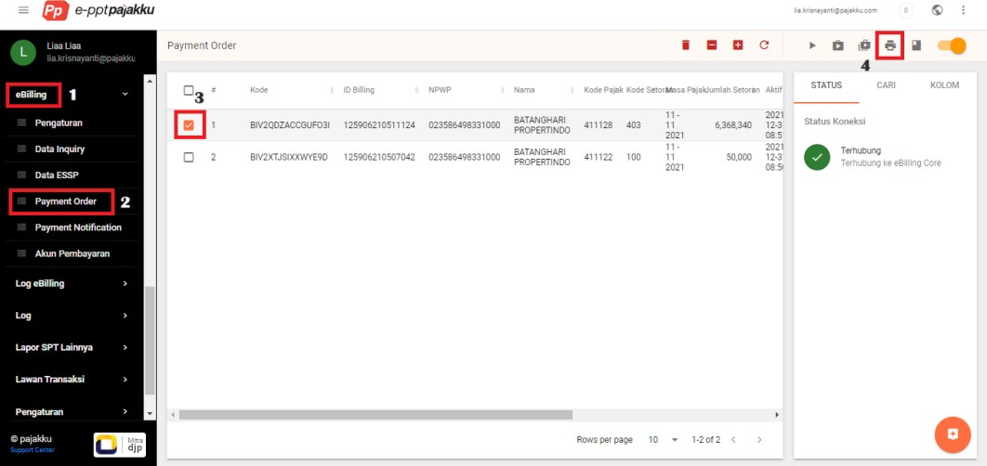
Figure 3.59 Steps to Create an Income Tax 21/26 Billing Payment Order

    - Inputting Counterparty Data
Steps to Input Opposite Transaction Data:
      - Click on the e-Billing menu
      - Select Payment Order
      - Tickmark the SSP that has been successfully generated and click Order
      - Select a Payment Method and click Confirm
      - Select Payment Account, and click Process
      - Check Payment Status on the Payment Notification menu
      - If Status on menu Payment Notification isCompleted, click Pull NTPN to enter into the respective tax return

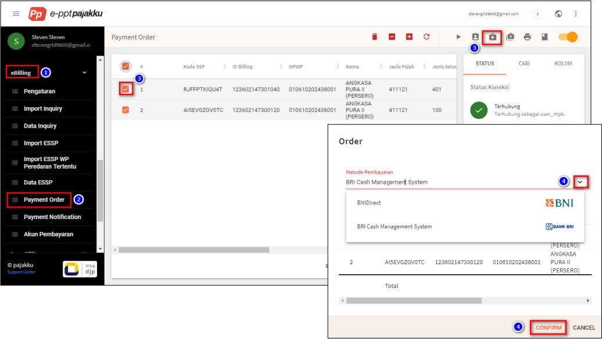

Figure 3.60 Steps to Input Opposite Transaction Data
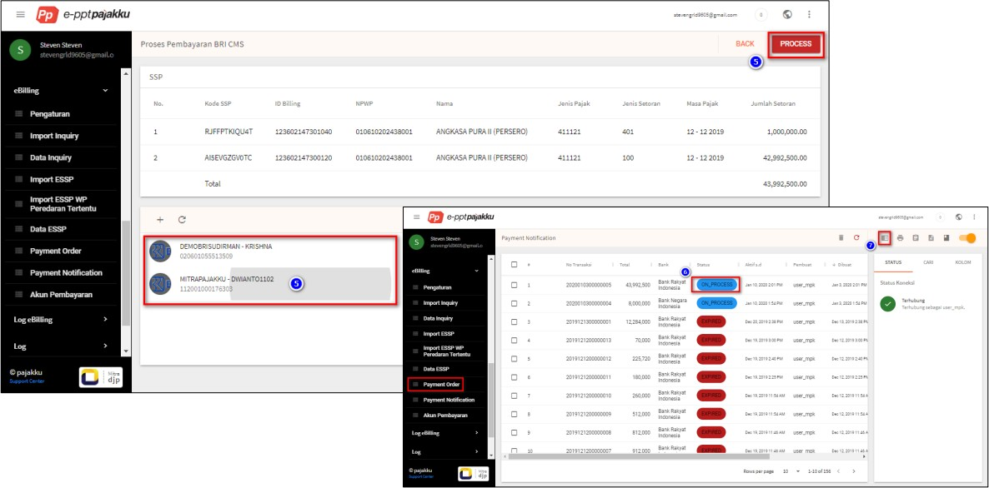
Figure 3.61 Payment Status on Payment Notification Menu

    - Create Domestic Withholding or Collection Data
Steps to Create Domestic Withholding or Collection Data:
      - Click E-Bunification
      - Select SPT List
      - Click the Actions button, then Open Tax Return
      - Click on Withholding/Collection and Self-Remittance
      - Click Domestic Withholding/Collection
      - Click the + (Create) icon
      - Opposite Transaction Input

      - Then input the income tax deducted
      - Click the Cutting Basics menu
      - Input Basic Cutting data, then Save
      - Cutter Identity Input
      - Choose Return or Overbooking of Excess
      - Check Statement
      - Click Create
      - Click Refresh and make sure the Withholding Slip has the status Completed
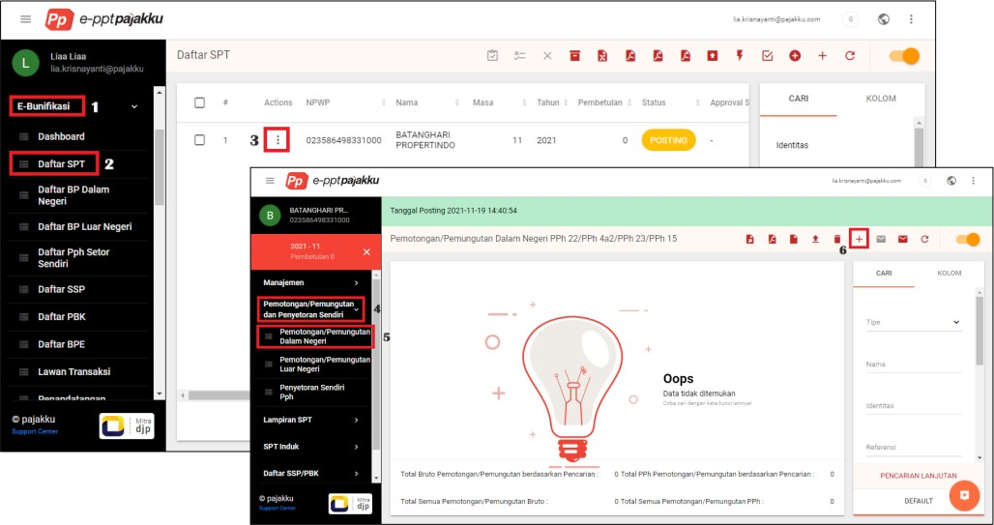
Figure 3.62 Steps to Create Domestic Withholding or Collection Data

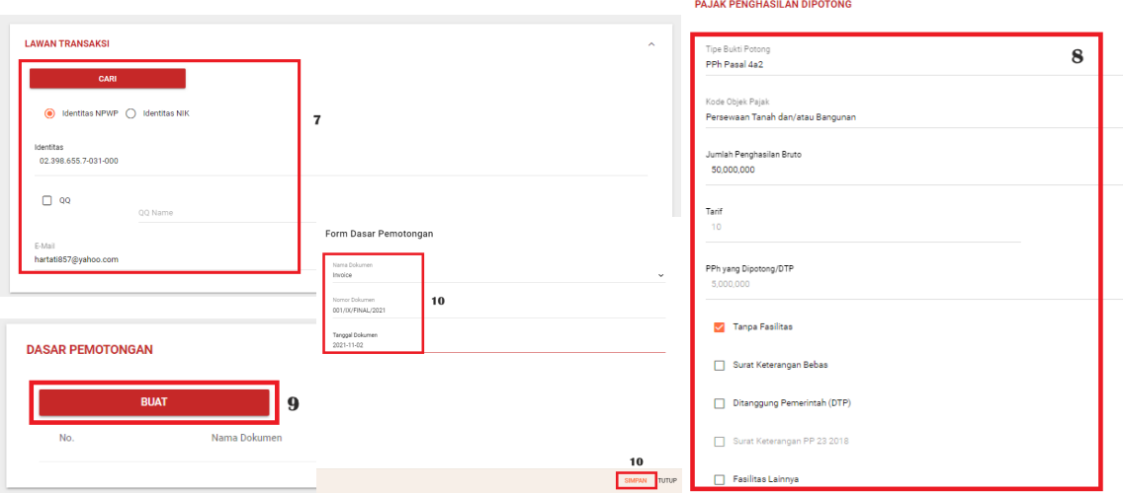

Figure 3.63 Inputting withheld income tax data

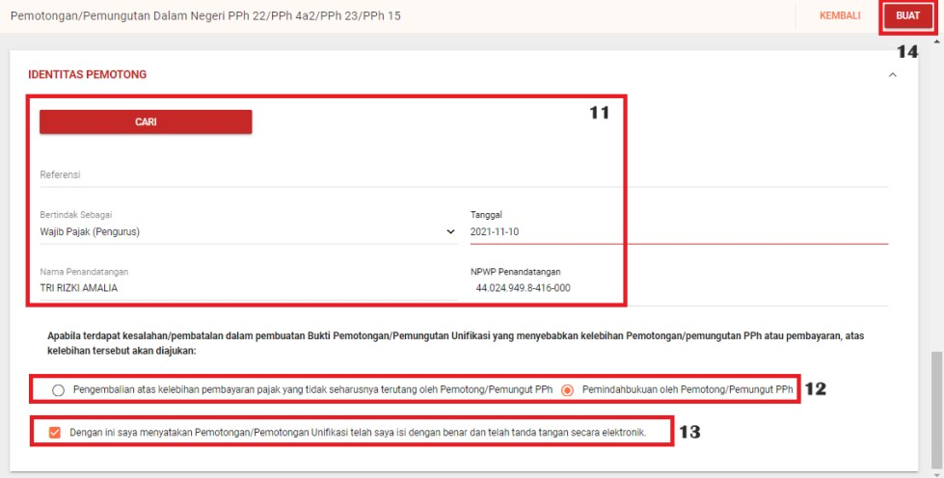

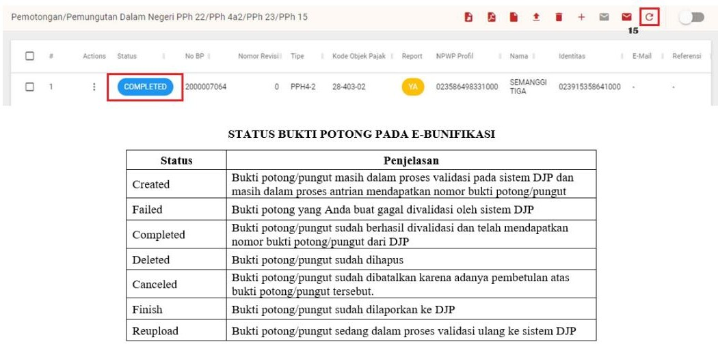
Figure 3.64 Return or Overbooking of Excesses

Figure 3.65 Cut Proof Status on E-Bunification

    - Create Overseas Withholding or Collection Data
Steps to Create Overseas Withholding or Collection Data:
      - Click E-Bunification
      - Select SPT List
      - Click the Actions button, then Open Tax Return
      - Click on Withholding/Collection and Self-Remittance
      - Click Foreign Withholding/Collection
      - Click the + (Create) icon
      - Opposite Transaction Input
      - Then input the income tax deducted
      - Click the Cutting Basics menu

      - Input Basic Cutting data, then Save
      - Cutter Identity Input
      - Choose Return or Overbooking of Excess
      - Check Statement
      - Click Create
      - Click Refresh and make sure the Withholding Slip has the status Completed
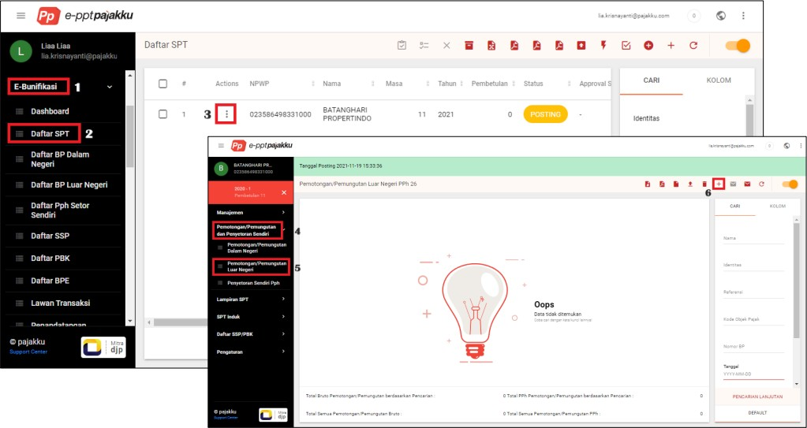
Figure 3.66 Steps to Create Overseas Withholding or Collection Data

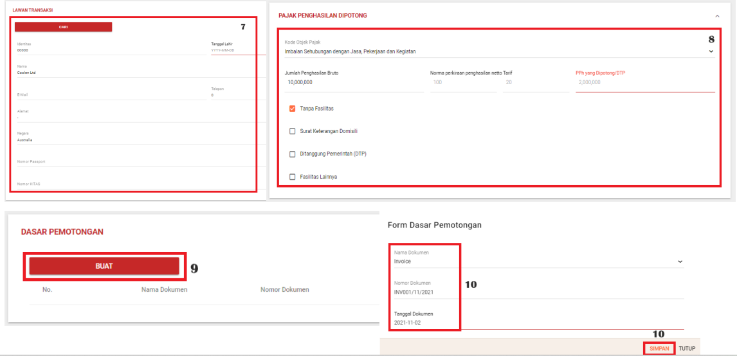
Figure 3.67 Inputting Opposite Transaction Data

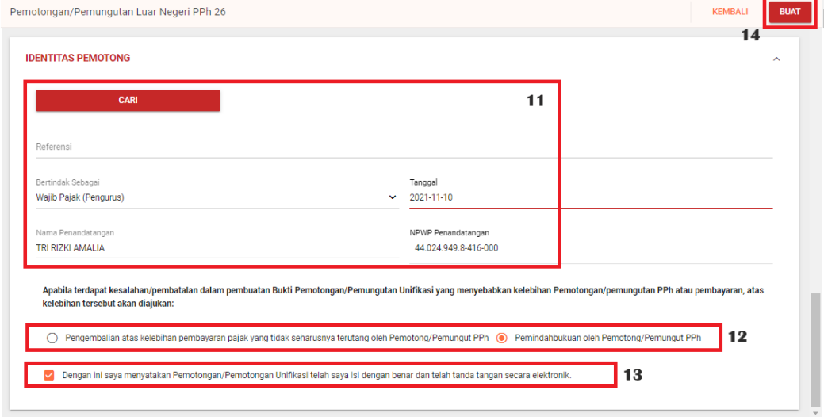

Figure 3.68 Inputting Cutter Identity

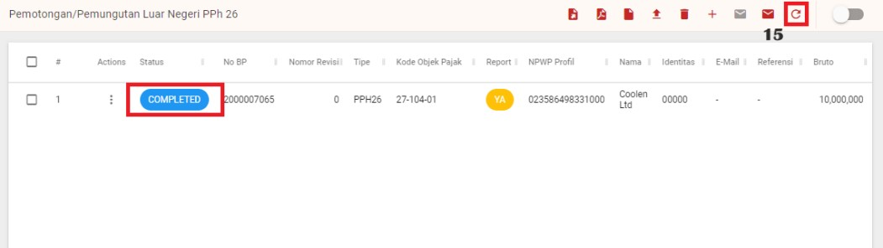

Figure 3.69 Proof of Cut with Completed Status

    - Creating Income Tax Self-Deposit Data
Steps to Create Income Tax Self-Deposit Data::
      - Click E-Bunification
      - Select SPT List
      - Click the Actions button, then Open Tax Return
      - Click on Withholding/Collection and Self-Remittance
      - Click Income Tax Self Deposit
      - Click the + (Create) icon
      - Select deposit data based on SSP or PBK
      - Input of Proof of Deposit Number
      - Select Deposit Type Code and Tax Object Code
      - Input Gross Income Amount and Paid-up Amount
      - Deposit date input
      - Click Create

      - Click Refresh and make sure the SSP/PBK is Completed.
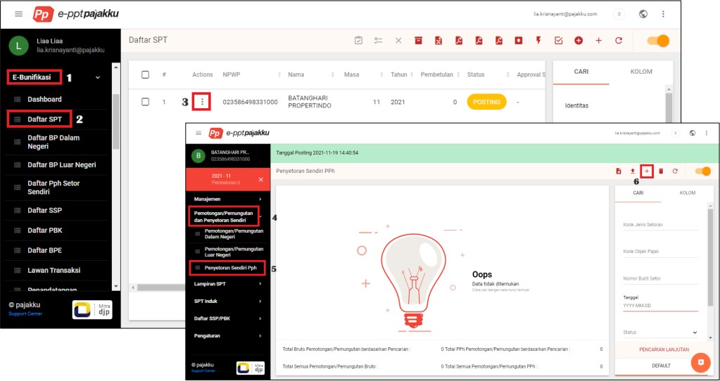
Figure 3.70 Steps to Create Income Tax Self-Deposit Data:

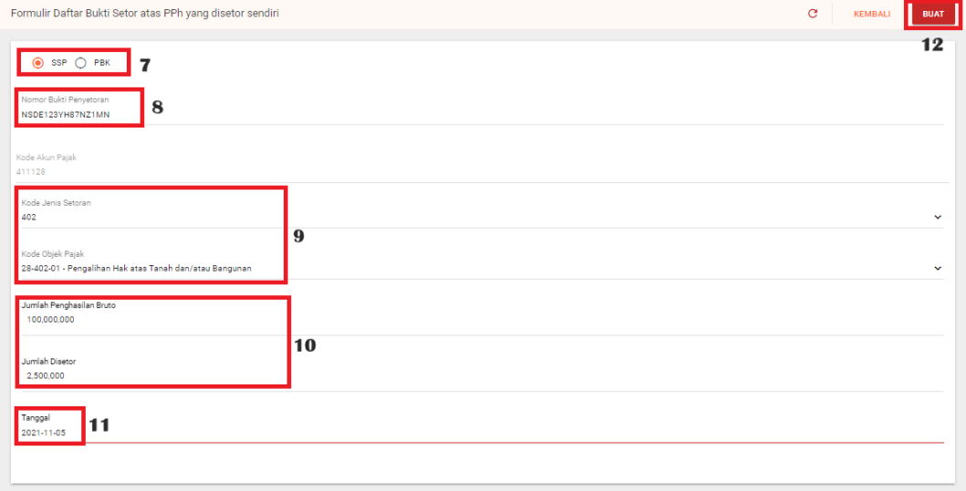
Figure 3.71 Inputting the Proof of Deposit Number

    - Importing ESSP Data
Steps to Import ESSP Data:
      - Click Import eBilling
      - Select Import ESSP E-Bunification
      - Click Template to download the import schema template
      - Click Example to download the sample import scheme
      - If the import scheme is ready, click the Choose File menu.
      - Select the file to import
      - Click the Import button

      - Then click Refresh, and make sure the import is successful and has a Finish status.
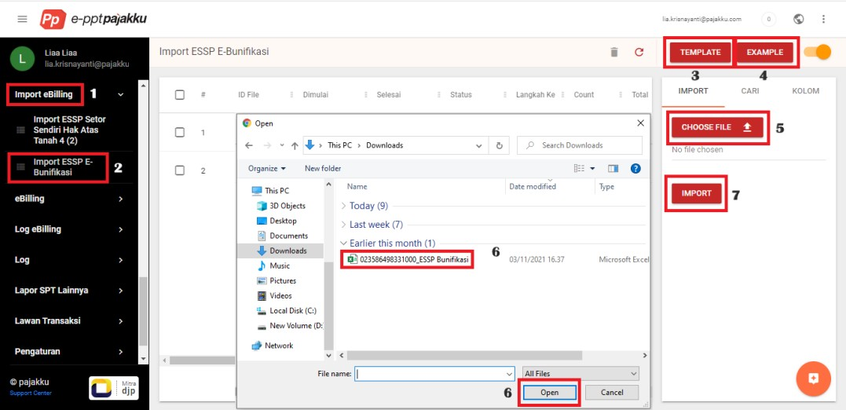
      - If Failed, click the Actions button and select more info to view the error description.
Figure 3.72 Steps to Import ESSP Data

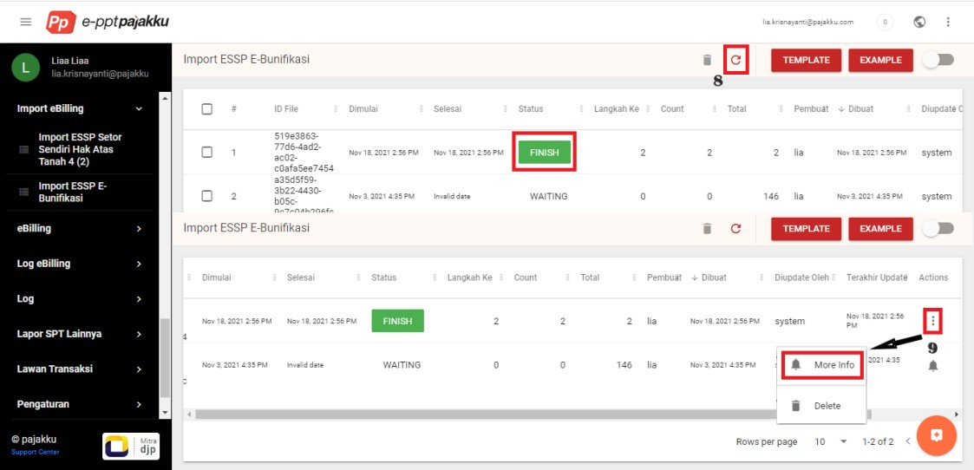

Figure 3.73 Import Data with Finish Status

    - Updating Office Equipment Inventory Data 2019 to 2023 Five rooms recorded for office equipment
      - Secretary's Room
      - General Manager's Room
      - Meeting Room
      - HR Room
      - Operations Room

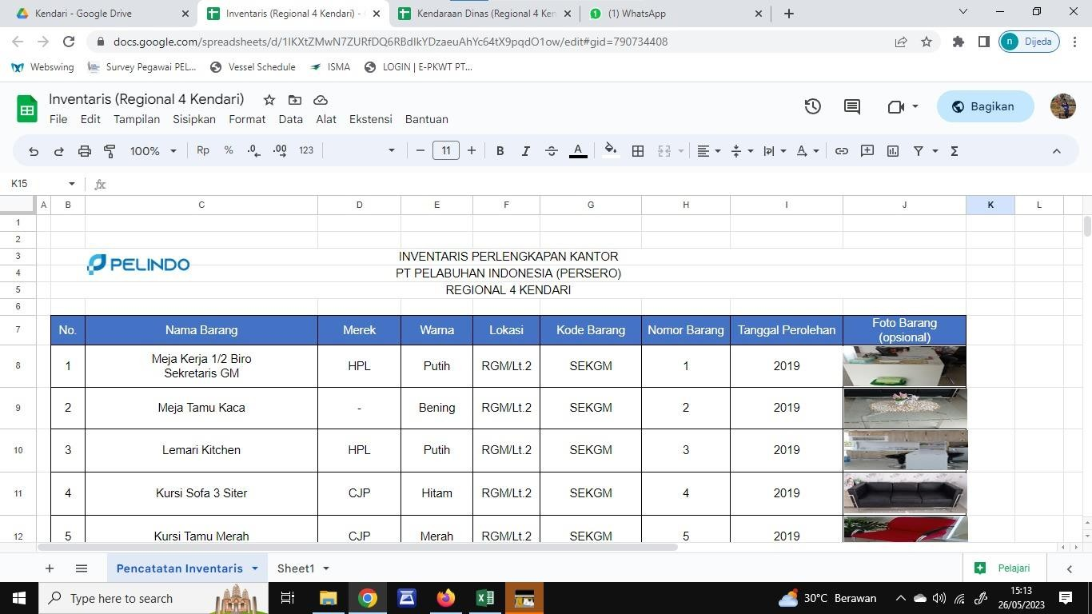

Table 3.5 Office Equipment Inventory Data

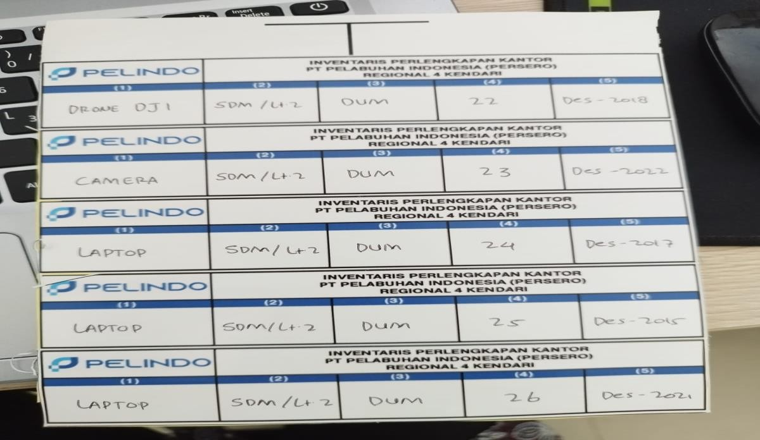
    - Labeling Pelindo Kendari Office Equipment Inventory
Figure 3.74 Office Supplies Inventory Label

    - Creating an archive of service notes from January 2022 - May 2023
      - Login to the PEO Application (Pelindo E-Office), then select the official manuscript and then select the official note option.
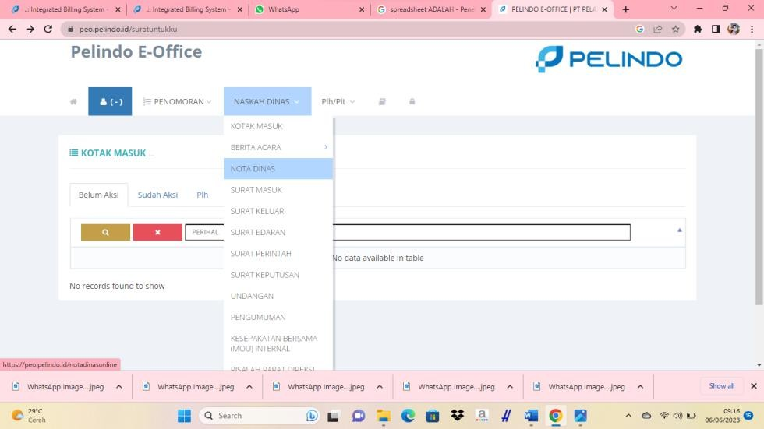
Figure 3.75 Pelindo E-Office Application Login

      - Change the date to January 2022 as shown below and then open the official memorandum that you want to download for archiving
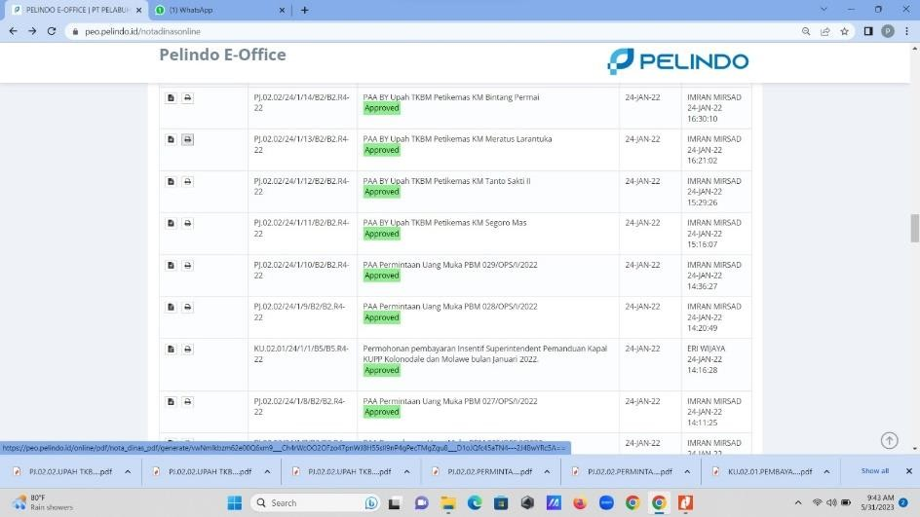
Figure 3.76 Set Date, Month, Year on Pelindo E-Office Application

      - The official memorandum will appear as follows then check download to archive
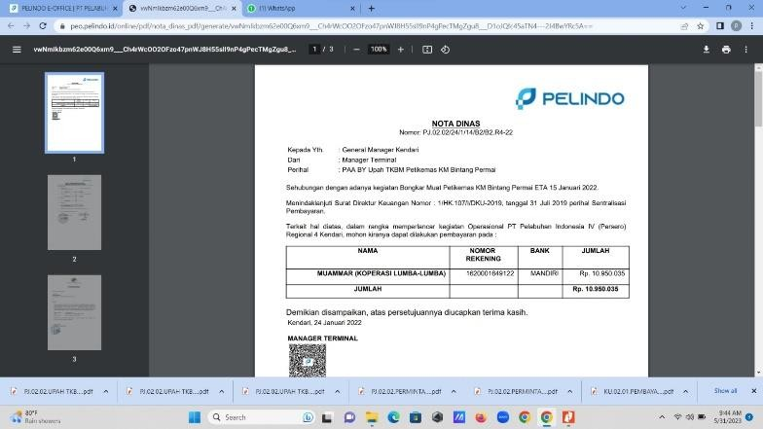
Figure 3.77 Download Service Memorandum

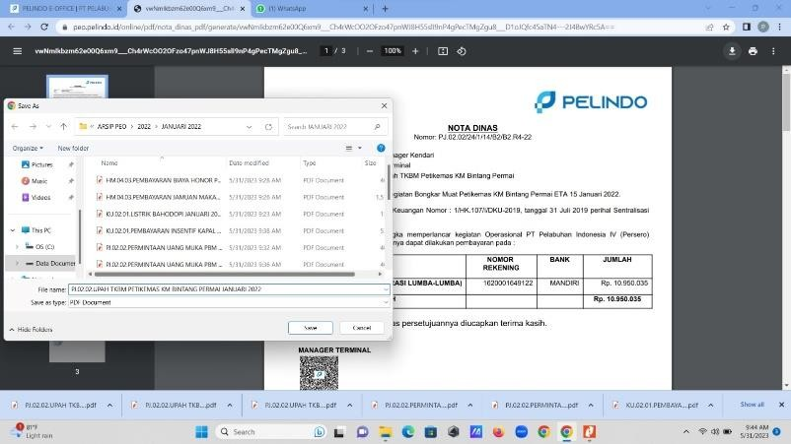
      - Save files in folders to make it easier to find archives
Figure 3.78 Save File in Archive Folder

      - The contents of the folder will appear as follows where official notes in the PO application often experience errors so that data is sometimes lost.
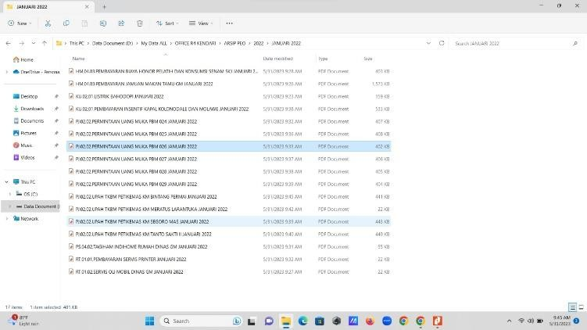
Figure 3.79 Service Note File After Downloading

In the SPJM Division (Subholding Pelindo Maritime Services), the activities carried out by Internship Students are to assist in inputting data into the Vessp4+ (Vessel Service System Pelindo 4) application.
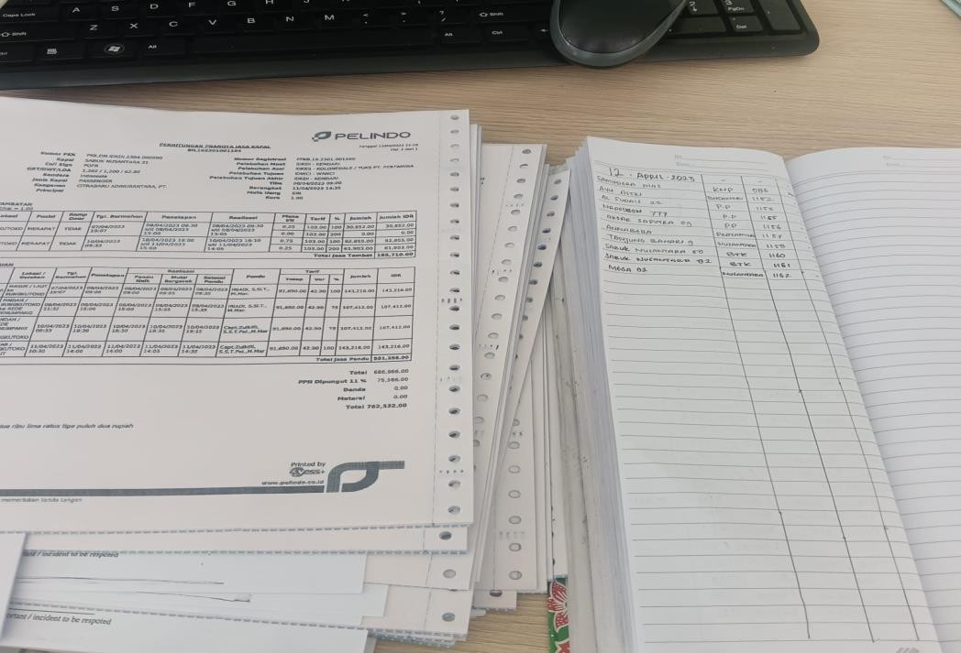
- Entering Form 3 Note Data in the Registration Book
Figure 3.80 Entering Form 3 Note Data in the Registration Book

- Entering Memorandum Form 2.1A Data into Vessp4 Application to be Converted into Memorandum Form 3
Steps for Processing Memorandum Form 2.A1 to Memorandum Form 3:
  - Open the website https://vessp4.pelindo.co.id. as shown below.
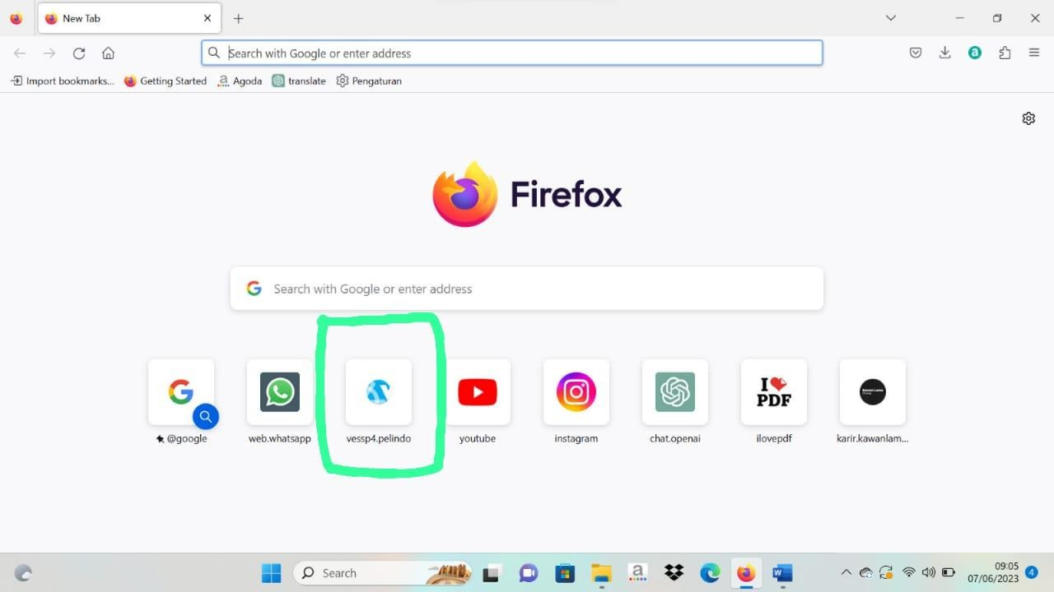
Figure 3.81 Vessp4 Application Logo

  - Then login, after that the homepage will appear as shown below
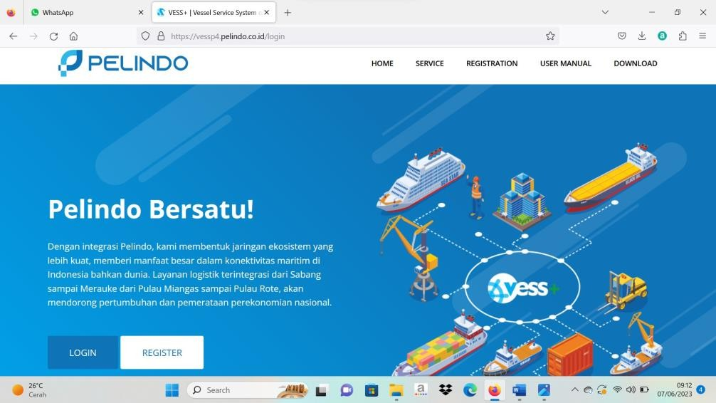
Figure 3.82 Vessp4 Application Login

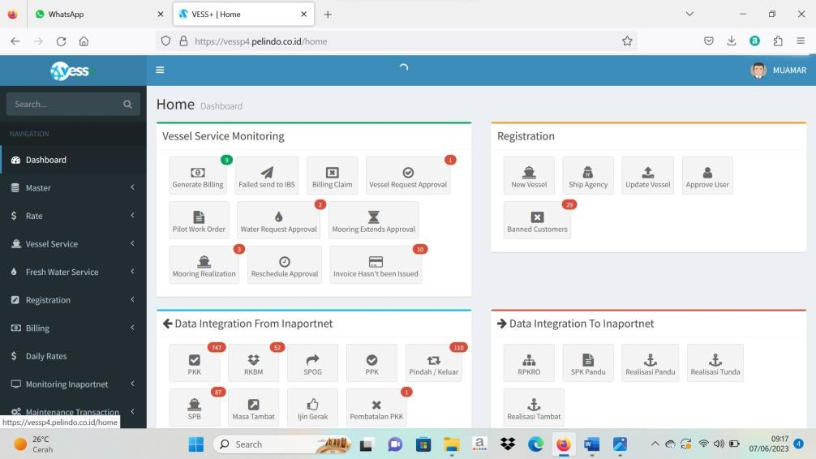
Figure 3.83 Homepage of the Vessp4 Application

  - On the Vessel Service Menu, select Pilot Work Order, then click Create Work Order Without Booking.
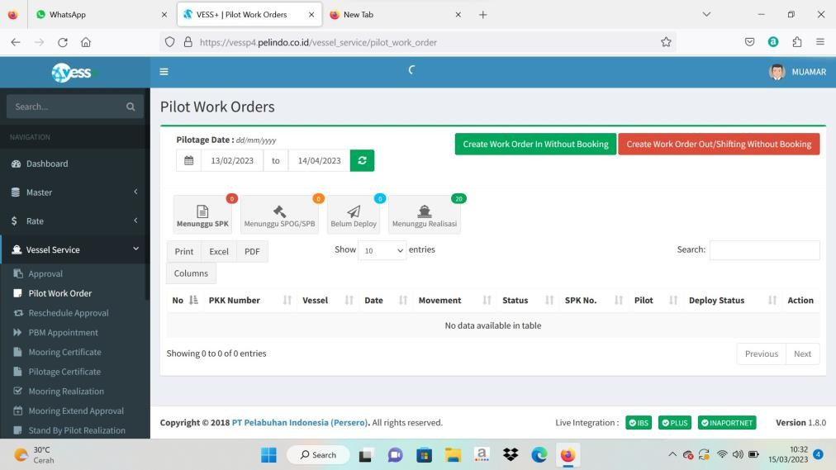
Figure 3.84 Vessel Service Menu on Vessp4 Application

  - Fill in the ship data according to what is contained in the 2.A1 form note, then click submit
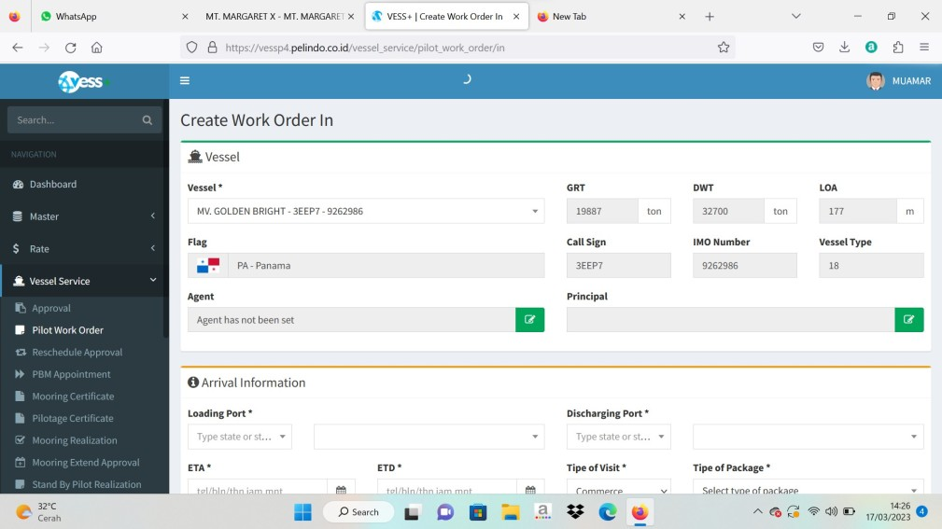
Figure 3.85 Create Word Order In

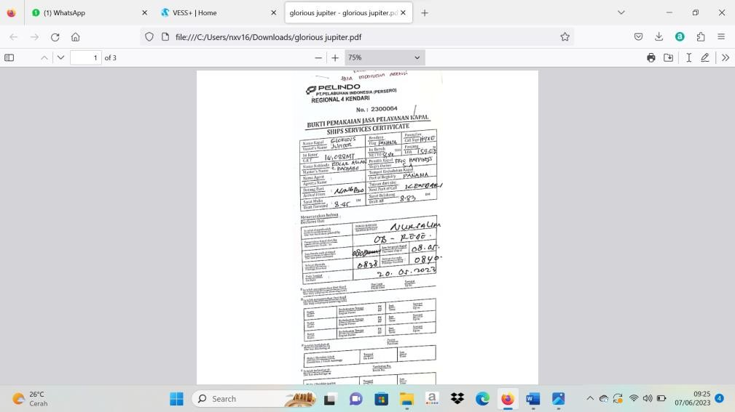
Figure 3.86 Note Form 2.A1

  - After submitting, return to the previous menu, then click Create Work Order Out Without Booking to fill in Movement 2 and 3 data, after that click Create Work Order in green, after that a window will appear as below
Figure 3.87 Create Work Order Out

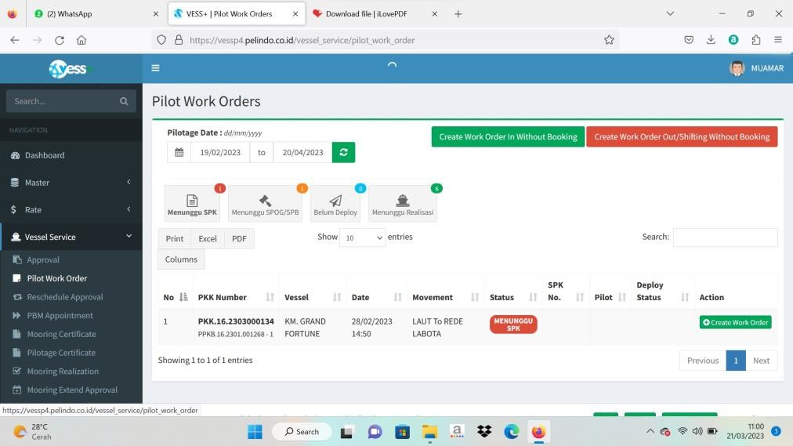
Figure 3.88 Create Work Order (+)

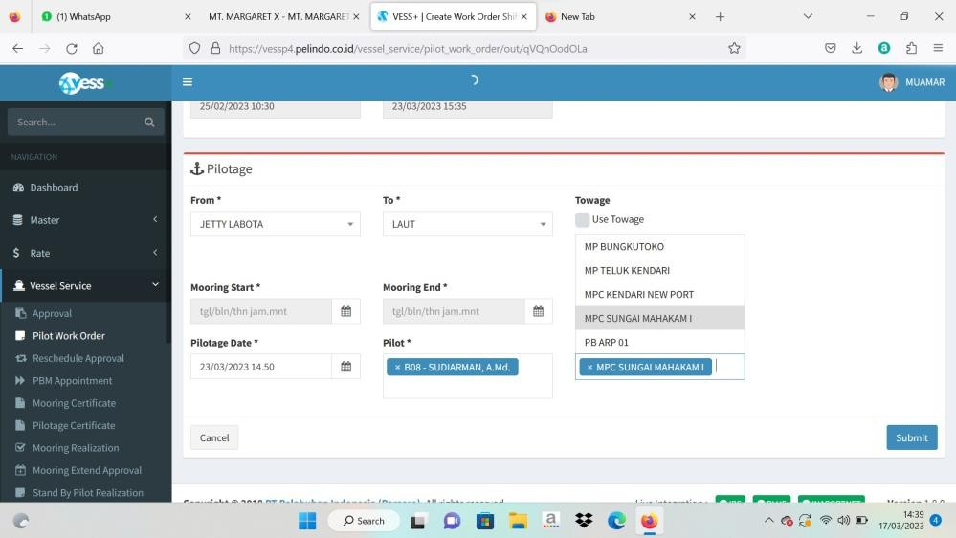
Figure 3.89 Data Filling 2 and 3

  - After completing filling in data 1, 2 and 3, then step on the realization page, then on the search menu write the name of the ship being processed as below, then select the green realization menu, and the following window will appear, and fill in according to the data listed in the previous note. (realization is done 3 times, namely for Movement 1, 2, and 3).
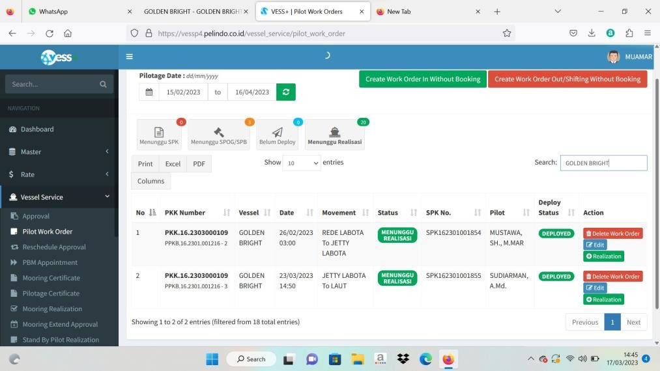
Figure 3.90 Realization page

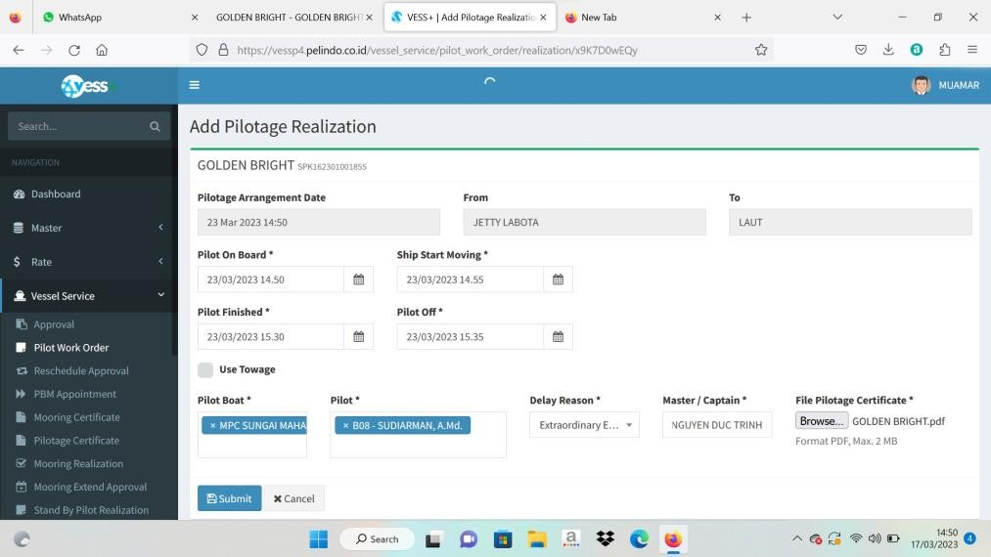
Figure 3.91 Realization Menu

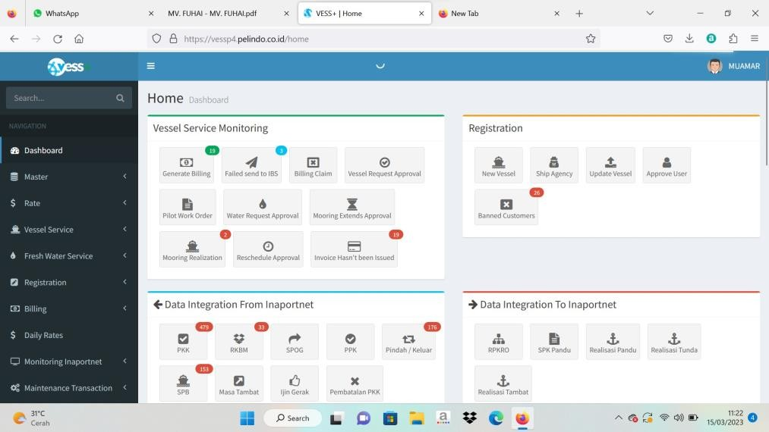
  - After completing the realization, you will return to the following window
Figure 3.92 Return to Main Menu

  - Next, select the Billing menu and select Create Billing, then write the name of the ship in the search menu, then click the orange preview menu to see the results of the 2.A1 form note process. as below and compare it with the note again whether it is appropriate.
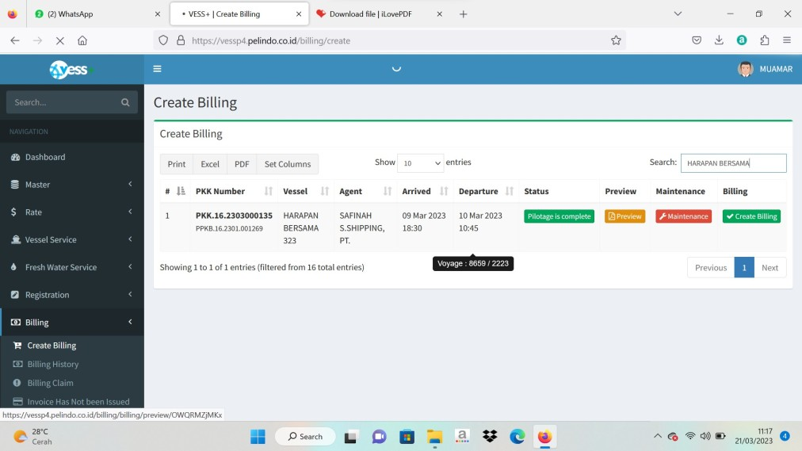
Figure 3.93 Billing Menu on Vessp4 Application

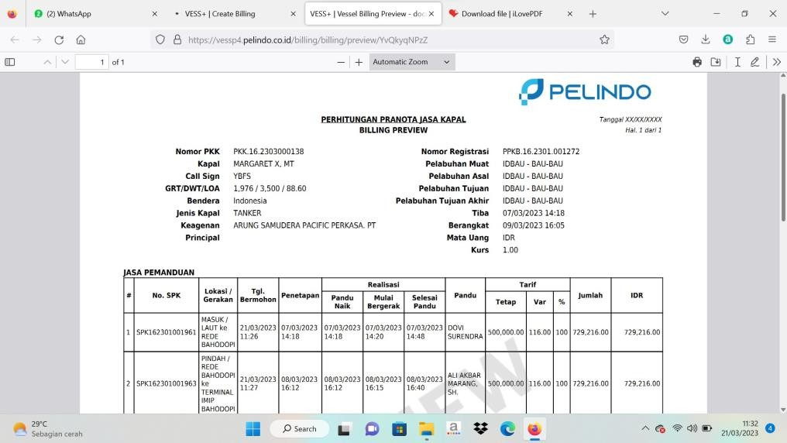
Figure 3.94 Results of the Memorandum Form 2.A1 Process

  - If both data are correct, the process is complete.

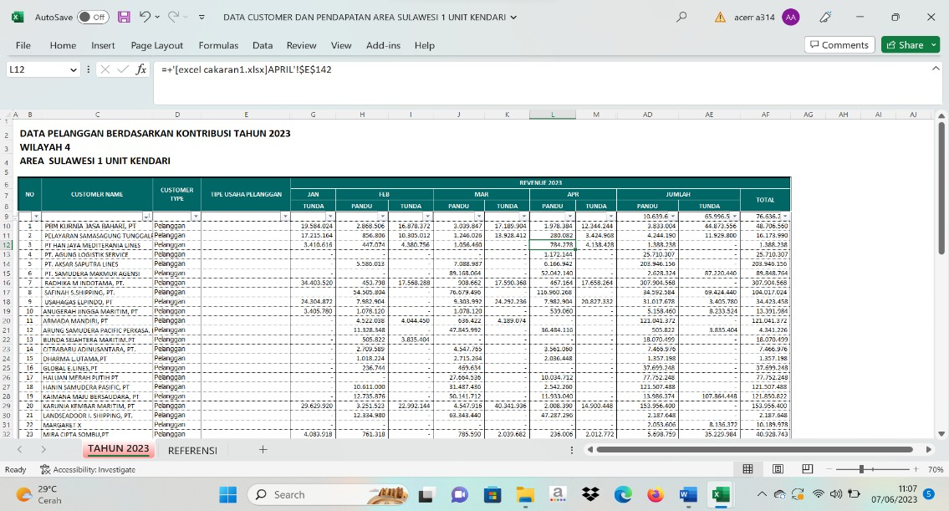
- Analyzing Customer Data by Contribution in 2023
Table 3.6 Customer Data by Contribution in 2023

Some of the activities we did together included:
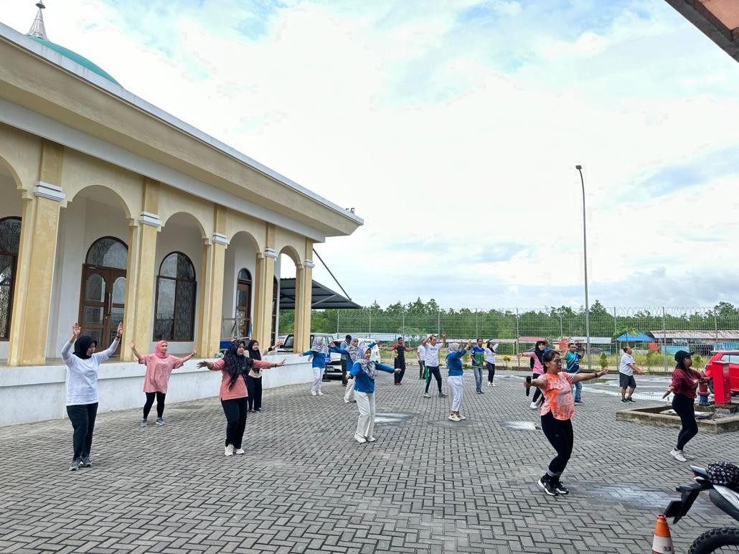
- Joining gymnastics every Friday
Figure 3.95 Gymnastics Activities

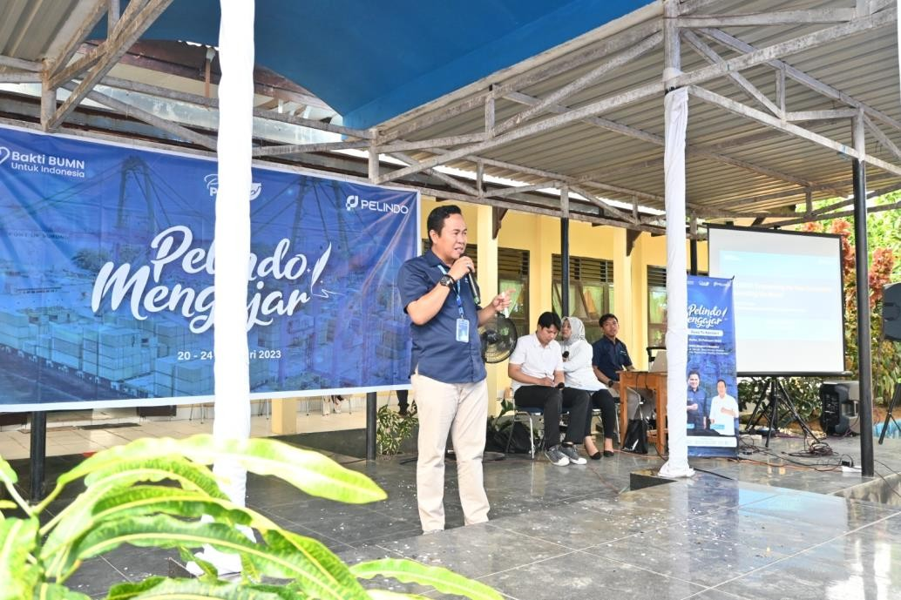
- Pelindo Mengajar Goes To Kendari activity at SMAN 8 Nambo
Figure 3.96 Pelindo Mengajar Goes To Kendari

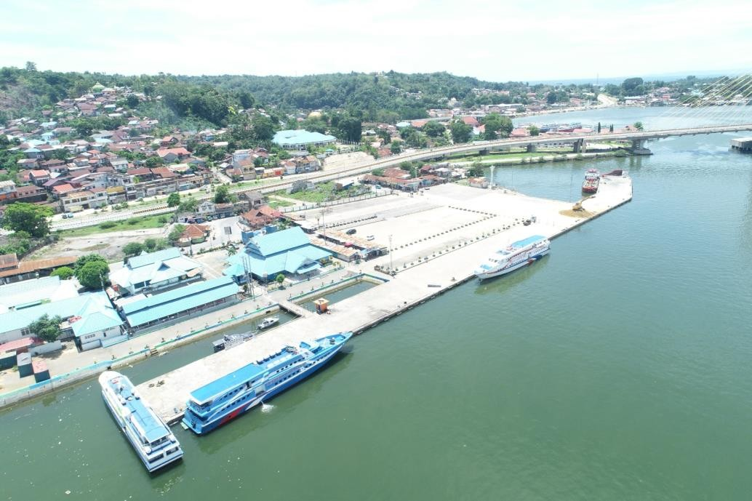
- Make a short movie The Development of the Archipelago's Ports Over the Year
Figure 3.97 Short Filming of Port Development

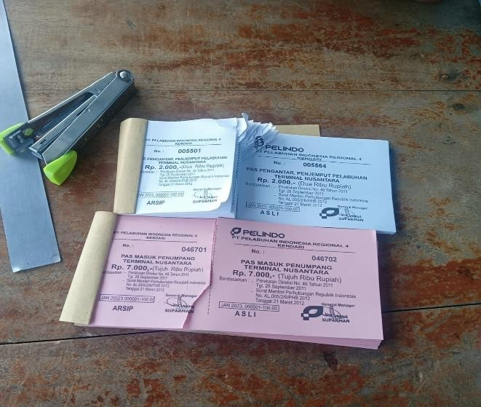
- Sale of Bonggol or Port Entry Pass
Figure 3.98 Port Entry Bump / Pass

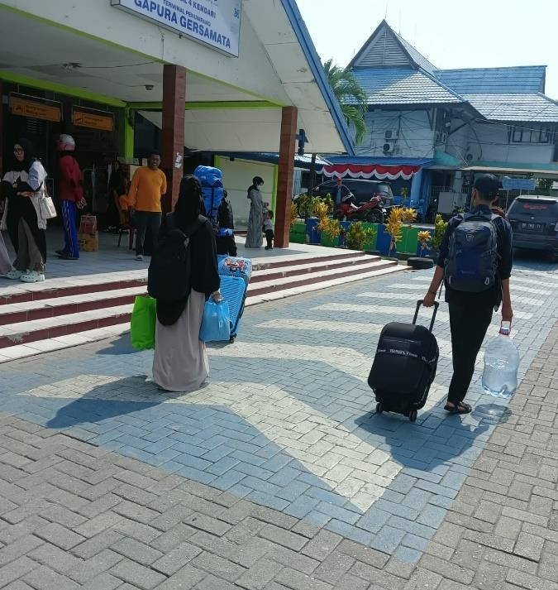
- Directing passengers to their destination ship
Figure 3.99 Directing Passengers to the Ship

- Learning activities: Receiving Leadership, Finance and Marketing Materials from the Manager of Human of Capital and General Service Pelindo Kendari
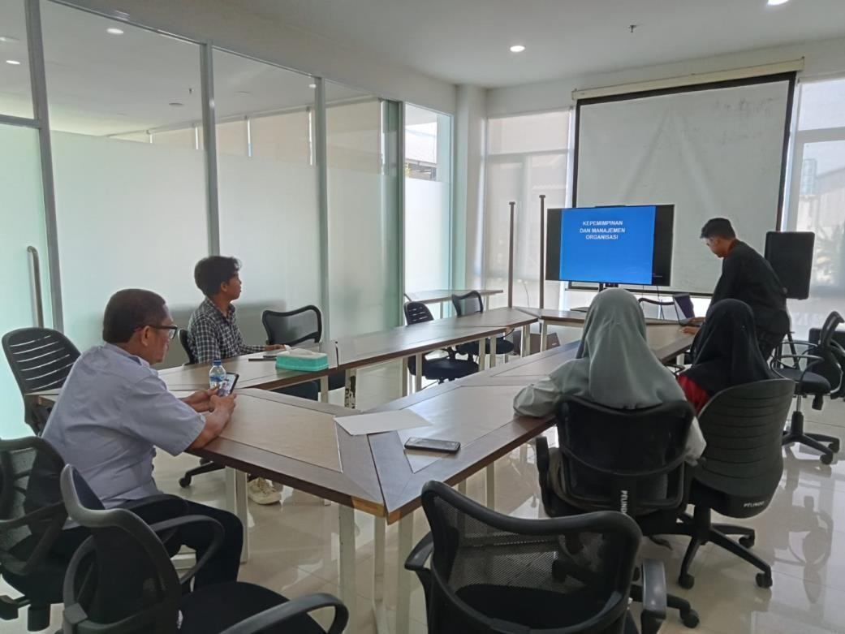
Figure 3.100 Teaching and Learning Process

- Participated in the Cultural Parade to Commemorate the Anniversary of Southeast Sulawesi Province
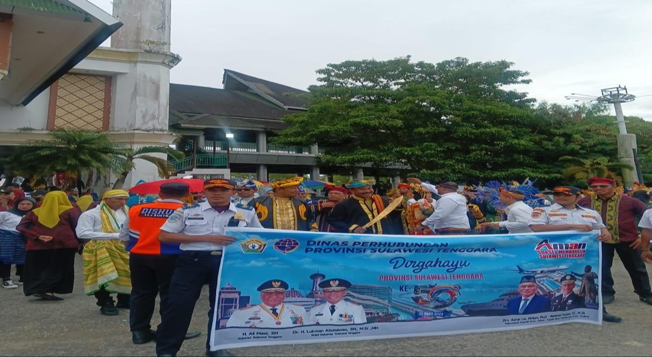
Figure 3.101 Cultural Parade

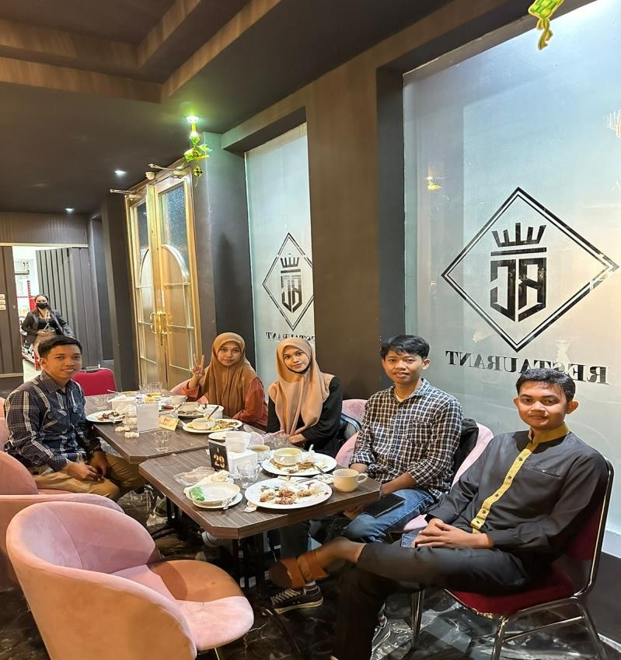
- Breaking the fast with Pelindo Kendari employees
Figure 3.102 Breaking the Fast with Pelindo Employees

- Working in the office area to celebrate World Environment Day
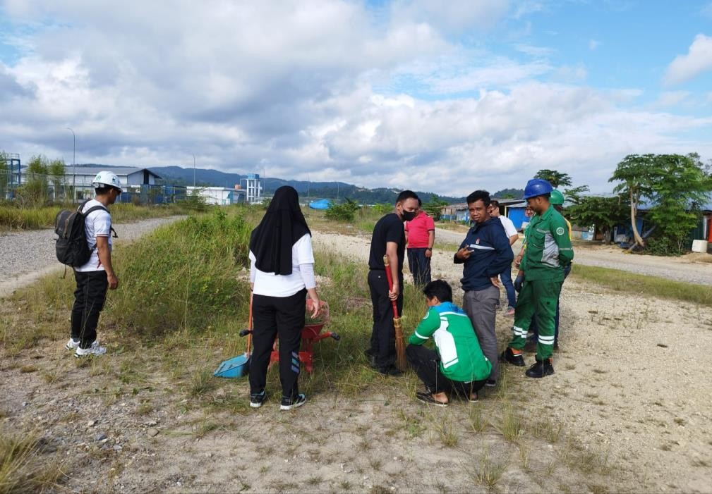
Figure 3.103 World Environment Day Community Service Work

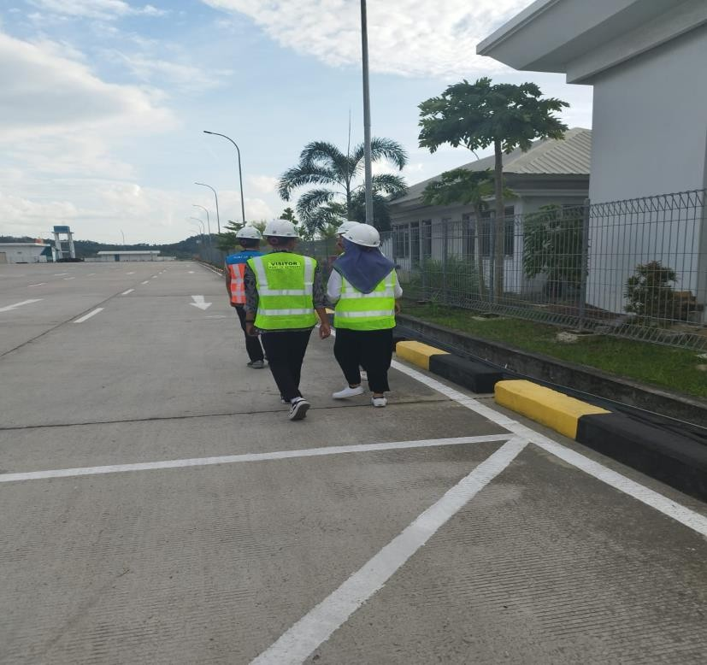
- Field study: Visiting Pelindo Kendari's container yard area.
Figure 3.104 Reviewing the Container Field Area

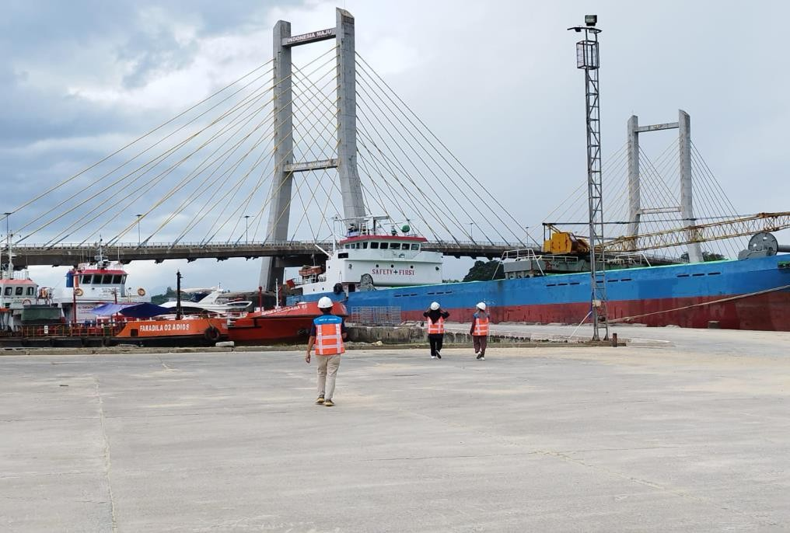
- Field study: reviewing the fast boat and night boat harbor areas
Figure 3.105 Viewing the Harbor Area of Fast Boats and Night Boats

Relevance of Internship Activities to Subjects Studied in College

Internship activities that students carry out at PT Pelabuhan Indonesia (Persero) Regional 4 Kendari, are a form of real practice from several courses obtained by the author in lectures. It can be said that the internship activity is a practice or simulation carried out based on the theory obtained. The theory given in lectures can be an additional knowledge to analyze a system in the company. Based on the internship activities carried out, students often find management aspects to run the company.
We found the suitability between the concentration of our study program, namely Business Administration with the placement and also some of the activities we did. For example, especially the concentration of study programs in Finance and Marketing, we were placed in several divisions that also took care of Marketing and Financial activities such as in the SPJM Division taking care of all kinds of administration related to requests for the use of ship services provided by PT Pelabuhan Indonesia (Persero) Regional 4 Kendari Branch. Then in the Regional 4 Finance Division, its relation to administration is to manage the entry and exit of office cash, the use of taxes on the use of services and on port employees, as well as the administration of ship letters and other office letters.
Then for the concentration in the field of Marketing and Finance, we find it appropriate that our internship site, PT Pelabuhan Indonesia (Persero) Regional 4 Kendari Branch, is one of the State-Owned Enterprises which is also oriented towards business, especially in providing container loading and unloading services and also using ship services.
Here are some of the courses we got this semester which are related to the Internship Activities carried out by Students at PT Pelabuhan Indonesia (Persero) Regional 4 Kendari:

INTERNATIONAL FINANCIAL MANAGEMENT
International financial management is financial management on the scale of international financial transactions. In international financial management, there are many things that must be considered and require a business concept.

mature and strategic.
Here are some of the activities we learned in the company related to International Financial Management:
  - Analyzing Vessp4+ Applications

The function of this application is to recheck the proof of use of ship services and can manage the berthing of foreign ships in several countries.
  - Analyzing Cooperation Agreements with Chinese Companies
PT Pelabuhan Indonesia entered into a Cooperation with PT Transon Bumindo Resources regarding the Utilization of the Pier at the Kendari Port Boat Base Terminal Pier.
  - Analyzing Overseas Collection Data
Foreign collection refers to the activity of collecting the amount of tax payable on a transaction from several foreign workers.

FINANCIAL BEHAVIOR
Financial Behavior encompasses a person's actions in managing their money in daily life. It is concerned with the way one organizes and utilizes available financial resources. Financial behavior also involves a person's financial responsibility in managing their finances effectively. Nababan and Sadalia (2012) suggest the following indicators of financial behavior: 1. Pay bills on time. 2. Making a budget for expenses and spending 3. Recording expenses and spending (daily, monthly, etc.) 4. Providing funds for unexpected expenses.
Here are some of the activities we learned in the company related to Service Marketing Management:
  - Analyzing Proof of Service for Tools
For example, the company PT Cahaya Karunia Logistik which rents facilities in the form of Forklifts to PT Pelabuhan Indonesia for a period of 2 weeks.
  - Analyzing Proof of Use of Ship Services

For example, the MV ALTHEA VIIV departed from Mataram on March 12, 2023 at 1:30 p.m. WITA and departed Balikpapan on March 15, 2023 at 2:20 p.m. WITA.
  - Analyzing Proof of Use of Mooring Services and Mooring Services
For example, KM TAREX 2 anchored at Kendari Port on March 1, 2023 at 07:10 and moored at B TOKO on March 7, 2023 at 11:50 WITA.
  - Analyzing the Ordering of Goods and Services
For example, PT Pelabuhan Indonesia (Persero) provides Ship Water Services for the First Quarter Period 2023 to the Lumba- lumba Cooperative for Fifteen Million Rupiah.

FINANCIAL MANAGEMENT SEMINAR
Financial Management Seminar is a compulsory concentration course for students majoring in management, this course discusses problems and cases of financial management in business practice and based on empirical studies.
Here are some of the activities we learned in the company related to the Financial Management Seminar:
  - Pelindo Mengajar Goes To Kendari at SMAN 8 Nambo
In this activity, the General Manager of PT Pelabuhan Indonesia (Persero) gave a seminar on financial management which discussed financial risk management, investment and project development that will be carried out in the future.
  - Learning Activities: Acceptance of Financial Management Materials
In the learning activities carried out in the meeting room by the Regional Division Manager 4, he provided some material about financial management including financial planning, cash flow management, financial risk management, funding, investment analysis and financial reporting.

REGIONAL FINANCIAL MANAGEMENT
Local Financial Management refers to financial management practices related to local governments or local government entities, such as cities, districts, provinces, or other regions.

Here are some of the activities we learned in the company related to Marketing Communication:
  - Analyzing PT PELNI Baubau Branch Payment Notes on Pelindo 4 IBS Application (Reimbursement Recap)
The analysis of the lunas note involves evaluating the records of debt payments that have been repaid by PT PELNI Baubau Branch to PT Pelabuhan Indonesia (Persero). This is important to ensure that payments have been made appropriately and to monitor the financial health of the company.
  - Analyze the Letter of Cooperation Agreement
Prepare a letter of Cooperation agreement between the Kendari class III port authority and PT Pelabuhan Indonesia regarding the cooperation of bungkutoko terminal port facilities with APBN funds.

FINANCIAL STATEMENT ANALYSIS
Financial Statement Analysis is the activity of analyzing financial statements using financial accounting concepts and standards. The accuracy and prevention of misinterpretation of financial information in the analysis of financial statements is done by using the nature and concepts of financial accounting during the analysis process.
Here are some of the activities we learned in the company related to Financial Statement Analysis:
  - Matching and research of PT Pertamina Trans Kontinental on IBS Application
PT Pertamina Trans Kontinental matching and research is a process to check and verify information about the Company, It involves collecting and analyzing relevant data by using IBS Application to ensure the correctness of information provided by the Company.
  - Analyzing the Payment Process
Concession / Revenue of Nusantara Terminal Port and Boat Base, Non-Tax State Revenue (PNBP) i.e. Guiding and

Ship Delays in SAP Application
  - Analyzing PT Rukma Padaya Trans's Payment Note on Pelindo 4 IBS Application (Reimbursement Recap)
A note analysis involves evaluating the records of debt payments that have been repaid by PT Rukma Padaya Trans to PT Pelabuhan Indonesia (Persero). This is important to ensure that payments have been made appropriately and to monitor the financial health of the company.
Some of the companies analyzed besides PT Rukma Padaya Trans are PT HUA Indonesia Agency, PT PELNI Baubau Branch, and PT Mitra Intertrans Forwarding.

LEADERSHIP
Leadership is the ability of a leader to control, lead, influence the thoughts, feelings or behavior of others to achieve predetermined goals.
Here are some of the activities we learned about in the company related to Leadership:
  - Pelindo Mengajar Goes To Kendari at SMAN 8 Nambo
In this activity, the General Manager of PT Pelabuhan Indonesia (Persero) provided material about leadership from his point of view, which said that leaders have certain qualities that make them different from their followers, sometimes leadership also provides indirect influence and means of shaping in accordance with their wishes.
  - Learning Activities: Marketing Management Material Acceptance
In the learning activities carried out in the meeting room by the Regional Division Manager 4, he provided some material about Leadership, including leadership in every organization has a goal to help establish work procedures that must be obeyed by each member, leadership must also be able to assist in taking attitudes and decisions together for the sustainability of the organization,

Challenges from activities carried out at the internship site
During internship activities, students do a lot of activities or work that is rarely or never done before. This is a challenge in undergoing internship activities. The next challenge for individual students is how to overcome these challenges.
In the SPJM Division, my group members experienced difficulties, especially in inputting certificates of proof of use of ship services. This is because we have never done this activity before and when inputting the certificate, it requires accuracy and concentration so that the data entered is correct or in accordance with what is stated in the physical certificate of proof of use of ship services.
In Regional Division 4, especially in document scanning activities, my group members experienced challenges, namely sometimes many old documents, especially in 2016, the paper was dull and many parts were folded so that the machine could not respond to the scanned data. Then in the HR division, especially in the finance department, there are difficulties in the application section because the IBS application for searching payment number info and invoice numbers is often down and also for filing Nota 3 sometimes has difficulty in the filing place which may be said to be less organized so that sometimes the document is scattered and difficult to find.
Broadly speaking, the internship activities that took place were going well. However, there are suggestions that the author would like to give to PT Pelabuhan Indonesia (Persero) Regional 4 Kendari Branch, namely regarding the acceptance of interns who should not be too many because it can cause ineffective internship activities regarding the division of tasks or the accumulation of the number of participants for several divisions. Advice for interns and especially for prospective interns is to easily adapt to a new environment, or at least try to adjust to the culture in the work environment, because based on my experience during the internship that

when I adapt to the environment or culture in the work environment, I will be more easily recognized, cared for, and treated better.

Mindset-Changing Internship Activities

After carrying out internship activities at PT Pelabuhan Indonesia (Persero) Regional 4 Kendari, we received various benefits, including in terms of knowledge, skills, and attitudes. Experience is the most valuable thing the author gets from these internship activities. In terms of knowledge, students become aware of the intricacies of the real world of work, how the atmosphere is to the challenges that exist in it in order to survive in the tight work competition. students can also find out how a large company maintains the consistency of its products, both from product availability, quality, and quantity.
Then in terms of attitude or attitude including order, discipline, and thoroughness. In carrying out internship activities, this attitude is needed because in the process, if it is not accompanied by order, discipline and thoroughness, it will hamper a job. In terms of discipline and order, the simplest thing is to be on time and obey the rules that have been made. In doing something, it becomes more motivated to be able to finish on time and with order and discipline, the work done will be neater in results. Thoroughness in working or doing a job is very important in order to achieve optimal results. Especially when carrying out internship activities related to customer satisfaction and responsibility to the field supervisor, so concentration is needed so that the work goes as expected.

Conclusion

CHAPTER IV CLOSING

Based on the internship activities carried out by students at PT Pelabuhan Indonesia (Persero) Regional 4 Kendari Branch, they have achieved the objectives that have been formulated, namely they have carried out various activities as instructed by the field supervisor and can complete them, besides that in carrying out their activities students also learn management systems, especially process management in the real world of work. In addition, the author gained experience in the real world of work, new insights and skills that can later be utilized in the world of work. Most of these experiences are not obtained in lectures where in the world of work there is more practice.
In facing the world of work in the future, the author concludes that soft skills and hard skills are needed. Soft skills needed to become competent resources later are leadership, problem solving, time management, organizational management, critical thinking, teamwork, analytical skills and self-confidence. As for the hard skills that need to be possessed are being able to do work in accordance with their scientific fields.

Advice
    - During our internship, which was approximately 1 semester or 6 months, we saw that there were still many internship students who were placed in divisions that were not in accordance with their study programs so we hope that in the future it can be improved.
    - We hope that the mosque and ablution place at PT Pelabuhan Indonesia (Persero) Regional 4 Kendari Branch will be given a separator between male and female worshipers to make it more comfortable in worship.
    - We hope that PT Pelabuhan Indonesia (Persero) Regional 4 Kendari Branch provides a special smoking place so that the workspace is smoke-free.
    - We hope that PT Pelabuhan Indonesia (Persero) Regional 4 Kendari Branch can be even better.

APPENDIX

Acceptance of Internship Students by the Manager of PT Pelindo who is Directly Accompanied by Field Supervisors
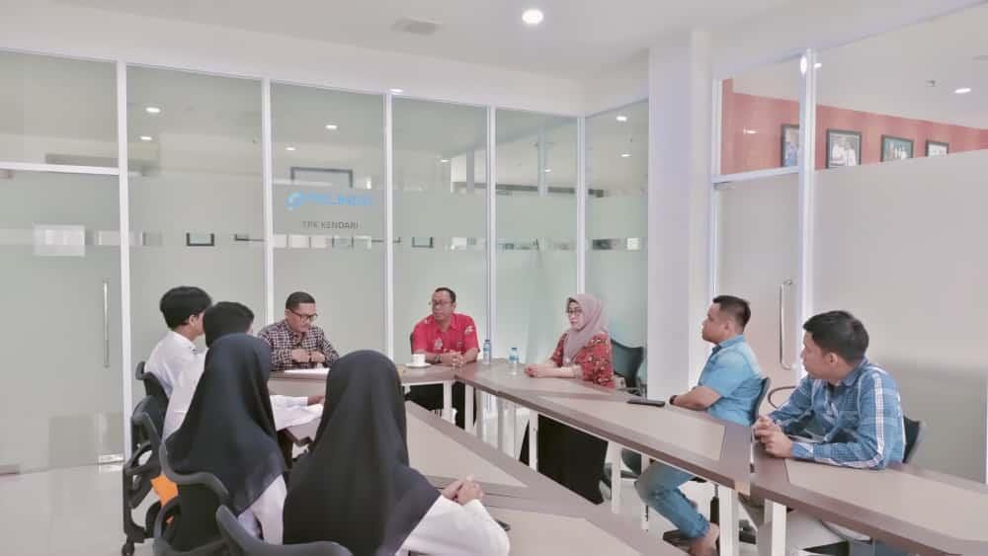

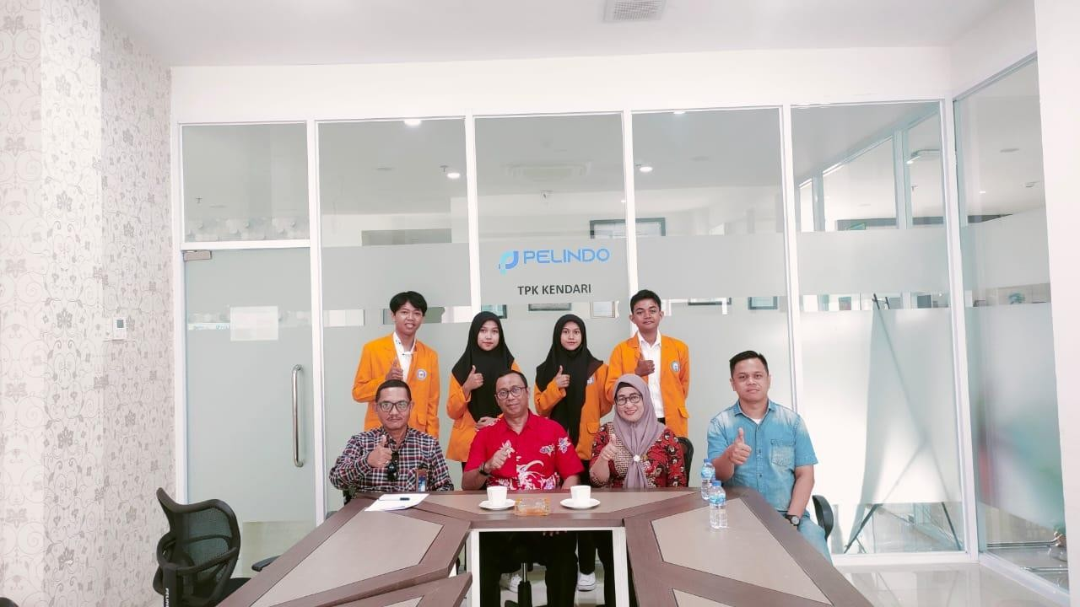

Pelindo Mengajar Goes To Kendari Held at SMAN 08 Nambo
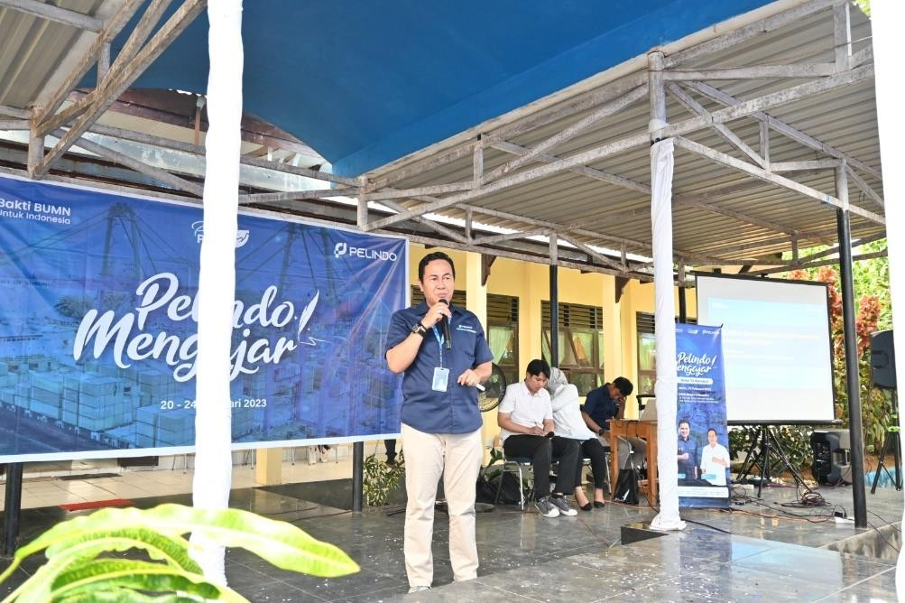
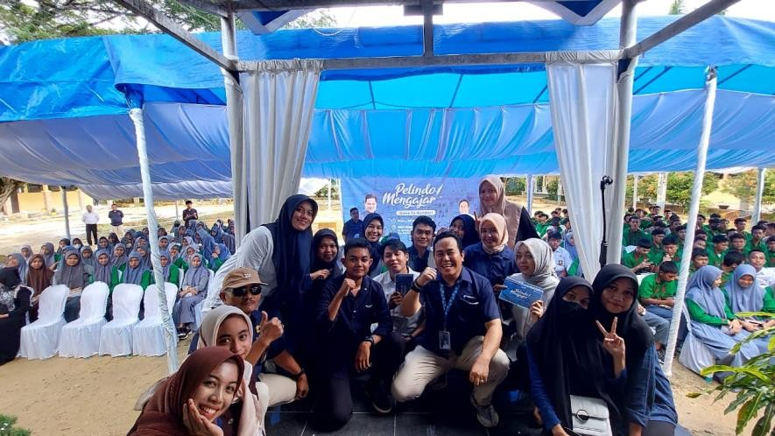
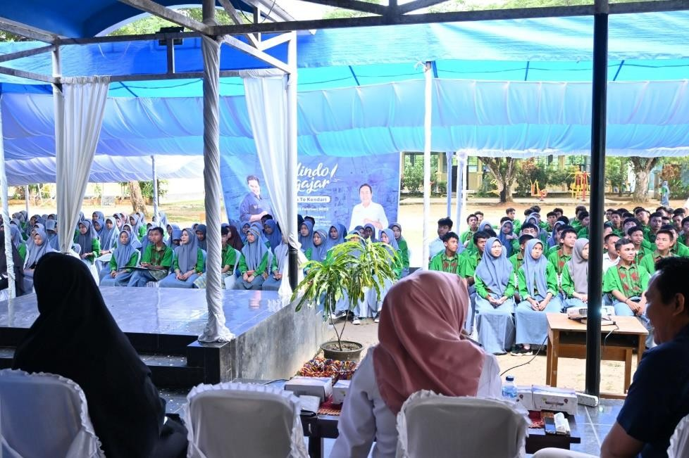

Field Study: Direct Observation of Container Field Area and Workshop Area

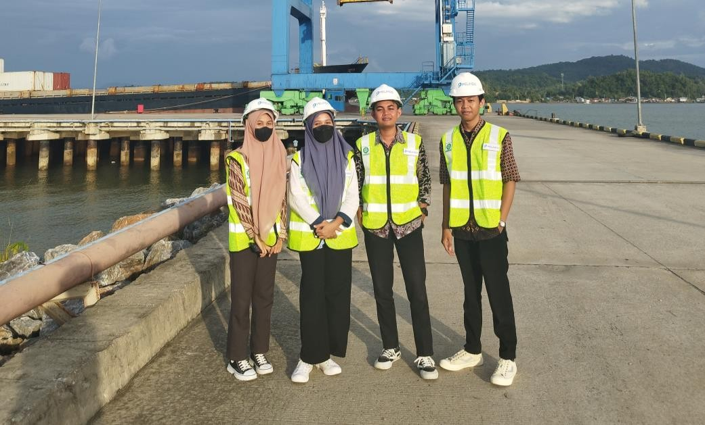

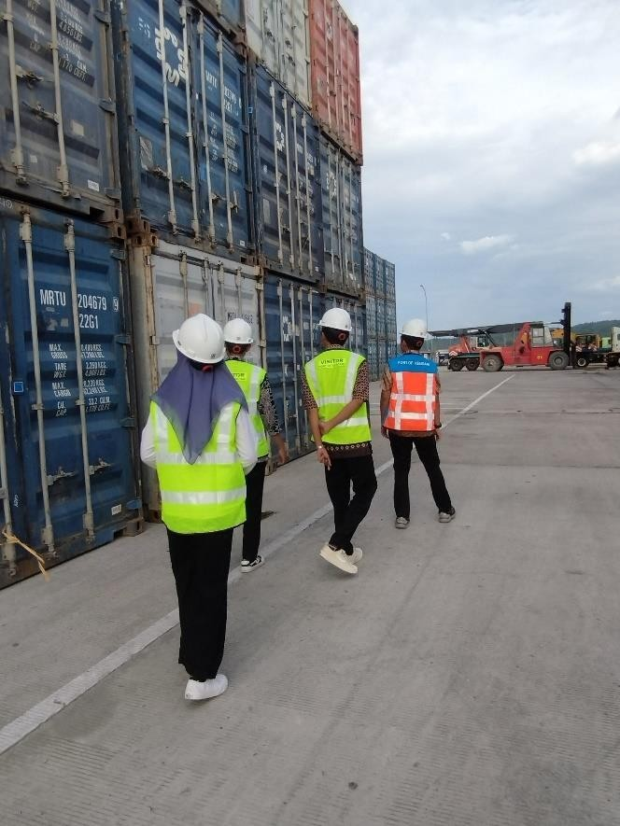

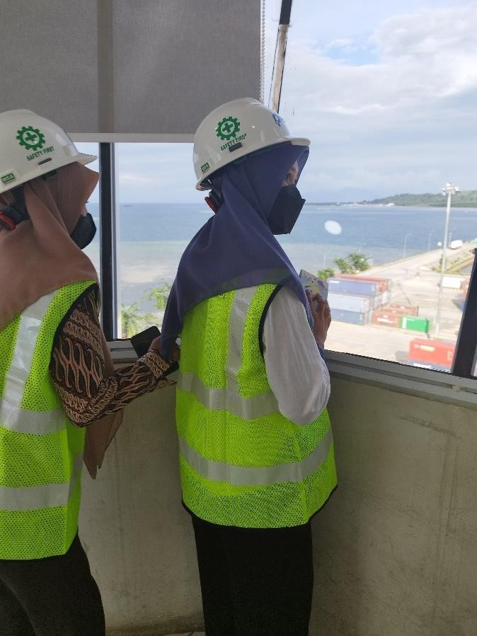
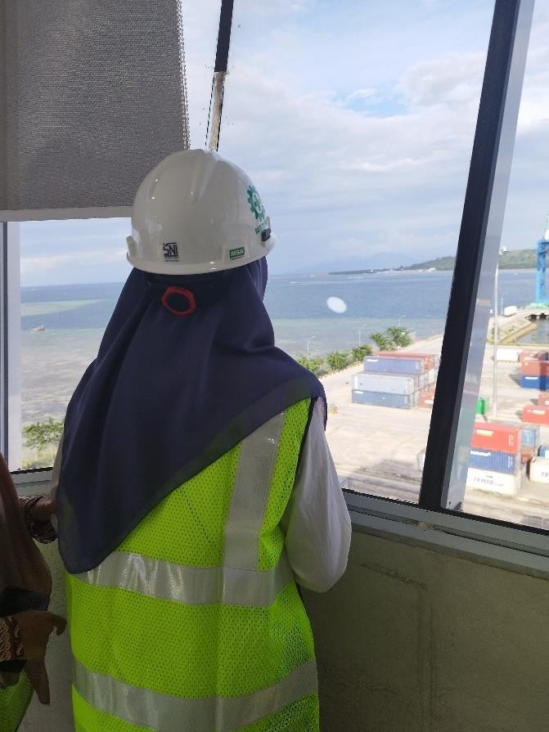

Daily Routine Work Process of Student Interns
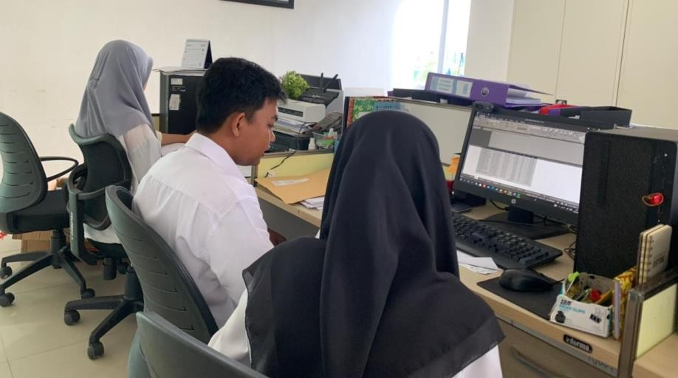
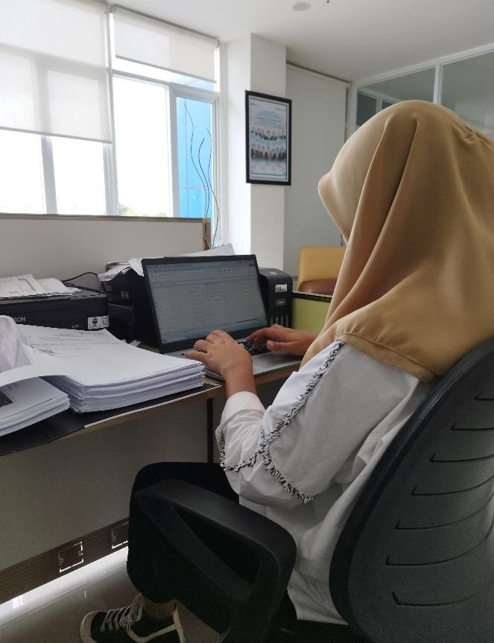

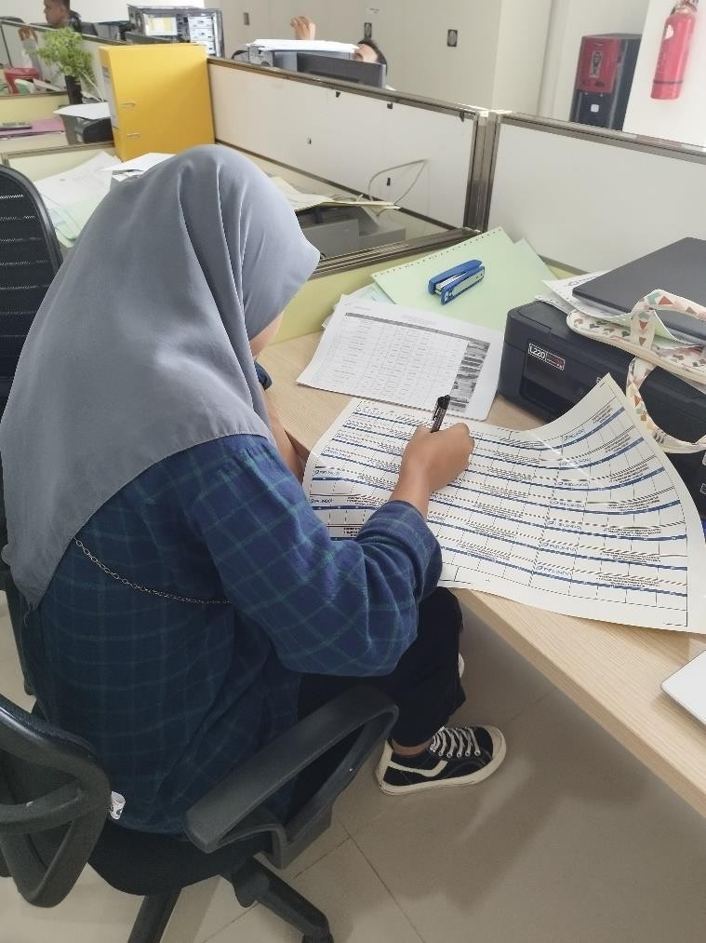
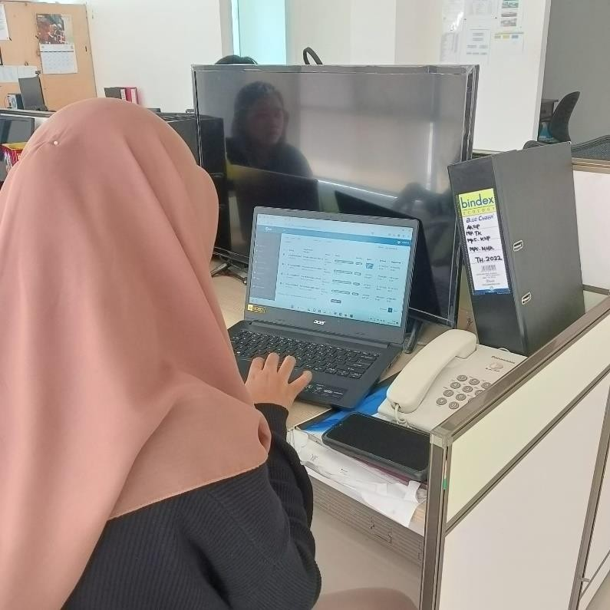

Field Study: Direct Review of Fast Boat and Night Boat Port Areas
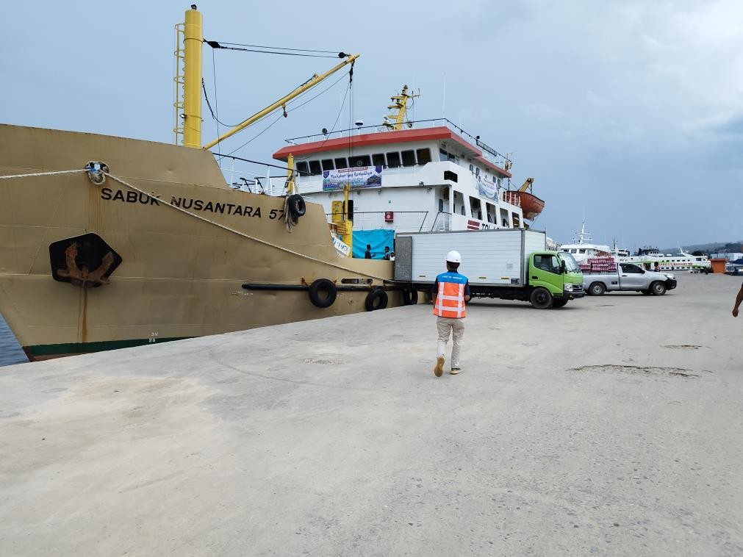

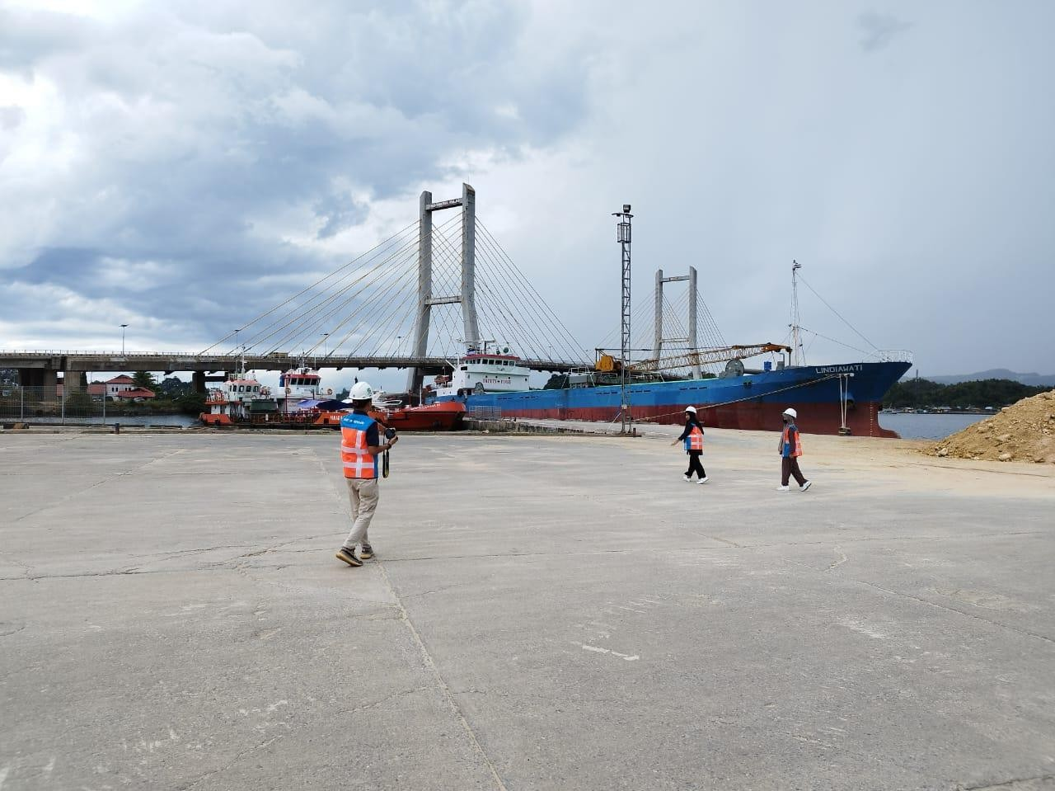

Breaking the Fast with Pelindo Employees

Teaching and Learning Process by the Manager of Pelindo 4 Kendari

Pelindo Employees Working Together to Commemorate Environment Day
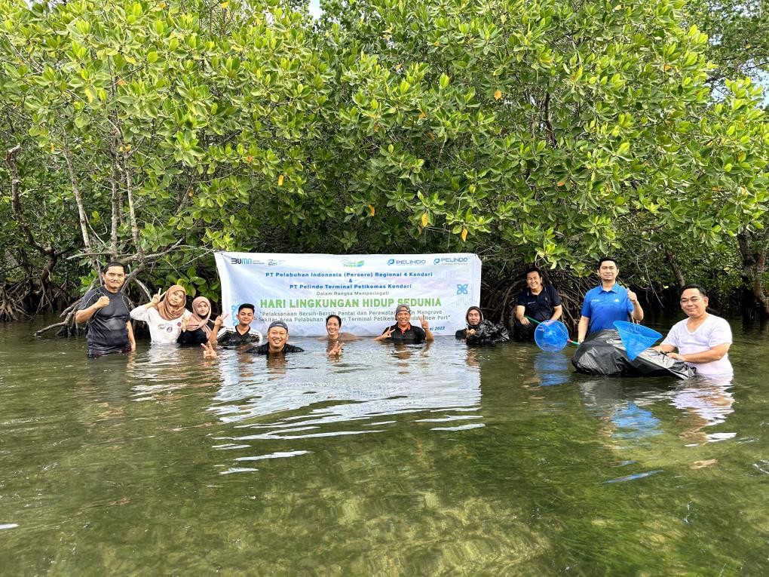

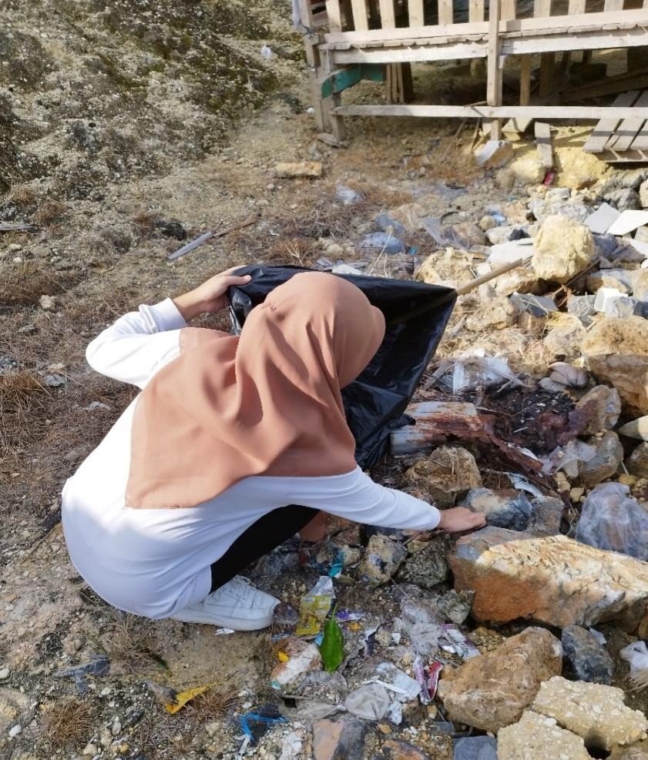

Cultural Parade Commemorating the Anniversary of Southeast Sulawesi Province
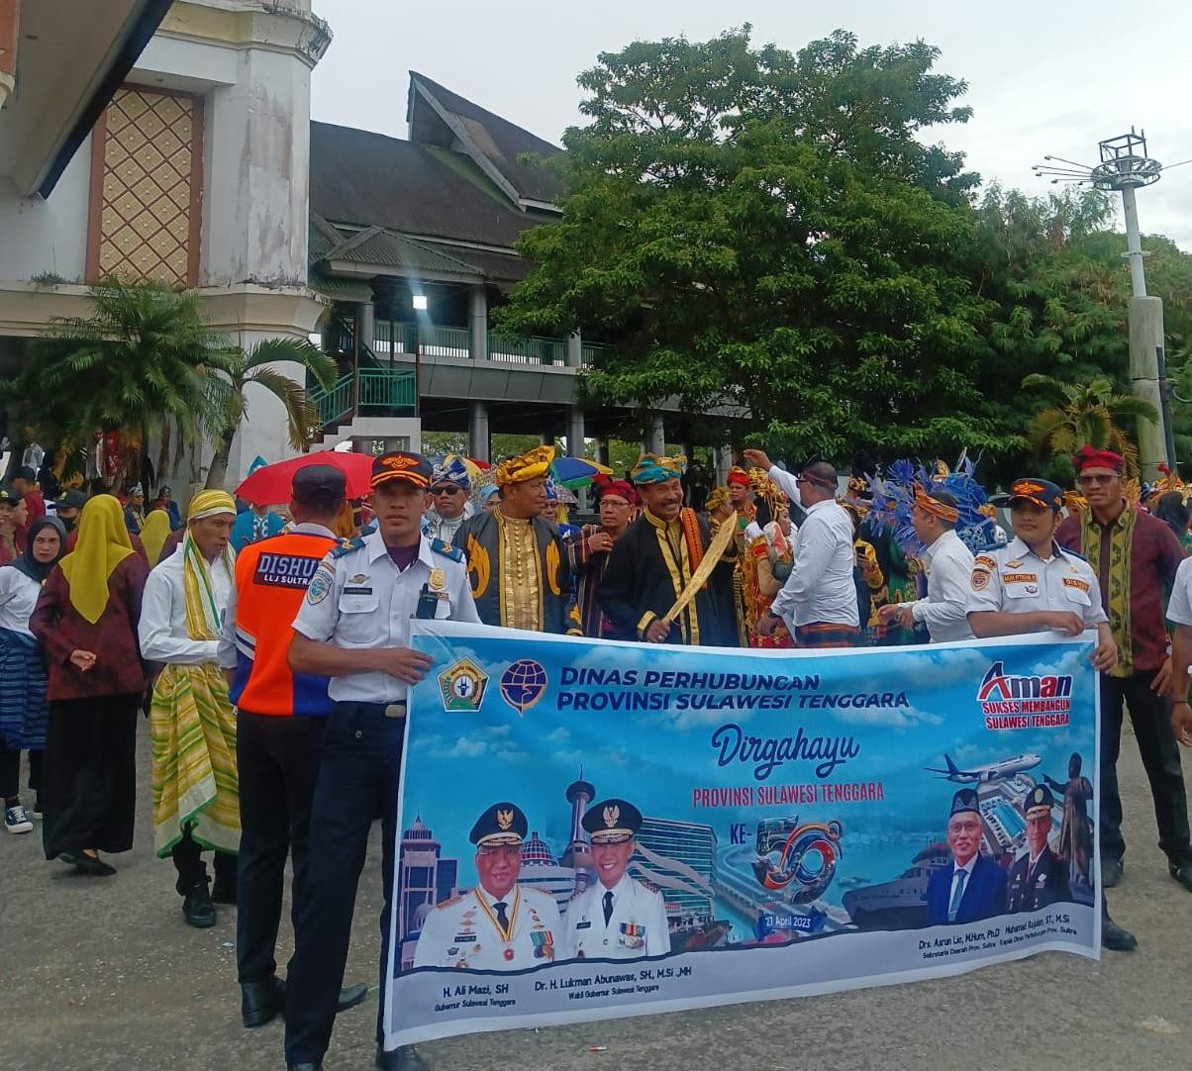
Providing Services to Port Passengers
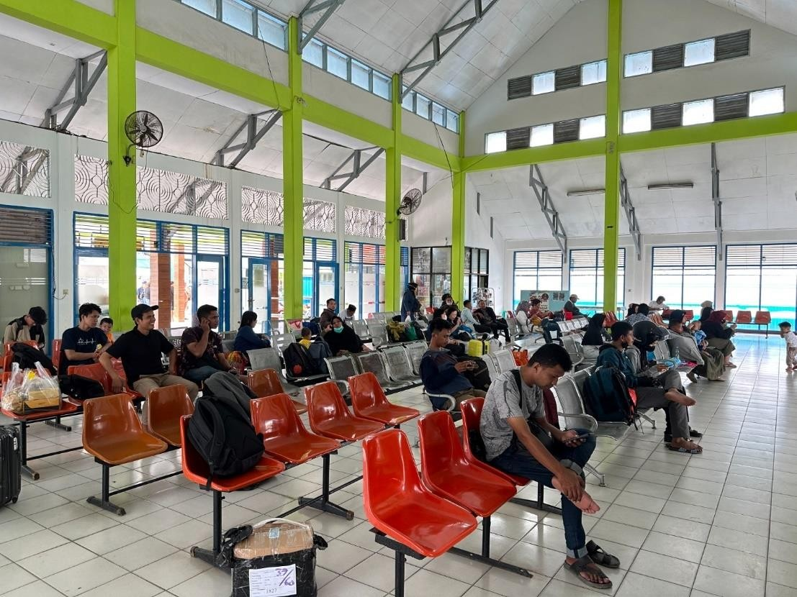

Gymnastics Activities
